|  |
| --- |
| **OUR PARISH**  **IS HERE FOR YOU**C:\Users\user\AppData\Local\Microsoft\Windows\Temporary Internet Files\Content.Outlook\T23GC0Q2\IMG_6096.PNG |
| **During this time of social distancing, we are commmited to continue serving our parishioners through our ministries and other resources** |

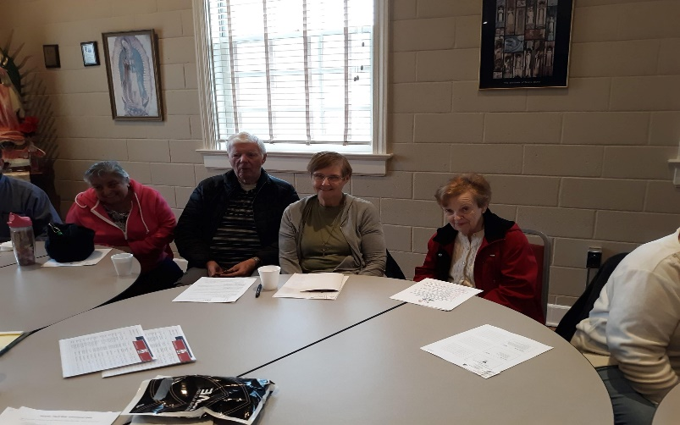

**OUR MINISTRIES**

During the Covid-19 pandemic, the Church of St. Therese will continue to be a source of spiritual life for our parishioners and friends.

Please contact the parish at 804-693-5939 if there is any way we can minister to you.

Keep updated on our website at www.sttheresechurch.info.

**We are answering the office phone during the weekdays: 804-693-5939**

**Father is available for emergencies and time-sensitive needs: 804-695-2785**