“Christ’s face became as dazzling as the sun, his clothes as radiant as light.”

Second Sunday of Lent

March 8, 2020

MASSES AND INTENTIONS
THIS WEEKEND OF
MARCH 7-8, 2020
Saturday 5:00 PM Mass
Intention: Catherine Hall (RIP)
Requested By: Jim & Phyllis Hall
Sunday 8:00 AM Mass
Intention: Lynn Casanave (RIP)
Requested By: Bruce & Trudy Vanderhoof
Sunday 10:30 AM Mass
Intention: St. Therese Parishioners

WEEK OF MARCH 9-13, 2020
Monday No Mass
Tuesday 12:00 Noon Mass
Intention: Missam Pro Populo
Wednesday 12:00 Noon Mass
Intention: Missam Pro Populo
Thursday 12:00 Noon Mass
Intention: Mass for the people
Friday 8:00 AM Mass
Intention: For the People

WEEKEND OF
MARCH 14-15, 2020
Saturday 5:00 PM Mass
Intention: Monica Fallon (RIP)
Requested By: Bob & Cheryl Davis
Sunday 8:00 AM Mass
Intention: The Theresians
Sunday 10:30AM Mass
Intention: St. Therese Parishioners


DAILY SCRIPTURE READINGS
Daily Readings may be found at the
www.USCCB.org website

BLESSED SACRAMENT CHAPEL
VASE FLOWERS
Perpetual living memorial for Anna Lupei

ST. THERESE’S TABERNACLE CANDLE
March 2-8, 2020
In Memory of Richard & Mary Clements and
Joseph & Marion Serra

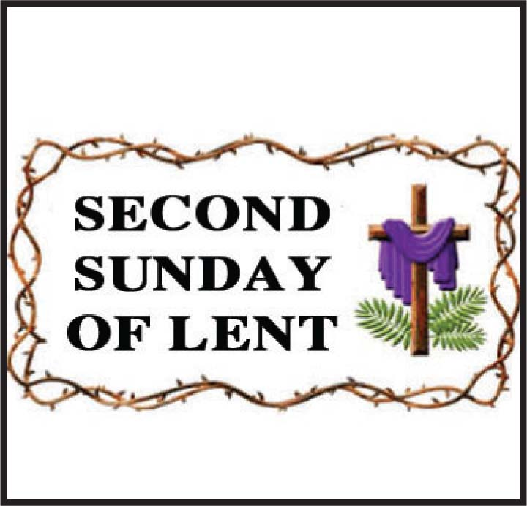

GIFT GIVING
Fiscal Year 7/1/19 through 6/30/2020
Annual operating expense budget: $650,886.40

Offertory Totals

Actual donations 3/1/2020: $6,554.34
Gifts were in envelopes and in loose cash/checks

Other donations 3/1/2020 not used for
operations totaled $717.00

In addition, we received E-giving support this week totaling $2,116.00

With a Weekend Mass (5 & 10:30)
attendance total of 262

"All tithes of the land, whether in grain from the fields or in fruit from the trees, belong to the LORD, as sacred to him." Leviticus 27:30

GIVE ONLINE THIS HOLY SEASON OF LENT
As you contemplate donations this holiday season, please keep St. Therese in mind. Your contributions are needed for everything from special programs to basic operating expenses—both are deserving of your support. Please be as generous as you can this holiday season and in the year ahead. For the convenience of church members, we offer online giving. To donate, visit the church website at www.sttheresechurch.info and locate the link to our online giving page and follow the instructions.

We can accept Visa, MasterCard, Discover,
and American Express, debit cards and savings/checking drafts.

MARCH SECOND COLLECTIONS
March 21/22 Church Fuel Assistance
March 28/29 Catholic Relief Services
MESSAGE FROM BISHOP KNESTOUT
On February 17, 2020 Bishop Barry C. Knestout announced an Independent Reconciliation Program. This program is a continuation of his commitment to “respond in charity and in justice” to assist victim survivors who, as minors, were sexually abused by Catholic clergy of our Diocese. This program is intended to be a resource for them on their paths of healing.
Other information about the Independent Reconciliation Program, including a message from Bishop Knestout, Program Protocol, and Program & Diocesan FAQ can be found at assistance.richmonddiocese.org. The deadline for initiating a claim is April 3, 2020.

BAPTISMAL PREP
Any parent wishing to have their child baptized must first make an appointment to speak with Father Gregory. Our next parent preparation class will be held Tuesday, March 17 at 7:00 PM. The next Baptismal weekend will be April 18-19, 2020. Please contact Nadine McGrady for questions at N.McGrady@StThersGlo.org or 693-5939.


BICENTENNIAL WEBSITE
Visit 2020.richmondiocese.org to find important information about the Bicentennial including a message from the Bishop, Diocesan History, the Bicentennial Prayer and Hymn, and a schedule of events that will be ongoing throughout the year.

YOUTH MINISTRY POSITION
Sharing the Gospel of Jesus Christ is an urgent responsibility that we have here in Gloucester. Especially with the challenges of a post-Christian, secular society, creating the climate that nurtures our young in the faith is crucial. That is why Fr. Gregory, in consultation with the Finance and Pastoral Councils, is seeking to hire an enthusiastic disciple of Jesus to build a dynamic Youth Ministry program in our parish. The successful candidate for this full-time position will be one who strives to lead a life of personal holiness and expresses a heartfelt desire to lead teens closer to Christ. Applicants should have at least a Bachelor's degree and experience in Youth Ministry. The position will be responsible for overseeing the middle school and high school programs in our parish with vision, including Sacramental preparation for Confirmation, with special attention given to empowering lay leadership in adults and teens. Send cover letter, resume, and Richmond Diocesan application to Dan Wenner, Search Committee Chair, at daniel.wenner@marist.edu.

EAGLE SCOUT CEREMONY FOR
ALEXANDER ROBERTS
Alexander Roberts and his family would like to invite all parishioners to participate in his Boy Scouts of America Eagle Scout Ceremony. The Ceremony will be in the Parish social hall on Sunday March 8 from 12 noon -2pm. Alex is so appreciative of all the support he has received from our Parish and this is his opportunity to say thank you.
NOMINATIONS TO PARISH PASTORAL COUNCIL
On the weekends of March 21-22 and March 28-29, we will be soliciting nominations at all Masses for new Pastoral Council members. Please begin to pray about people in our parish that you think would be great to serve on the Pastoral Council to provide leadership and vision to the Church of Saint Therese in collaboration with Father Gregory. All parishioners will be given the opportunity to nominate others or themselves for discernment to serve on the Council.

ADULT FORMATION OPPORTUNITY
All the baptized have been called to share in the priesthood of Jesus Christ. On Sunday, March 15 (beware the Ides of March!), between the morning Masses (starting about 9:15 AM), Father Gregory’s adult Sunday school topic will be The Priesthood of the Baptized and the Ordained in the Meeting Room. All are welcome. Like all good Catholics, BYOB: Bring your own Bible!

YOUTH MINISTRY MOVIE NIGHT
Join us for a viewing of The Passion of The Christ directed by Mel Gibson, followed by Stations of the Cross with Father Gregory in the church, Friday March 13th starting at 4:00pm in the YLC. This movie is rated R due to its graphic nature. It depicts the final twelve hours in the life of Jesus of Nazareth, on the day of his crucifixion in Jerusalem. Please RSVP to Jennifer Roberts - youthministry@stthersglo.org

KINGSFEST AT KINGS DOMINION
This is a three-day event, June 18, 19 and 20; with the option to choose three, two, or one day. They offer a discount for groups of 15 or more so we are opening this up to the entire parish. Cost are as follows: 3-day: $83, 2-day: $73, 1-day: $47. Transportation options will be determined by interest. Please contact Jennifer Roberts as soon as possible if interested. youthministry@stthersglo.org

LENTEN WORSHIP SCHEDULE
March 10 Lenten Reconciliation
OLBS West Point 7:00 PM
March 12 Lenten Reconciliation
St. Therese 7:00 PM
March 13 Theresian Lenten Rosary 10:00-10:30 AM
Soup With Love 11:30 AM-1:00 PM
KofC Lenten Fish Fry 5:30-7:00 PM
Stations of the Cross 7:00 PM
March 20 Theresian Lenten Rosary 10:00-10:30 AM
Soup With Love 11:30 AM-1:00 PM
KofC Lenten Fish Fry 5:30-7:00 PM
Stations of the Cross 7:00 PM
March 27 Theresian Lenten Rosary 10:00-10:30 AM
Soup With Love 11:30 AM-1:00 PM
KofC Lenten Fish Fry 5:30-7:00 PM

April 3 Theresian Lenten Rosary 10:00-10:30 AM
Soup With Love 11:30 AM-1:00 PM

