“Lazarus, come out!”

Fifth Sunday of Lent

March 29, 2020

MASSES AND INTENTIONS
THIS WEEKEND OF
MARCH 28-29, 2020
Saturday 5:00 PM Livestreaming Mass
Live streamed on Facebook and Youtube. Visit our website at sttheresechurch.Info for the links to each.

Intention: St. Therese Parishioners

Sunday Masses are live s streamed on Facebook and Youtube

WEEK OF MARCH 30-APRIL 3, 2020
ALL DAILY MASSES ARE BEING LIVESTREAMED ON FACEBOOK AND YOUTUBE AT 12:00 NOON
Monday No Mass
Tuesday No Mass
Intention: Annie O'Neill (RIP)
Requested By: Donna Hull
Wednesday No Mass
Intention: Barbara Loonam (RIP)
Requested By: John Loonam
Thursday No Mass
Intention: Carol Wezensky (RIP)
Requested By: Larry and Glenda Espiritu
Friday No Mass
Intention: For the Theresians

WEEKEND OF
APRI 4-5, 2020
Saturday 5:00 PM Livestreaming Mass
Live streamed on Facebook and Youtube. Visit our website at sttheresechurch.Info for the links to each.
Sunday Masses are live s streamed on Facebook and Youtube


DAILY SCRIPTURE READINGS
Daily Readings may be found at the
www.USCCB.org website

BLESSED SACRAMENT CHAPEL
VASE FLOWERS
Perpetual living memorial for Anna Lupei

ST. THERESE’S TABERNACLE CANDLE
March 23-29, 2020
In Memory of Patricia Casanave

GIFT GIVING
Fiscal Year 7/1/19 through 6/30/2020
Annual operating expense budget: $650,886.40

Offertory Totals

No Mass totals at this time

"All tithes of the land, whether in grain from the fields or in fruit from the trees, belong to the LORD, as sacred to him." Leviticus 27:30

GIVE ONLINE THIS HOLY SEASON OF LENT
As you contemplate donations this holiday season, please keep St. Therese in mind. Your contributions are needed for everything from special programs to basic operating expenses—both are deserving of your support. Please be as generous as you can this holiday season and in the year ahead. For the convenience of church members, we offer online giving. To donate, visit the church website at www.sttheresechurch.info and locate the link to our online giving page and follow the instructions.

We can accept Visa, MasterCard, Discover,
and American Express, debit cards and savings/checking drafts.


Visit 2020.richmondiocese.org to find important information about the Bicentennial including a message from the Bishop, Diocesan History, the Bicentennial Prayer and Hymn, and a schedule of events that will be ongoing throughout the year.

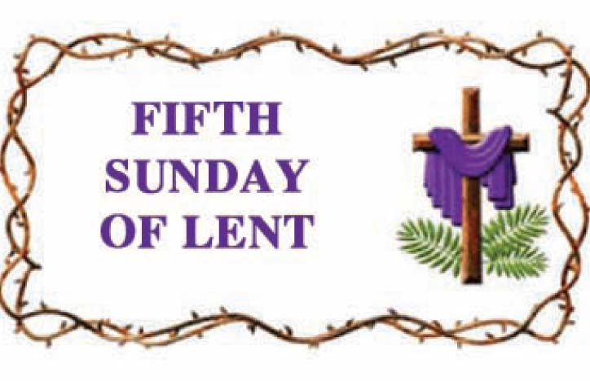
YOUTH MINISTRY POSITION
Sharing the Gospel of Jesus Christ is an urgent responsibility that we have here in Gloucester. Especially with the challenges of a post-Christian, secular society, creating the climate that nurtures our young in the faith is crucial. That is why Fr. Gregory, in consultation with the Finance and Pastoral Councils, is seeking to hire an enthusiastic disciple of Jesus to build a dynamic Youth Ministry program in our parish. The successful candidate for this full-time position will be one who strives to lead a life of personal holiness and expresses a heartfelt desire to lead teens closer to Christ. Applicants should have at least a Bachelor's degree and experience in Youth Ministry. The position will be responsible for overseeing the middle school and high school programs in our parish with vision, including Sacramental preparation for Confirmation, with special attention given to empowering lay leadership in adults and teens. Send cover letter, resume, and Richmond Diocesan application to Dan Wenner, Search Committee Chair, at daniel.wenner@marist.edu.

CHURCH OF ST. THERESE
OUR MASSES ARE NOW LIVESTREAMED!!
Masses will be livestreamed Tuesday through Friday at noon and the weekend (Sunday) Mass at 5:00 on Saturday.
Watch the Livestream on Facebook:
www.facebook.com/churchofsttherese.
Watch the replay on YouTube: Church Of St. Therese – Gloucester, VA YouTube Channel


ST. THERSE PARISH APP
New to St. Therese, Dee Printing, Inc.; now has an app that you can download free. Go to your app store on your smart phone and search for “InOurParish”. After you download the app, search for St. Therese, Gloucester. In the app, you will be able to view Mass times, bulletins, go to the website, online giving, prayer requests, and notifications. To receive notifications, you need to be sure that you enable notifications. To enable the notifications, go to the notifications setup block on the main menu, tap on it and check the box for General Messages and save it. Once enabled you will receive notifications from the parish office, for example: a funeral service day and time, unexpected office closure or cancellation of events. If you have any questions, contact Ann in the Parish Office.

MESSAGE FROM BISHOP KNESTOUT
On February 17, 2020, Bishop Barry C. Knestout announced an Independent Reconciliation Program. This program is a continuation of his commitment to “respond in charity and in justice” to assist victim survivors who, as minors, were sexually abused by Catholic clergy of our Diocese. This program is intended to be a resource for them on their paths of healing.
Other information about the Independent Reconciliation Program, including a message from Bishop Knestout, Program Protocol, and Program & Diocesan FAQ can be found at assistance.richmonddiocese.org. The deadline for initiating a claim is April 3, 2020.
From Father Gregory:
Today Bishop Knestout suspended all public Masses in the Diocese until further notice.
All non-essential meetings at the church are cancelled.
Our church is open during normal office hours, and on Sunday morning from 9:00 until noon, for private prayer before the Blessed Sacrament which is in the tabernacle on our main altar. The daily Mass chapel, however, is closed until further notice. Please understand that, per the instructions of the Bishop, no more than 10 people can be in our church at one time.
Let us pray for healing for those who have contracted the coronavirus, for protection for caregivers, and for an end to this pandemic. As God’s sons and daughters, we draw close to the Lord and remember Jesus’ constant refrain in the Gospels, “Do not be afraid”. Fear is the Devil’s greatest tool; but as our holy patroness Saint Therese teaches us, we who believe trust in God’s goodness.
Peace in Jesus our Savior,
fr.gregory+

FOR PRIVATE PRAYER BEFORE THE
BLESSED SACRAMENT
I believe that you are present in the Most Blessed Sacrament. I love you above all things, and I desire to receive you into my soul. Since I cannot now receive you sacramentally, come at least spiritually into my heart. I embrace you as if you were already there, and unite myself wholly to you. Never permit me to be separated from you. Amen

PARISH OFFICE HOURS
Parish Office hours are Monday through Thursday 9:00 AM to 2:00 PM. The Parish Office will be closed on Fridays. The Church will be opened Monday through Friday for private prayer from 9:00 AM until 2:00 PM. We appreciate your understanding during this time of uncertainty.

BULLETINS
Dee Printing has notified us that they are suspending all bulletin printing for the time being. With that being said, the office will continue to put a bulletin together to keep parishioners informed. This information bulletin will only be placed on the website at www.sttheresechurch.info. Thank you for your understanding and patience.

