“Now you are light in the Lord.”

Fourth Sunday of Lent

March 22, 2020

MASSES AND INTENTIONS
THIS WEEKEND OF
MARCH 21-22, 2020
Saturday 5:00 PM Mass
Intention: Cheryl Boll (RIP)
Requested By: The Rice Family
Sunday 8:00 AM Mass
Intention: St. Therese Parishioners
Sunday 10:30 AM Mass
Intention: Celeste Dudley (RIP)
Requested By: Tony & Mary Sinsi

WEEK OF MARCH 23-27, 2020
Monday No Mass
Tuesday No Mass
Wednesday No Mass
Thursday No Mass
Friday No Mass

WEEKEND OF
MARCH 28-29, 2020
Saturday 5:00 PM Mass
Intention: Barbara Loonam (RIP)
Requested By: John Loonam
Sunday 8:00 AM Mass
Intention: Carol Wezensky (RIP)
Requested By: Larry & Glenda Espiritu
Sunday 10:30AM Mass
Intention: St. Therese Parishioners


DAILY SCRIPTURE READINGS
Daily Readings may be found at the
www.USCCB.org website

BLESSED SACRAMENT CHAPEL
VASE FLOWERS
Perpetual living memorial for Anna Lupei

ST. THERESE’S TABERNACLE CANDLE
March 23-29, 2020
In Memory of Patricia Casanave

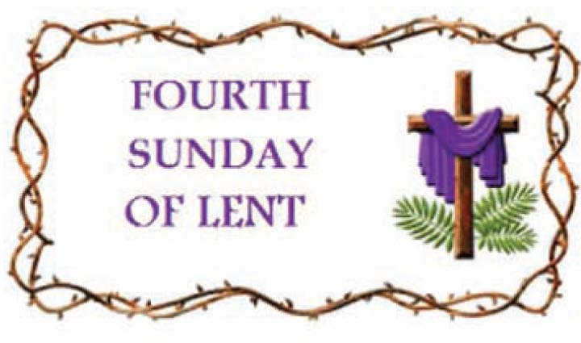

GIFT GIVING
Fiscal Year 7/1/19 through 6/30/2020
Annual operating expense budget: $650,886.40

Offertory Totals

Actual donations 3/15/2020: $3149.50
Gifts were in envelopes and in loose cash/checks

In addition, we received E-giving support this week totaling $2,912.50

With a Weekend Mass
attendance total of 207

"All tithes of the land, whether in grain from the fields or in fruit from the trees, belong to the LORD, as sacred to him." Leviticus 27:30

GIVE ONLINE THIS HOLY SEASON OF LENT
As you contemplate donations this holiday season, please keep St. Therese in mind. Your contributions are needed for everything from special programs to basic operating expenses—both are deserving of your support. Please be as generous as you can this holiday season and in the year ahead. For the convenience of church members, we offer online giving. To donate, visit the church website at www.sttheresechurch.info and locate the link to our online giving page and follow the instructions.

We can accept Visa, MasterCard, Discover,
and American Express, debit cards and savings/checking drafts.

MARCH SECOND COLLECTIONS
March 28/29 Catholic Relief Services



MESSAGE FROM BISHOP KNESTOUT
On February 17, 2020, Bishop Barry C. Knestout announced an Independent Reconciliation Program. This program is a continuation of his commitment to “respond in charity and in justice” to assist victim survivors who, as minors, were sexually abused by Catholic clergy of our Diocese. This program is intended to be a resource for them on their paths of healing.
Other information about the Independent Reconciliation Program, including a message from Bishop Knestout, Program Protocol, and Program & Diocesan FAQ can be found at assistance.richmonddiocese.org. The deadline for initiating a claim is April 3, 2020.

SOUP WITH LOVE
Soup with Love served on Friday, March 13, 56 guests and collected $267 in donations. The Soup with Love has been cancelled for Friday, March 27, 2020.

YOUTH MINISTRY POSITION
Sharing the Gospel of Jesus Christ is an urgent responsibility that we have here in Gloucester. Especially with the challenges of a post-Christian, secular society, creating the climate that nurtures our young in the faith is crucial. That is why Fr. Gregory, in consultation with the Finance and Pastoral Councils, is seeking to hire an enthusiastic disciple of Jesus to build a dynamic Youth Ministry program in our parish. The successful candidate for this full-time position will be one who strives to lead a life of personal holiness and expresses a heartfelt desire to lead teens closer to Christ. Applicants should have at least a Bachelor's degree and experience in Youth Ministry. The position will be responsible for overseeing the middle school and high school programs in our parish with vision, including Sacramental preparation for Confirmation, with special attention given to empowering lay leadership in adults and teens. Send cover letter, resume, and Richmond Diocesan application to Dan Wenner, Search Committee Chair, at daniel.wenner@marist.edu.

THEATER ‘N’ THEOLOGY
Our next Lenten TNT (Theater ‘N’ Theology) takes place on Friday, April 3, beginning promptly at 7 pm. All are welcome to come watch a movie in our St. Therese Movie Theater (the “Meeting Room”) with comfortable seating, large projection, and good sound. Afterwards (the “Theology” part), we discuss the movie’s relevance to our life in Christ. Our April Lenten feature is the 1996 film The Crucible. Caught performing a “sinful” dance, a group of New England girls, led by Winona Ryder, claim they were overtaken by the Devil; soon their village is caught in a frenzy of accusations, naming various citizens as witches without so much as a shred of evidence. First American film rendering of Arthur Miller’s classic 1953 play about parallels between Salem witch-hunts of the 1600s and Communist witch-hunts of the 1940s and ‘50s. Gets off to a shaky start, but finds its voice as the story deepens, and hits its stride with the arrival of Paul Scofield, who is brilliant as the judge and inquisitor. Miller himself wrote the screenplay. Also starring Daniel Day-Lewis and Joan Allen. Rated PG-13. Facilitated by Fr. Gregory. All are welcome. If you want to bring refreshments to share, we’ll have refreshments! Come watch a great movie with your brothers and sisters in Christ!
CATHOLIC RELIEF SERVICE SECOND COLLECTION
Next week, our parish will take up The Catholic Relief Services Collection (CRSC). Funds from this collection provide food to the hungry, support displaced refugees, and bring Christ’s love and mercy to all people here and abroad. Next week, please give generously to the CRSC and help Jesus in disguise. Learn more about the collection at www.usccb.org/catholic-relief.

EASTER FLOWERS
We are accepting donations for Easter Lilies, which may be in memory and/or in honor of a loved one. Please put your intentions on the back of your envelopes. Easter lily memorials will be collected and a bulletin insert will be prepared for the Easter bulletin. We are blessed from your generosity!

LENTEN WORSHIP SCHEDULE
March 27 Theresian Lenten Rosary 10:00-10:30 AM
April 3 Theresian Lenten Rosary 10:00-10:30 AM
Soup With Love 11:30 AM-1:00 PM
April 9 Holy Thursday Mass 7:00 PM
April 10 Good Friday Service 7:00 PM
April 11 Easter Vigil Mass 8:00 PM
April 12 Easter Sunday Masses 8:00 & 10:30 AM

GOOD FRIDAY “WAITING AND WATCHING”
On Good Friday, April 10, from 12:00pm to 3:30pm there will be a “Waiting and Watching” program for all interested parishioners and non-parishioners alike whose hearts are moved to deeper prayer and reflection upon the crucifixion of our Lord. Below is the schedule of devotions planned; please join us in the main worship space here at St. Therese for as much of this very holy time as you can give.
12:00pm – Stations of the Cross
12:40pm – 3:00pm – Prayerful reflections on the “Seven Last Words” of Jesus on the Cross, interspersed with corresponding music, and silent personal reflection.
3:00pm – Chaplet of Divine Mercy
Following the Divine Mercy Chaplet, the church will remain open for silent prayer. Please be advised there will be some activity as the altar is prepared for the Good Friday liturgy will take place at 7:00pm.


ST. THERSE PARISH APP
New to St. Therese, Dee Printing, Inc.; now has an app that you can download free. Go to your app store on your smart phone and search for “InOurParish”. After you download the app, search for St. Therese, Gloucester. In the app, you will be able to view Mass times, bulletins, go to the website, online giving, prayer requests, and notifications. To receive notifications, you need to be sure that you enable notifications. To enable the notifications, go to the notifications setup block on the main menu, tap on it and check the box for General Messages and save it. Once enabled you will receive notifications from the parish office, for example: a funeral service day and time, unexpected office closure or cancellation of events. If you have any questions, contact Ann in the Parish Office.

