“Arise and shine; your light has come.”

Solemnity of the Epiphany of the Lord

January 5, 2020

MASSES AND INTENTIONS
THIS WEEKEND OF
JANUARY 4-5, 2020
Saturday 5:00 PM Mass
Intention: Paul Fitzpatrick (RIIP) Happy Birthday
Requested By: Edwina, Children and Grandchildren
Sunday 8:00 AM Mass
Intention: St. Therese Parishioners

Sunday 10:30 AM Mass
Intention: Eugene & June Wlock (RIP)
Requested By: Dave & Sally Dispirito

WEEK OF JANUARY 6-10, 2020
Monday No Mass
Tuesday 8:00 AM Mass
Intention: For the People
Wednesday 12:00 AM Mass
Intention: Don & Audrea Cowan
Requested By: Rice Family
Thursday 12:00 Noon Mass
Intention: Connie Francis (RIP)
Requested By: Ed & JoAnn Kizer
Friday 12:00 Noon Mass
Intention: Sean O'Malley
Requested By: Teresa Hinton

WEEKEND OF
JANUARY 11-12, 2020
Saturday 5:00 PM Mass
Intention: Edward & Winifred Confroy (RIP)
Requested By: Edwina Fitzpatrick
Sunday 8:00 AM Mass
Intention: Teri Syslo (RIP)
Requested By: Sylvester & Linda McClellan
Sunday 10:30AM Mass
Intention: St. Therese Parishioners


DAILY SCRIPTURE READINGS
Daily Readings may be found at the
www.USCCB.org website

See the bulletin board leading to the social hall
to sign up for Altar Flowers for the 2020
calendar year. Thank you for your donations
of Altar Flowers.

BLESSED SACRAMENT CHAPEL
VASE FLOWERS
Perpetual living memorial for Anna Lupei

ST. THERESE’S TABERNACLE CANDLE
January 6-12, 2020
In Memory of Kenneth Wahlman

GIFT GIVING UPDATE
Fiscal Year 7/1/19 through 6/30/2020
Annual operating expense budget: $650,886.40

Offertory Totals

No offertory totals due to early
Bulletin deadline. Thank you for
your contributions throughout the year.

"To whom much Is given, much is expected." Luke 12:48

MAKE YEAR-END GIFTS ON THE CHURCH WEBSITE
In the course of year-end tax planning, you may find yourself considering special one-time donations. There is a growing trend among donors to make contributions to their favorite organizations via the Web during the final week of the year. As you contemplate year-end gifts, please keep St. Therese in mind. We welcome your donations through the giving page on the church website at www.sttheresechurch.info. We wish you all New Year’s Blessings!!

We can accept Visa, MasterCard, Discover,
and American Express, debit cards and savings/checking drafts.

JANUARY COLLECTIONS

January 4/5 MM&R (Major, Maintenance & Repair)
January 18/19 Respect Life

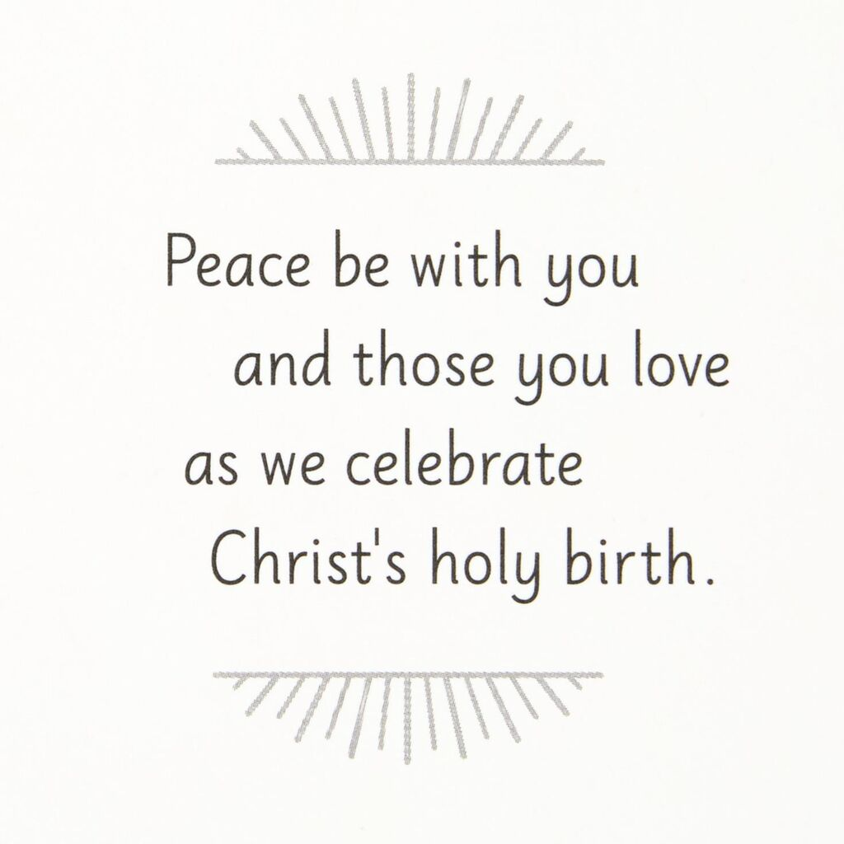
NEW TO THE PARISH OR NEED TO UPDATE YOUR PARISH REGISTRATION
Being a registered parishioner makes the process much easier when it is time for infant Baptism, Religious Educations registration, weddings, when asked to be a Baptismal or Confirmation sponsor, and even funerals. A register parishioner receives all parish mailings. Registration forms are in the rack near the office, on the website at www.sttheresechurch.info, or you may stop in at the Parish Office during office hours for more information and a registration form.

MORNING BIBLE STUDY
The Morning Bible Study Group will resume its weekly meetings on January 9, 2020. The group meets on Thursday mornings from 10:15 to 11:45 AM. Various sections or themes of the Bible are discussed in an informal setting. The next six-week segment will discuss Isaiah 40-55 Build a Highway for God. New participants are always welcomed. If interested or would like more information, please call Doris Melancon at 693-0311 or Sid Dugas at 642-5869.

GRIEFSHARE PROGRAM
The GriefShare program is a 13-week program to support those who have experienced the loss of a loved one. The program is based on Christian scriptures and utilizes videos, a workbook and discussions to facilitate attendees in their journey of mourning. The program will be offered two different days and times.
All meetings will be at the church ALC. This is the second White House in front of the Bread for Life pantry.
The morning sessions will begin Tuesday, January 21 from 10:00-11:30 am.
The evening sessions will begin Thursday, January 30 from 6:30-8:00 pm. Contact Linda Gregory to register or for questions at 804-815-7695. Information on the program is also available at GriefShare.org.

UPCOMING YOUTH EVENTS
Join us for our Youth Christmas Party, Saturday Jan. 4 after the 5pm mass! All parishioners are invited! Free will offering of a nonperishable food item for the food pantry. We will have a live DJ, games, fun, food and fellowship! We will also have an ugly Christmas Sweater contest and a white elephant gift exchange! Please bring a wrapped gift ($5-$10 max) that anyone could enjoy, non-age and non-gender specific, if you want to participate!
Upcoming Youth Events:
Jan 17th-19th High School Youth Charlottesville Retreat with
Fr. Gregory
Feb 7th – 9th High School Diocesan Youth Conference in Richmond
Please register for the retreat and conference ASAP

THERESIANS MEETING
Ladies of the parish, please join us at our next Theresian’s meeting on Sunday, January 19, 2020. We will be meeting in the Social Hall beginning at 9:00 AM.

KROGER COMMUNITY REWARDS
Kroger wants to give to St. Therese! Please visit http://www.kroger.com to create a Kroger account. Link your shopper rewards card number to your Kroger.com account and search for Church of St. Therese 554 either by name or UP530 and then click Enroll. You will need a valid email address and a rewards card. *Customers must have a registered Kroger rewards card account to link to your organization. If a member does not yet have a Kroger rewards card, please let them know they are available at the customer service desk at any Kroger.
Purchases will not count for our church until after you register your rewards card. Parishioners must swipe their registered Kroger rewards card or use the phone number that is related to their registered Kroger rewards card when shopping for each purchase to count.

NEW PARISH EVENT:
Praise, Worship & Adoration Preview night, Wednesday Jan. 15th at 6:30pm. We will start the night with an overview about how praise and worship works then proceed with exposition, adoration with praise and worship, benediction and end with mass. We encourage all parishioners to attend. We especially invite our youth to experience another way to strengthen their relationship with God. Can’t wait to see you there!

VISITING PRIEST
Fr. Bob Brownell will be visiting our parish the weekend of
January 18-19, while Fr. Gregory is out of town. If you would like to host Fr. Brownell for dinner after the Saturday evening Mass, please contact Ann in the parish office at 693-5939. Thank you.

PARISH OFFERTORY ENVELOPES
If you have not picked up your Parish Offertory Envelopes, they are now available in the social hall and will be available until the weekend of January 21-22, 2020. After that weekend, you may contact the parish office to pick up your envelopes. St. Therese also offers e-giving which is online. Please visit our website at www.sttheresechruch.info to sign-up or contact Dedee Rice in the parish office for more information on how to sign-up. Please let the office know if you choose e-giving and no longer wish to receive offertory envelopes. We thank you for your continued support.

THANK YOU FOR YOUR PARISH STAFF
We want to thank you, our parish family, for all your well wishes, cards and gifts during this Christmas Season. Many blessings and peace in this New Year 2020! Thank you!



