“Here is my servant, my chosen one with whom I am well pleased.”

Feast of the Baptism of the Lord

January 12, 2020

MASSES AND INTENTIONS
THIS WEEKEND OF
JANUARY 11-12, 2020
Saturday 5:00 PM Mass
Intention: Edward & Winifred Confroy (RIP)
Requested By: Edwina Fitzpatrick
Sunday 8:00 AM Mass
Intention: Teri Syslo (RIP)
Requested By: Sylvester & Linda McClellan
Sunday 10:30 AM Mass
Intention: St. Therese Parishioners

WEEK OF JANUARY 13-17, 2020
Monday No Mass
Tuesday 12:00 Noon Mass
Intention: For the People
Wednesday 7:30 PM Mass
Intention: Missam pro populo
Requested By: Rice Family
Thursday 12:00 Noon Mass
Intention: For all those in Ministry
Friday 11:00 AM WRCC Mass
Intention: For the Homebound

WEEKEND OF
JANUARY 18-19, 2020
Saturday 5:00 PM Mass
Intention: Dennis Gregory (RIP)
Requested By: Linda Gregory
Sunday 8:00 AM Mass
Intention: St. Therese Parishioners
Sunday 10:30AM Mass
Intention: Marsha Pohorence (RIP)
Requested By: Bob & Cheryl Davis


DAILY SCRIPTURE READINGS
Daily Readings may be found at the
www.USCCB.org website

See the bulletin board leading to the social hall
to sign up for Altar Flowers for the 2020
calendar year. Thank you for your donations
of Altar Flowers.

BLESSED SACRAMENT CHAPEL
VASE FLOWERS
Perpetual living memorial for Anna Lupei

ST. THERESE’S TABERNACLE CANDLE
January 13-19, 2020
In Memory of June Weatherly & Virginia Freyou

GIFT GIVING UPDATE
Fiscal Year 7/1/19 through 6/30/2020
Annual operating expense budget: $650,886.40

Offertory Totals

Actual donations 1/5/2020: $6,975.57
Gifts were in envelopes and in loose cash/checks

Other donations 1/5/2020 not used for
operations totaled $1,514.00

In addition, we received E-giving support this week totaling $4,068.90

With a Weekend Mass attendance total of 420

"To whom much Is given, much is expected." Luke 12:48

ANNUAL PLEDGE MESSAGE
As St. Therese prepares for a new year, it is important to know what support we can depend on from our congregation members. By knowing what you are willing to commit financially, we are able to better plan for the future. Please consider setting up a recurring giving plan. Automating your financial commitments means your contributions will be received on a steady, uninterrupted basis.
To set-up a recurring giving schedule, visit us online at www.sttheresechurch.info, locate the Online Giving Button and set-up your recurring giving schedule.

We can accept Visa, MasterCard, Discover,
and American Express, debit cards and savings/checking drafts.

JANUARY COLLECTIONS

January 18/19 Respect Life

NEW TO THE PARISH OR NEED TO UPDATE YOUR PARISH REGISTRATION
Being a registered parishioner makes the process much easier when it is time for infant Baptism, Religious Educations registration, weddings, when asked to be a Baptismal or Confirmation sponsor, and even funerals. A register parishioner receives all parish mailings. Registration forms are in the rack near the office, on the website at www.sttheresechurch.info, or you may stop in at the Parish Office during office hours for more information and a registration form.

GRIEFSHARE PROGRAM
The GriefShare program is a 13-week program to support those who have experienced the loss of a loved one. The program is based on Christian scriptures and utilizes videos, a workbook and discussions to facilitate attendees in their journey of mourning. The program will be offered two different days and times.
All meetings will be at the church ALC. This is the second White House in front of the Bread for Life pantry.
The morning sessions will begin Tuesday, January 21 from 10:00-11:30 am.
The evening sessions will begin Thursday, January 30 from 6:30-8:00 pm. Contact Linda Gregory to register or for questions at 804-815-7695. Information on the program is also available at GriefShare.org.

UPCOMING YOUTH EVENTS
Jan 17th-19th High School Youth Charlottesville Retreat with
Fr. Gregory
Feb 7th – 9th High School Diocesan Youth Conference in Richmond
Please register for the retreat and conference ASAP

THERESIANS MEETING
Ladies of the parish, please join us at our next Theresian’s meeting on Sunday, January 19, 2020. We will be meeting in the Social Hall beginning at 9:00 AM.

KROGER COMMUNITY REWARDS
Kroger wants to give to St. Therese! Please visit http://www.kroger.com to create a Kroger account. Link your shopper rewards card number to your Kroger.com account and search for Church of St. Therese 554 either by name or UP530 and then click Enroll. You will need a valid email address and a rewards card. *Customers must have a registered Kroger rewards card account to link to your organization. If a member does not yet have a Kroger rewards card, please let them know they are available at the customer service desk at any Kroger.
Purchases will not count for our church until after you register your rewards card. Parishioners must swipe their registered Kroger rewards card or use the phone number that is related to their registered Kroger rewards card when shopping for each purchase to count.

VISITING PRIEST
Fr. Bob Brownell will be visiting our parish the weekend of
January 18-19, while Fr. Gregory is out of town. If you would like to host Fr. Brownell for dinner after the Saturday evening Mass, please contact Ann in the parish office at 693-5939. Thank you.
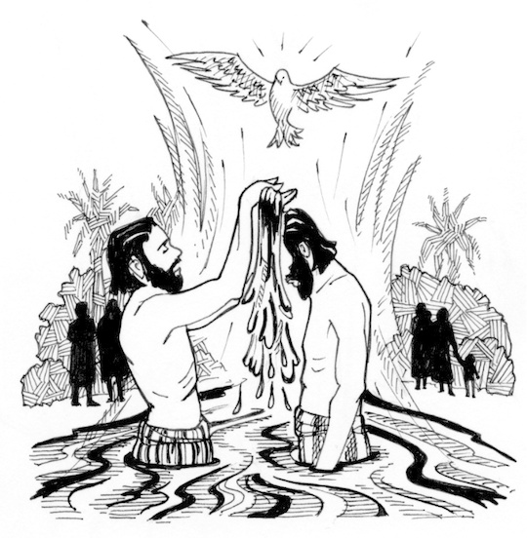

NEW PARISH EVENT:
Praise, Worship & Adoration Preview night, Wednesday Jan. 15th at 6:30pm. We will start the night with an overview about how praise and worship works then proceed with exposition, adoration with praise and worship, benediction and end with mass. We encourage all parishioners to attend. We especially invite our youth to experience another way to strengthen their relationship with God. Can’t wait to see you there!

PARISH OFFERTORY ENVELOPES
If you have not picked up your Parish Offertory Envelopes, they are now available in the social hall and will be available until the weekend of January 18-19, 2020. After that weekend, you may contact the parish office to pick up your envelopes. St. Therese also offers e-giving which is online. Please visit our website at www.sttheresechruch.info to sign-up or contact Dedee Rice in the parish office for more information on how to sign-up. Please let the office know if you choose e-giving and no longer wish to receive offertory envelopes. We thank you for your continued support.

WISDOM: GOD’S VISION FOR LIFE – A NEW SCRIPTURE STUDY FOR ALL INTERESTED ADULTS
“In everything from friendships to finances, making decisions to attaining peace of mind, Scripture offers a vision for happiness and well-being. Drawing on the “wisdom literature” of the Bible – Proverbs, Wisdom, Sirach, Ecclesiastes, Job and the Wisdom Psalms - Wisdom: God’s Vision for Life provides sound guidance on attaining wisdom. This journey will take us through Lent and brighten our Easter worship experience. All parishioners and non-parishioners, particularly those interested in learning more about the Catholic faith and the St. Therese community, are welcome to join us as we embark on a brand new Scripture study. This will begin on February 8, 2020. Please see the poster and literature in the gathering space/commons for more information and to sign up for this amazing study. Questions? Contact Kerry Fallon in the parish office, k.fallon@stthersglo.org or 804-693-5939.

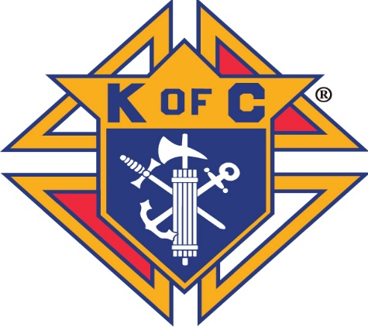BRUNSWICK STEW
Sponsored by
Knights of Columbus Council 9428
Saturday, February 1, 2020
Church of St. Therese
6262 Main St., Gloucester
(Set-up is on Belroi Rd. side)
Serving starts at 11:00 A.M.
$8.00/ Quart TAKE OUT ONLY
Proceeds to benefit
Local Charities

