“Get up, awake the child and his mother and flee to Egypt.”

Feast of the Holy Family of Jesus, Mary and Joseph

December 29, 2019

MASSES AND INTENTIONS
THIS WEEKEND OF
DECEMBER 28-29, 2019
Saturday 5:00 PM Mass
Intention: Ed Drechsel (RIIP)
Requested By: Linda O'Connell
Sunday 8:00 AM Mass
Intention: Great Grandparents & Great Aunt
Requested By: The Family
Sunday 10:30 AM Mass
Intention: St. Therese Parishioners

WEEK OF DEC. 30, 2019-JANUARY 3, 2020
Monday No Mass
Tuesday 5:30 PM Mass
Intention: Joseph Spanuola
Requested By: Teresa Hinton
Wednesday--Solemnity of Mary 10:00 AM Mass
Intention: Joseph & Barbara Mange
Requested By: Teresa Hinton
Thursday 12:00 Noon Mass
Intention: For the people
Friday 12:00 Noon Mass
Intention: Shirley Baker
Requested By: James Rice

WEEKEND OF
JANUARY 4-5, 2020
Saturday 5:00 PM Mass
Intention: Paul Fitzpatrick (RIP) Happy Birthday
Requested By: Edwina, Children and Grandchildren
Sunday 8:00 AM Mass
Intention: St. Therese Parishioners

Sunday 10:30AM Mass
Intention: Eugene & June Wlock (RIP)
Requested By: Dave & Sally Dispirito


DAILY SCRIPTURE READINGS
Daily Readings may be found at the
www.USCCB.org website

See the bulletin board leading to the social hall
to sign up for Altar Flowers for the 2020
calendar year. Thank you for your donations
of Altar Flowers.

BLESSED SACRAMENT CHAPEL
VASE FLOWERS
Perpetual living memorial for Anna Lupei

ST. THERESE’S TABERNACLE CANDLE
December 30, 2019--January 5, 2020
In Memory of Trudeau and Flannigan Families

GIFT GIVING UPDATE
Fiscal Year 7/1/19 through 6/30/2020
Annual operating expense budget: $650,886.40

Offertory Totals

No offertory totals due to early
Bulletin deadline. Thank you for
your contributions throughout the year.

"Give, and gifts will be given to you; good measure, packed together, shaken down, and overflowing, will be poured into your lap. For the measure with which you measure will In return be measured out to you." Luke 6:38

MAKE YEAR-END GIFTS ON THE CHURCH WEBSITE
In the course of year-end tax planning, you may find yourself considering special one-time donations. There is a growing trend among donors to make contributions to their favorite organizations via the Web during the final week of the year. As you contemplate year-end gifts, please keep St. Therese in mind. We welcome your donations through the giving page on the church website at www.sttheresechurch.info. We wish you all New Year’s Blessings!!

We can accept Visa, MasterCard, Discover,
and American Express, debit cards and savings/checking drafts.

JANUARY COLLECTIONS

January 1, 2020 Solemnity of Mary
January Initial Offering
January 4/5 MM&R (Major, Maintenance & Repair)
January 18/19 Respect Life

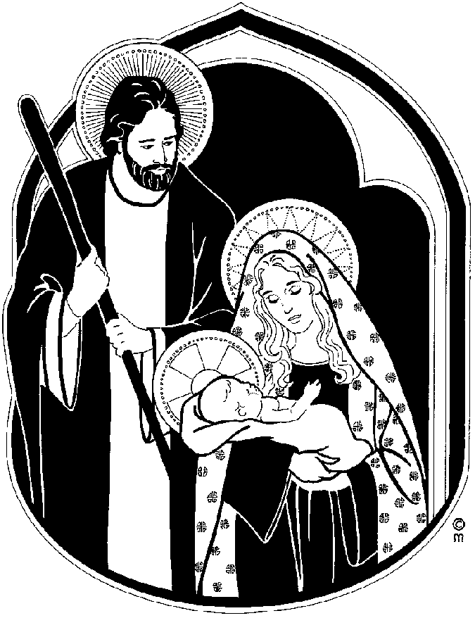


December 31 New Year’s Eve Mass 5:30 PM
New Year’s Eve Party 8:00 PM
January 1 Solemnity of Mary 10:00 AM
The Parish Office will be closed December 23, 24, 25, 26, 31 and January 1.

NEW TO THE PARISH OR NEED TO UPDATE YOUR PARISH REGISTRATION
Being a registered parishioner makes the process much easier when it is time for infant Baptism, Religious Educations registration, weddings, when asked to be a Baptismal or Confirmation sponsor, and even funerals. A register parishioner receives all parish mailings. Registration forms are in the rack near the office, on the website at www.sttheresechurch.info, or you may stop in at the Parish Office during office hours for more information and a registration form.


NEW YEAR’S EVE PARTY
Saint Therese will once again be ringing in the New Year. Plan to attend the Annual St. Therese New Year’s Eve celebration. This year we will party on Tuesday, December 31 starting at 8:00 pm. Heavy hors d’oeuvres and champagne provided by the church. Bring your favorite drinks and come party with us. Tickets will go on sale soon.

MORNING BIBLE STUDY
The Morning Bible Study Group will resume its weekly meetings on January 9, 2020. The group meets on Thursday mornings from 10:15 to 11:45 AM. Various sections or themes of the Bible are discussed in an informal setting. The next six-week segment will discuss Isaiah 40-55 Build a Highway for God. New participants are always welcomed. If interested or would like more information, please call Doris Melancon at 693-0311 or Sid Dugas at 642-5869.

GRIEFSHARE PROGRAM
The GriefShare program is a 13-week program to support those who have experienced the loss of a loved one. The program is based on Christian scriptures and utilizes videos, a workbook and discussions to facilitate attendees in their journey of mourning. The program will be offered two different days and times.
All meetings will be at the church ALC. This is the second White House in front of the Bread for Life pantry.
The morning sessions will begin Tuesday, January 21 from 10:00-11:30 am.
The evening sessions will begin Thursday, January 30 from 6:30-8:00 pm. Contact Linda Gregory to register or for questions at 804-815-7695. Information on the program is also available at GriefShare.org.
THEATER ‘N’ THEOLOGY (TNT)
We marvel at how God's mercy, presence, and grace breaks into the lives of ordinary people in good times and in crisis. That is what we see in the films that we view and discuss at our new parish TNT (Theater ‘N’ Theology). Our Christmas season TNT takes place on Friday, January 3, beginning promptly at 7 pm. All are welcome to come to our St. Therese Movie Theater (the “Meeting Room”). After the movie (the “Theater” part), we discuss the film’s relevance to our life in Christ and note the action of God’s mercy (the “Theology” part). We will have an intermission midway through the film, and if anyone wants to bring refreshments to share, we’ll have refreshments! Our Christmas feature is the 1951 British classic film A Christmas Carol. This superb film is too good to be shown only at Christmastime; the always-delightful Alastair Sim makes Scrooge a three-dimensional character in this faithful, heartwarming rendition of the Dickens classic. Facilitated by Fr. Gregory. All are welcome. Come watch a great movie with your brothers and sisters in Christ!

UPCOMING YOUTH EVENTS
Join us for our Youth Christmas Party, Saturday Jan. 4 after the 5pm mass! All parishioners are invited! Free will offering of a nonperishable food item for the food pantry. We will have a live DJ, games, fun, food and fellowship! We will also have an ugly Christmas Sweater contest and a white elephant gift exchange! Please bring a wrapped gift ($5-$10 max) that anyone could enjoy, non-age and non-gender specific, if you want to participate!
Upcoming Youth Events:
Sat. Jan. 4th – Youth Christmas Party
Jan 17th-19th High School Youth Charlottesville Retreat with
Fr. Gregory
Feb 7th – 9th High School Diocesan Youth Conference in Richmond
Please register for the retreat and conference ASAP

KROGER COMMUNITY REWARDS
Kroger wants to give to St. Therese! Please visit http://www.kroger.com to create a Kroger account. Link your shopper rewards card number to your Kroger.com account and search for Church of St. Therese 554 either by name or UP530 and then click Enroll. You will need a valid email address and a rewards card. *Customers must have a registered Kroger rewards card account to link to your organization. If a member does not yet have a Kroger rewards card, please let them know they are available at the customer service desk at any Kroger.
Purchases will not count for our church until after you register your rewards card. Parishioners must swipe their registered Kroger rewards card or use the phone number that is related to their registered Kroger rewards card when shopping for each purchase to count.
