“It pleased God to make absolute fullness reside in Christ, making peace through the blood of his cross.”

Christ the King

November 24, 2019

MASSES AND INTENTIONS
THIS WEEKEND OF
NOVEMBER 23-24, 2019
Saturday 5:00 PM Mass
Intention: Bob Dugin (RIP)
Requested By: The Theresians
Sunday 8:00 AM Mass
Intention: St. Therese Parishioners
Sunday 10:30 AM Mass
Intention: Mike Melancon (RIP)
Requested By: Doris Melancon

WEEK OF
NOVEMBER 25-29, 2019
Monday No Mass
Tuesday 12:00 Noon Mass
Intention: Arnie Nye (RIP)
Requested By: Bob & Cheryl Davis
Wednesday 7:00 PM Mass
Intention: For all families
Thursday No Mass
Friday No Mass

WEEKEND OF
NOVEMBER 30-DECEMBER 1, 2019
Saturday 5:00 PM Mass
Intention: Bill Trolembreg (RIP)
Requested By: Donna Hull
Sunday 8:00 AM Mass
Intention: Mass for the people
Sunday 10:30AM Mass
Intention: St. Therese Parishioners


DAILY SCRIPTURE READINGS
Daily Readings may be found at the
www.USCCB.org website.


Christmas Poinsettia Memorials will
be accepted now through December 15.
A bulletin insert will be published.
BLESSED SACRAMENT CHAPEL
VASE FLOWERS
Perpetual living memorial for Anna Lupei

ST. THERESE’S TABERNACLE CANDLE
November 25-December 1, 2019
In Memory of Adam & David Panek

GIFT GIVING UPDATE
Fiscal Year 7/1/19 through 6/30/2020
Annual operating expense budget: $650,886.40

Offertory Totals--November 17, 2019

Actual donations 11/17/2019: $4,665.85
Gifts were in envelopes and in loose cash/checks

Other donations 11/17/2019 not used for
operations totaled $75.00

In addition, we received E-giving support this week totaling $4,602.50

With a Weekend Mass attendance total of 402

"For where your treasure is, there your heart will be also." Matthew 6:21

THANKSGIVING MESSAGE
As the St. Therese parish family prepares for this holiday, it is important to share our wishes for your family’s blessings. We pray for your continued health and happiness as we enter this season of Advent. Please be reminded that you can set up a recurring giving schedule. Visit us online at www.sttheresechurch.info. Locate the Online Giving button and set-up your recurring giving schedule. The first time you give, you will select a password that will enable you to log in at any time and make changes to your giving or view your complete online giving history.

We can accept Visa, MasterCard, Discover,
and American Express, debit cards and savings/checking drafts.

DECEMBER SECOND COLLECTIONS

Nov 30/December 1 MM&R (Major
Maintenance & Repair)
December 25 Catholic Charities
TRAINING FOR GUEST HOMELESS SHELTER
Anyone interested in volunteering for the GUEST Homeless shelter the next training sessions will be:
Thursday, Dec 5 @ 7 pm at Petsworth Baptist Church
Sunday, Dec 8 @ 4 pm at Grace Covenant Presbyterian Church
Sunday, Dec 15 @ 4 pm at Abingdon Episcopal Church

THERESIAN MEETING/MASS
All are invited to join the Theresian’s on December 6 to pray the rosary at 8:30 followed by Mass at 9:00.

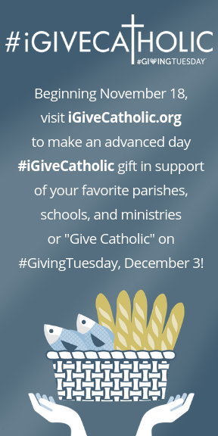

ADORATION
Reminder there will be no Adoration Wednesday, November 27. Adoration will resume Wednesday, December 3.

THEATER ‘N’ THEOLOGY
We marvel at how God's mercy, presence, and grace breaks into the lives of ordinary people in good times and in crisis. That is what we will see in the films that we will view and discuss at our new parish TNT (Theater ‘N’ Theology). Our first TNT takes place on Friday, December 6, beginning promptly at 7 pm. All are welcome to come to our St. Therese Movie Theater (the “Meeting Room”) with comfortable seating and large projection. After the movie (the “Theater” part), we discuss the film’s relevance to our life in Christ and note the action of God’s mercy (the “Theology” part). We will have an intermission midway through the film, and if anyone wants to bring refreshments to share, we’ll have refreshments! Our Advent feature is the 2006 film Amazing Grace. It’s about the idealist William Wilberforce as he maneuvers his way through Parliament, endeavoring to end the British transatlantic slave trade. Stars Benedict Cumberbatch and Albert Finney. Rated PG. Facilitated by Fr. Gregory. All are welcome. Come watch a great movie with your brothers and sisters in Christ!


ANGEL TREE
The Angel Tree with tags will be available for pick-up starting the weekend of November 23/24. If you take a tag from the Angel Tree, please return your gifts by Sunday, December 8. Please display the tag prominently on your unwrapped gifts. Thank you for your generosity!
VOCATIONS
“Jesus, remember me when you come into Your kingdom.” Will you make Christ the King and His merciful love remembered as a priest, deacon or in the consecrated life? Please call the Vocations Office at (804) 359-5661, to speak with Fr. Michael Boehling or Fr. Brian Capuano; or write to vocations@richmonddiocese.org.

VIRTUS TRAINING
There will be a VIRTUS training here at St. Therese on Saturday, December 14, 2019 from 12:00 Noon – 3:00 PM. Refreshments will be provided. This training is for anyone working with youth under the age of 18 and those working with Vulnerable Adults (homebound, disabled, elderly etc). Registration is through the Diocesan Website: www.richmonddiocese.org. click on the Protecting God’s Children Link in the upper right hand corner. Scroll down and click on Training (Virtus) icon: Click to View Upcoming Sessions and Register: follow directions, making sure you register for session you want. Contact Nadine McGrady at N.McGrady@StThersGlo.org for questions.

EVENING BIBLE STUDY GROUP
The Evening Bible Study Group will be starting a new book from the Threshold Bible Study Series by Steven Binz on December 6, 2019 titled: Advent Light. If you are interested in joining our small group every other week for one hour in the evening. Please contact Jim Lee at (804) 693-0826.

ANYONE NEEDING MATTRESS SET AND FRAME
Father Gregory has a full sized mattress, box spring, and frame for anybody who can come and pick it up at the rectory! Please contact Father Gregory at the church office at (804)693-5939.

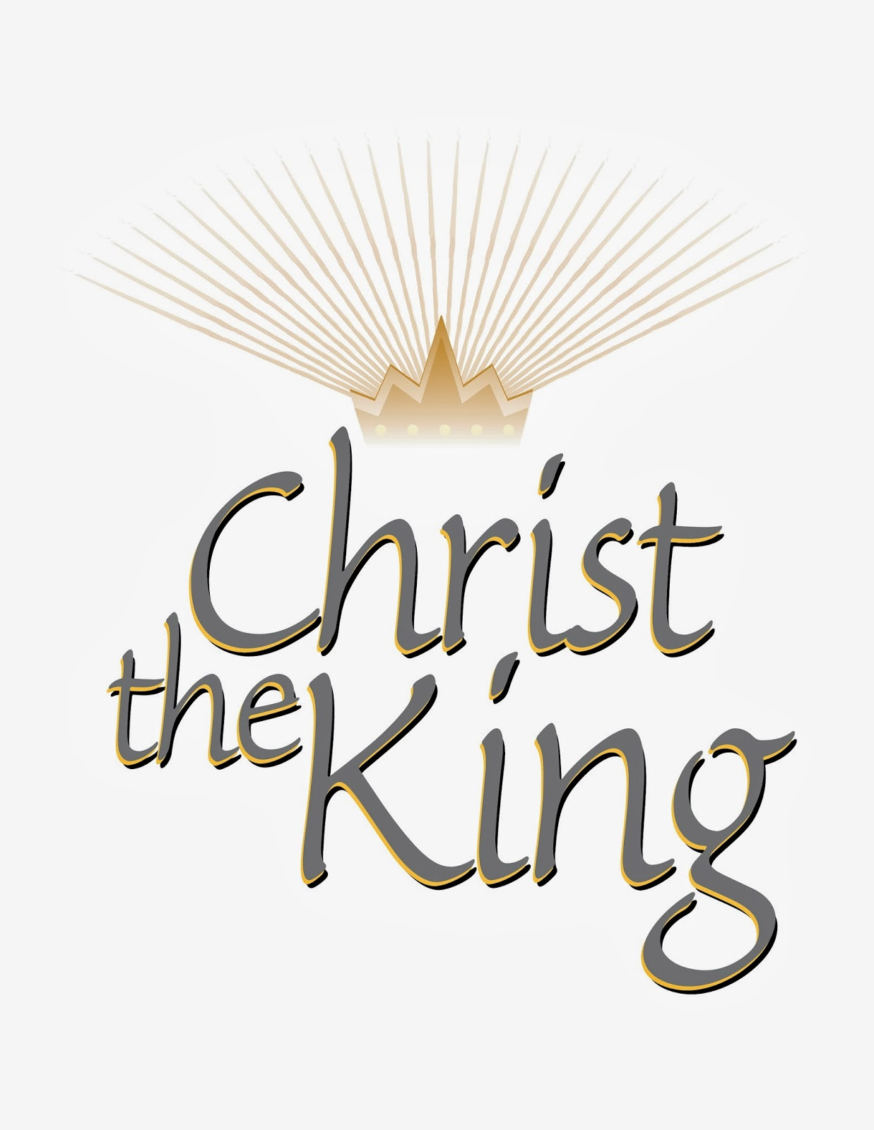

OFFICE CLOSURE REMINDER!
The parish office will be closed on Thursday, November 28 and Friday, November 29 and will reopen on Monday, December 2 at 9:00 AM. The parish staff wishes everyone a happy and safe Thanksgiving weekend.

