“The night is far spent; the day draws near.”

First Sunday of Advent

December 1, 2019

MASSES AND INTENTIONS
THIS WEEKEND OF
NOVEMBER 30--DECEMBER 1, 2019
Saturday 5:00 PM Mass
Intention: Bill Trolemberg (RIP)
Requested By: Donna Hull
Sunday 8:00 AM Mass
Intention: Mass for the people
Sunday 10:30 AM Mass
Intention: St. Therese Parishioners

WEEK OF
DECEMBER 2-6, 2019
Monday No Mass
Tuesday 7:00 PM Mass
Intention: For all persons with disabilities
Wednesday 12:00 Noon Mass
Intention: Arlene Allegretto (RIP)
Requested By: Ralph and Ann Martin
Thursday 12:00 Noon Mass
Intention: For all those in ministry
Friday 9:00 AM Mass
Intention: The Theresians

WEEKEND OF
DECEMBER 7-8, 2019
Saturday 5:00 PM Mass
Intention: St. Therese Parishioners
Sunday 8:00 AM Mass
Intention: Randolph Boyd Louk (RIP)
Requested By: Sylvester and Linda McClellan
Sunday 10:30AM Mass
Intention: Bernie and Joan Gillott (RIP)
Requested By: Debbie Kelly


DAILY SCRIPTURE READINGS
Daily Readings may be found at the
www.USCCB.org website.

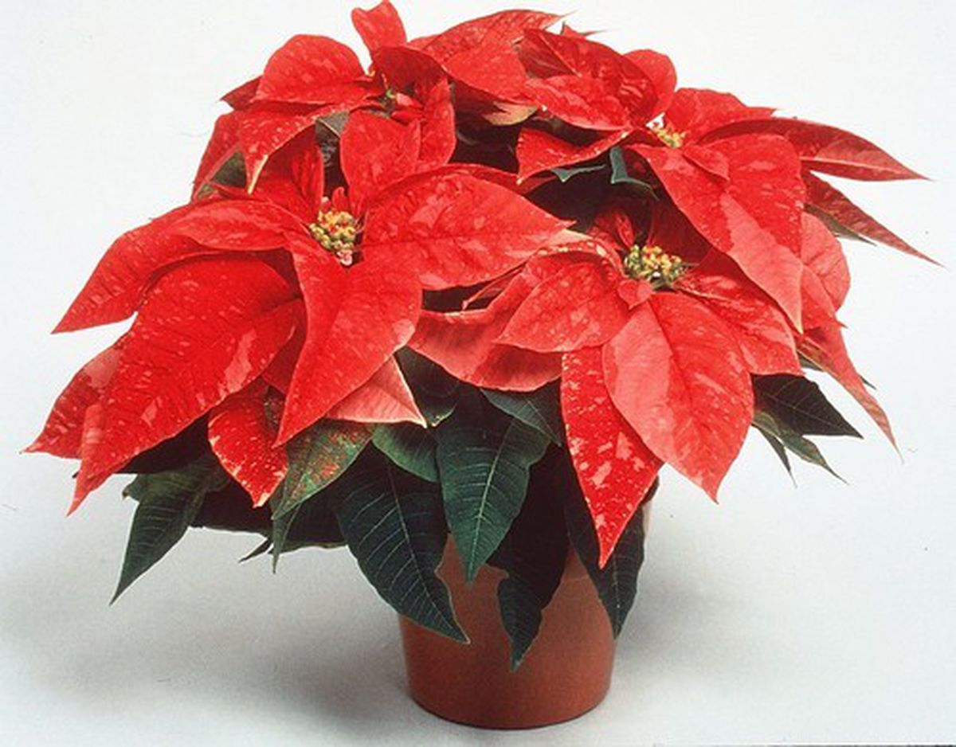
Christmas Poinsettia Memorials will
be accepted now through December 15.
A bulletin insert will be published.
BLESSED SACRAMENT CHAPEL
VASE FLOWERS
Perpetual living memorial for Anna Lupei

ST. THERESE’S TABERNACLE CANDLE
December 2--8, 2019
In Memory of Mr. & Mrs. Steve Blasko and
Mr. & Mrs. William Skelley

GIFT GIVING UPDATE
Fiscal Year 7/1/19 through 6/30/2020
Annual operating expense budget: $650,886.40

Offertory Totals
No Offertory totals for the weekend of
November 24, 2019 due to early bulletin deadline.

"Give, and gifts will be given to you; good measure, packed together, shaken down, and overflowing, will be poured into your lap. For the measure with which you measure will In return be measured out to you." Luke 6:38

CHRISTMAS GIFTS
In this season of gift giving to family, friends, and those less fortunate, we hope you will also consider your gifts to St. Therese. It is through the donations of every individual and family in the congregation that we are able to carry on our work. You can use electronic giving options for both regular offerings and one-time gifts. To help us achieve a more consistent level of funding, please visit www.sttheresechurch.info. Merry Christmas and God Bless!

We can accept Visa, MasterCard, Discover,
and American Express, debit cards and savings/checking drafts.

DECEMBER SECOND COLLECTIONS

Nov 30/December 1 MM&R (Major
Maintenance & Repair)
December 25 Catholic Charities

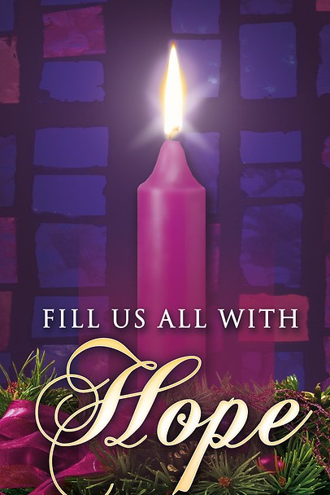
TRAINING FOR GUEST HOMELESS SHELTER
Anyone interested in volunteering for the GUEST Homeless shelter the next training sessions will be:
Thursday, Dec 5 @ 7 pm at Petsworth Baptist Church
Sunday, Dec 8 @ 4 pm at Grace Covenant Presbyterian Church
Sunday, Dec 15 @ 4 pm at Abingdon Episcopal Church

THERESIAN MEETING/MASS
All are invited to join the Theresian’s on December 6 to pray the rosary at 8:30 followed by Mass at 9:00.

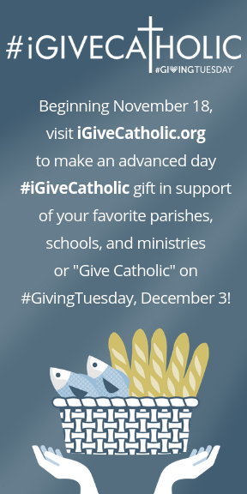

THEATER ‘N’ THEOLOGY
We marvel at how God's mercy, presence, and grace breaks into the lives of ordinary people in good times and in crisis. That is what we will see in the films that we will view and discuss at our new parish TNT (Theater ‘N’ Theology). Our first TNT takes place on Friday, December 6, beginning promptly at 7 pm. All are welcome to come to our St. Therese Movie Theater (the “Meeting Room”) with comfortable seating and large projection. After the movie (the “Theater” part), we discuss the film’s relevance to our life in Christ and note the action of God’s mercy (the “Theology” part). We will have an intermission midway through the film, and if anyone wants to bring refreshments to share, we’ll have refreshments! Our Advent feature is the 2006 film Amazing Grace. It’s about the idealist William Wilberforce as he maneuvers his way through Parliament, endeavoring to end the British transatlantic slave trade. Stars Benedict Cumberbatch and Albert Finney. Rated PG. Facilitated by Fr. Gregory. All are welcome. Come watch a great movie with your brothers and sisters in Christ!

THANK YOU
Thank you for the cards, thoughts, and prayers that you offered
for my sister Marie and for our family. The love and support of
our St. Therese family brought us comfort. Ann and Mike Foster


ANGEL TREE
If you have taken a tag from the Angel Tree, please return your gifts by Sunday, December 8. Please display the tag prominently on your unwrapped gifts. Thank you for your generosity!

VIRTUS TRAINING
There will be a VIRTUS training here at St. Therese on Saturday, December 14, 2019 from 12:00 Noon – 3:00 PM. Refreshments will be provided. This training is for anyone working with youth under the age of 18 and those working with Vulnerable Adults (homebound, disabled, elderly etc). Registration is through the Diocesan Website: www.richmonddiocese.org. click on the Protecting God’s Children Link in the upper right hand corner. Scroll down and click on Training (Virtus) icon: Click to View Upcoming Sessions and Register: follow directions, making sure you register for session you want. Contact Nadine McGrady at N.McGrady@StThersGlo.org for questions.

EVENING BIBLE STUDY GROUP
The Evening Bible Study Group will be starting a new book from the Threshold Bible Study Series by Steven Binz on December 6, 2019 titled: Advent Light. If you are interested in joining our small group every other week for one hour in the evening. Please contact Jim Lee at (804) 693-0826.

ANYONE NEEDING MATTRESS SET AND FRAME
Father Gregory has a full sized mattress, box spring, and frame for anybody who can come and pick it up at the rectory! Please contact Father Gregory at the church office at (804)693-5939.

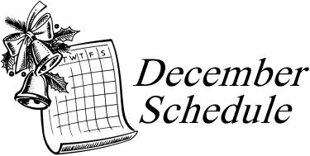

December 9 Immaculate Conception Mass 10:00 AM
December 10 Advent Reconciliation Blessed Sacrament
West Point 7:00 PM
December 18 Advent Reconciliation St. Therese 7:00 PM
December 19 Advent Reconciliation St. Jerome’s
Newport News 7:00 PM
December 20 Advent Reconciliation Francis de Sales
Mathews 7:00 PM
December 24 Christmas Eve Children’s Mass 5:00 PM
Christmas Eve Mass 9:00 PM
December 25 Christmas Day Mass 10:00 AM
January 1 Solemnity of Mary 10:00 AM
The Parish Office will be closed December 23, 24, 25 and January 1.

