“You have approached Jesus, the mediator of a new covenant.”

Twenty-Second Sunday in Ordinary Time

September 1, 2019

MASSES AND INTENTIONS
THIS WEEKEND OF
AUGUST 31-SEPTEMBER 1, 2019
Saturday 5:00 PM Mass
Intention: Arthur Keith (RIP)
Requested By: Donna Hull
Sunday 8:00 AM Mass
Intention: St. Therese Parishioners
Sunday 10:30 AM Mass
Intention: Carl & Pat Snyder's 65th Anniversary

WEEK OF
SEPTEMBER 2-6, 2019
Monday No Mass
Tuesday No Mass
Wednesday No Mass
Thursday 12:00 Noon Mass
Intention: So I can get some rest
Requested By: Joel Rivera
Friday 9:00 AM Mass
Intention: The Theresians

WEEKEND OF
SEPTEMBER 7-8, 2019
Saturday 5:00 PM Mass
Intention: Edward Hull (RIP)
Requested By: Patricia & Martin Corcoran
Sunday 8:00 AM Mass
Intention: For all Grandparents
Sunday 10:30AM Mass
Intention: For all St. Therese Parishioners


DAILY SCRIPTURE READINGS
Daily Readings may be found at the
www.USCCB.org website.

Donated by: Carl & Pat Snyder
In honor of their 65th Wedding Anniversary

BLESSED SACRAMENT CHAPEL
VASE FLOWERS
Perpetual living memorial for Anna Lupei

ST. THERESE’S TABERNACLE CANDLE
August 26-September 1, 2019
In Memory of Steven Libassi

GIFT GIVING UPDATE
Fiscal Year 7/1/19 through 6/30/2020
Annual operating expense budget: $650,886.40

Offertory Totals--August 25, 2019
Actual donations 8/25/2019: $5,421.58
Gifts were in envelopes and in loose cash/checks

Other donations 8/25/2019 not used for
operations totaled $50.00

In addition, we received E-giving support this week totaling $3,829.00

With a Weekend Mass attendance total of 424

"No one shall appear before the LORD empty-handed, but each of you with as much as he can give, in proportion to the blessings which the LORD, your God, has bestowed on you." Deuteronomy 16:17

WELCOME BACK FROM YOUR SUMMER BREAK!
We have missed you and are glad you are back home! If you haven’t already signed up to e-give, please visit the parish website at www.stthereschurch.info. Consider automating your offertory today!

We can accept Visa, MasterCard, Discover,
and American Express, debit cards and savings/checking drafts.

SEPTEMBER SECOND COLLECTIONS
August 31/September 1 Major Maintenance & Repair (MMR)
September 7/8 Fuel Assistance
September 28/29 Retirement for
Religious


HOMEBOUND MINISTRY
“Do this in memory of Me”
As Roman Catholics, Eucharist is a central belief. We are able to receive Eucharist as often as mass is celebrated. Many parishioners can no longer participate in mass and the reception of Eucharist because of health or age. St. Therese has very committed Eucharistic Ministers that bring the Body of Christ on a regular basis to some of those parishioners. We are in need of many more ministers to reach out to our members. The Homebound Ministry asks that you discern whether God is calling you to this ministry. The only requirement is a love of the Eucharist. If after prayerful consideration you determine this is a ministry you can support, please contact Linda Gregory. She can be reached by phone, 804-815-7694 or email at lgregory0530@gmail.com. There is a need for substitute ministers as well as ministers for full time visiting.

HOME VISITATION
St. Therese has Ministers that bring the Eucharist to you in your home. If you have had surgery, cannot drive to church, or are ill, ministers of the Eucharist can bring it to you. All that is required is that you or a family member contact the office and leave a name and contact information. We as a community of Christ must be fed regularly. Please don’t hesitate to give the office a call. Someone will contact you about visiting at your convenience.

ADULT FAITH FORMATION AND RCIA
Adult Faith Formation and RCIA are combining again to offer a study on the Book of Revelation. This is a 10-week study; please see the display in the commons for information on registering. We will begin the study on Saturday, September 7, at 2:30 PM and run through early November. We will approach this study from “the sound and sane” Catholic perspective, decoding John the Apostles apocalyptic vision. In other words, as the introduction to the Ascension Press study suggests: “this book is full of images, numbers, colors, and creatures unfamiliar to a twenty-first century reader. Though the images in this book may seem fantastical, once the rich symbolism is understood, you will find it very relevant to your daily life. Please invite your friends, Catholic and non-Catholic, potential RCIA inquirers. All are welcome! For more information, contact Kerry Fallon in the parish office at k.fallon@stthersglo.org or 693-5939.

MORNING BIBLE STUDY
The Morning Bible Study Group will resume its weekly meetings on September 5. The group meets on Thursday mornings from 10:15 to 11:45 AM. Various sections or themes or the Bible are discussed in an informal setting. New participants are always welcomed. If interested, or would like more information, please call Doris Melancon at 693-0311 or Sid Dugas at 642-5869.

BINGO IS BACK!!
We will begin Monday, September 9. Doors open at 5:30 PM; games begin at 7:00 PM. Please come and join in for some good, old fashioned fun and fellowship. If you have any questions, please call Donna Raschke at (804) 695-9912.

THERESIAN MASS AND MEETING
Ladies of the parish, please join us at our next Theresian meeting on Friday 6, 2019 after the 9:00 AM service. There is also a Rosary at 8:30 just before mass. We will be meeting in the social hall.

OFFICE CLOSURE
The parish office will be closed on Monday, September 2, for the Labor Day Holiday. The office will reopen on Tuesday, September 3, at 9:00 AM. We hope everyone has a safe Labor Day.

BACK BY POPULAR DEMAND:
As requested by many. The Monthly Breakfast will return on Sunday, September 8 and on the 2nd Sunday of the month thereafter following the 8:00 Mass. Where else can you go in the county and not have to cook for the price? We’ll be serving sausage, bacon, eggs, biscuits, pancakes, fruit and much more. All for the cost of $5.00 per person. So, be sure to come and enjoy a hot breakfast, fellowship and help us make charitable donations. Don’t forget, mark your calendars.

VOCATIONS TO THE PRIESTHOOD
“Take my yoke upon you, says the Lord.” Are you willing to accept the yoke of the Lord through a vocation as a priest? Call the Vocations Office at (804)359-5661, to speak with Fr. Michael Boehling or Fr. Brian Capuano; or write to vocations@richmonddiocese.org.

PARISH CELEBRATION TO ST. THERESE
The annual parish picnic will be held this year Sunday, September 29. The picnic will start at 12:00 and last until 3:00 pm. Good food, good music and good people will be there. Join us to honor our patron and share the day with parishioners and friends. Aluminum pans will be set out for those that may wish to donate a dish. Hot dogs, hamburgers, and drinks will be provided by the church. The Pastoral Council hopes to see everyone there.
CALLING ALL HOMESCHOOLERS!!
A Catholic Homeschool group is starting to form and we want you to join us! All ages are welcome! Please contact Jennifer Roberts at masqerade1982@yahoo.com or text at (757) 619-3061.

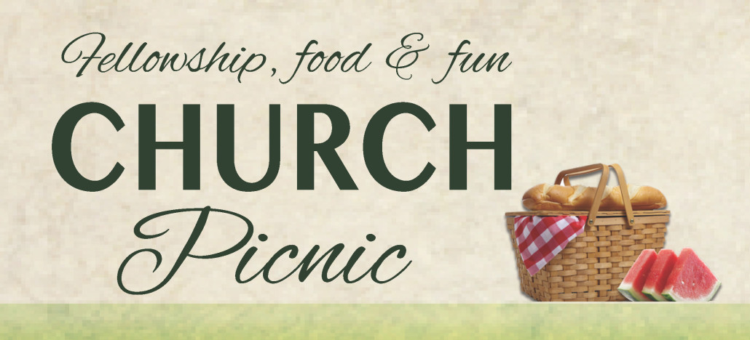
PARISH CELEBRATION TO ST. THERESE
The annual parish picnic will be held this year Sunday, September 29. The picnic will start at 12:00 and last until 3:00 pm. Good food, good music and good people will be there. Join us to honor our patron and share the day with parishioners and friends. Aluminum pans will be set out for those that may wish to donate a dish. Hot dogs, hamburgers, and drinks will be provided by the church. The Pastoral Council hopes to see everyone there.

VISITING PRIEST
Fr. Gregory has invited a Priest from Food for the Poor to celebrate Mass the weekend of September 14 & 15. Any parishioner wishing to either provide transportation to or from the airport and dinner for Saturday evening, please contact Ann in the parish office.

