“There is need of only one thing.”

Sixteenth Sunday in Ordinary Time

July 21, 2019

MASSES AND INTENTIONS
THIS WEEKEND OF
JULY 20-21, 2019
Saturday 5:00 PM Mass
Intention: Chuck Thompson (RIP)
Requested By: Agnes Thompson
Sunday 8:00 AM Mass
Intention: St. Therese Parishioners
Sunday 10:30 AM Mass
Intention: The Theresian Society

WEEK OF
JULY 22-26, 2019
Monday No Mass
Tuesday 12:00 Noon Mass
Wednesday 12:00 Noon Mass
Thursday 12:00 Noon Mass
Friday 12:00 Noon Mass

WEEKEND OF
JULY 27-28, 2019
Saturday 5:00 PM Mass
Intention: Elizabeth Spinelli (RIP)
Requested By: Donna Hull
Sunday 8:00 AM Mass
Intention: St. Therese Parishioners
Sunday 10:30AM Mass
Intention: Tom Witty (RIP)
Requested By: The Martin Family


DAILY SCRIPTURE READINGS
Daily Readings may be found at the
www.USCCB.org website.


ALTAR FLOWERS
Donated by: Suzanne Downs
In Memory William Folli

BLESSED SACRAMENT CHAPEL
VASE FLOWERS
Perpetual living memorial for Anna Lupei

ST. THERESE’S TABERNACLE CANDLE
July 22-28, 2019
In Memory of Deceased love ones of the
Kemp & Exler Families

GIFT GIVING UPDATE
Fiscal Year 7/1/19 through 6/30/2020
Annual operating expense budget: $650,886.40

Offertory Totals-July 14, 2019
Actual donations 7/14/2019: $4,214.48
Gifts were in envelopes and in loose cash/checks

Other donations 7/14/2019 not used for
operations totaled $80.00

In addition, we received E-giving support this week totaling $2,595.00

With a Weekend Mass attendance total of 425
"To whom much is given, much is expected."
Luke 12:48

A SPECIAL MESSAGE FOR SUMMER TRAVELERS
Would you find it helpful to have your offerings debited directly from your bank account as you probably do with other obligations? St. Therese offers electronic giving for those of you who wish to have contributions transferred electronically to the church’s accounts. If you have plans to travel this summer, electronic giving gives you a convenient way to keep up with your intended offerings. Simply visit www.sttheresechurch.info to get started!

We can accept Visa, MasterCard, Discover,
and American Express, debit cards and savings/checking drafts.

LOM AND ANNUAL APPEAL PLEDGES
“We appreciate you honoring your pledges!” Additional proceeds for the following should be mailed to:
For: LOM FOR: Annual Appeal
Catholic Diocese of Richmond Catholic Diocese of Richmond
Living Our Mission PO Box 79212
PO Box 79160 Baltimore, MD 21279-0212
Baltimore, MD 21279-0160


ST. THERSE PARISH APP
New to St. Therese, Dee Printing, Inc.; now has an app that you can download free. Go to your app store on your smart phone and search for “InOurParish”. After you download the app, search for St. Therese, Gloucester. In the app, you will be able to view Mass times, bulletins, go to the website, online giving, prayer requests, and notifications. To receive notifications, you need to be sure that you enable notifications. To enable the notifications, go to the notifications setup block on the main menu, tap on it and check the box for General Messages and save it. Once enabled you will receive notifications from the parish office, for example: a funeral service day and time, unexpected office closure or Mass cancellation. If you have any questions, contact Ann in the Parish Office. There are blue Parish App cards on the welcome stand in the commons.

THE CHURCH LAWN MAINTENANCE CREW
The crew is in need of one (1) volunteer (18 years of age or older) to assist in maintaining the church lawn and grounds. We meet each Thursday (weather permitting) from 7:00 to 8:00 AM and finish prior to 12:00 noon. Anyone interested in supporting this worthy and rewarding ministry please contact Milton Campo at 804-694-7500.

THERESIAN MEETING
All ladies are invited to come to the meeting on Sunday, July 21. We will have a meeting in our room in the back of the hallway. Hope to see you there.

PARISH REGISTRATION
If you are new to the Catholic Church of St. Therese, we welcome you! Registering in a parish is a declaration of your desire to be part of a Catholic Community and to make a commitment to the life of the Catholic Church of St. Therese Community. A registered parishioner receives all parish mailings. Registration forms are available on the website, in the rack near the office or by contacting Ann in the parish office.

ANNOUNCING A NEW SUMMERTIME EVENT
AT SAINT THERESE!
It is the litnic. Litnics are Liturgy picnics, and here’s how they work. Someone who wants to host a litnic calls the parish office and signs up for one of the posted available dates. They receive parish guidelines for hosting a litnic which must be read carefully. Litnics are particularly intended for Catholics in the host’s neighborhood, but all parishioners are invited to litnics. A Mass is celebrated in the home or the yard (the lit) followed by a potluck supper (the nic). A suggested time for a Litnic would be 6:30, but that would be up to the host. Available dates for this summer follow:
July 26, 30
August 7, 16, 21, 30

CATHOLIC CHARITIES IS SEEKING
COMPANION CARE WORKERS FOR SENIORS
CCEVA is hiring several Companion Care workers to provide companionship to clients enrolled in the Companion Care Pilot Program in order for them to stay socially engaged and to provide assistance with their daily activities in order to remain in their home comfortably and safely. The program provides non-medical, in-home support services such as home management (light housekeeping, laundry, bed making, and trash removal), meal planning and preparation, grocery shopping and running errands for client, transporting clients in your car to run errands and shopping, and providing medication reminders. This is considered a contracted position, part-time with flexible schedules. Successful applicants will have two or more years of recent experience in caring for the elderly. Certified Nursing Assistant (CNA) or have successfully completed a Home Care Training Program is preferred. Applicants must complete a 25-hour training course. For more information or an application, call the Companion Care Care coordinator, at Catholic Charities of Eastern Virginia 757-456-2366.


CATHOLIC CHARITIES IN NEED OF NEW OR GENTLY USED 3T, 4T, AND 5T CLOTHING
Catholic Charities Care’s Centers in Virginia Beach and Newport News are in desperate need of new or gently used boy and girl 3T, 4T, and 5T clothing. Donations can be dropped off in Virginia Beach at 5361 Virginia Beach Boulevard or in Newport News at 12829 Jefferson Avenue, Suite 101. Questions? Call Rebekah Hall at 757-456-2366.
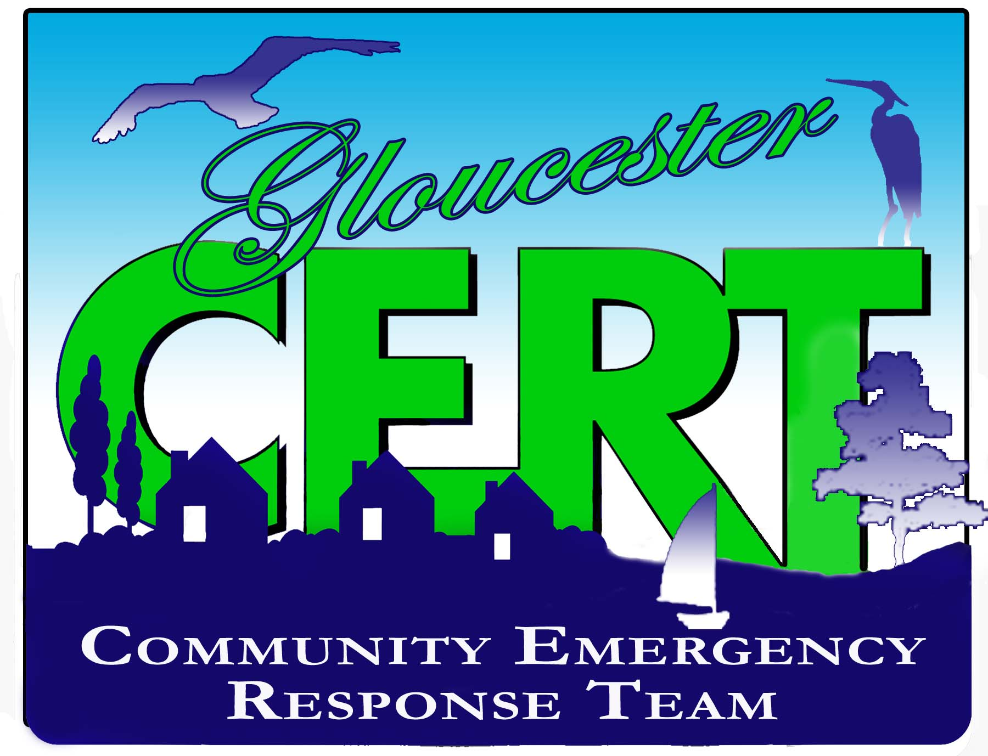

DO YOU LIVE IN MATHEWS, MIDDLESEX OR GLOUCESTER COUNTY?
Do you want to learn how to be prepared for an emergency?
Do you want to volunteer in your community during an emergency?
Are you a part of an organization that wants to serve during an emergency?
Your Community Emergency Response Team is a group of community volunteers that learn to:
Manage utilities and put out small fires, provide Basic First Aid, learn how to search an area safely, help at local events and more!
C.E.R.T. is a positive and realistic approach to emergency and disaster situations where citizens may initially be on their own. While people will respond to others in need without the training, one goal of the CERT program is to help them do so effectively and efficiently without placing themselves in unnecessary danger. CERT members are NOT first responders but offer support in our communities. C.E.R.T. training is free. The classes are July 27th and 28th and 8am-4pm. They will be held at 7478 Justice Dr. Gloucester, Va. 23061. Lunch is provided.
Email jwenner@gloucesterva.info or call 804 693 1390 to register.

