“Count the stars
if you can.”

Second Sunday of Lent

March 17, 2019

MASSES AND INTENTIONS
THIS WEEKEND OF
MARCH 16-17, 2019
Saturday 5:00 PM Mass
Intention: St. Therese Parishioners
Sunday 8:00 AM Mass
Intention: Chuck Thompson (RIP)
Requested By: Sylvester McClellan
Sunday 10:30 AM Mass
Intention: The Theresians

WEEK OF
MARCH 18-22, 2019
Monday No Mass
Tuesday 12:00 Noon Mass
Intention: Chuck Thompson (RIP)
Requested By: Bob & Susan Quinzel
Wednesday 12:00 Noon Mass
Intention: Edward and Elizabeth Cowles (RIP)
Thursday No Mass
Friday No Mass

WEEKEND OF
MARCH 23-24, 2019
Saturday 5:00 PM Mass
Intention: St. Therese Parishioners
Sunday 8:00 AM Mass
Intention: Residents of Nursing Homes and Rehab
Sunday 10:30AM Mass
Intention: Nick Dattoli (RIP)


DAILY SCRIPTURE READINGS
Daily Readings may be found at the
www.USCCB.org website.


ALTAR FLOWERS
Please see the sign-up sheet on the bulletin board
In the hallway leading to the Social Hall for
Available weekends

BLESSED SACRAMENT CHAPEL
VASE FLOWERS
Perpetual living memorial for Anna Lupei

ST. THERESE’S TABERNACLE CANDLE
March 18-25, 2019
In Memory of Bill Eacho

GIFT GIVING UPDATE
Fiscal Year 7/1/18 through 6/30/2019
Annual operating expense budget: $604,400.00

Offertory Totals-March 10, 2019
Actual donations 3/10/2019: $5,930.23
Gifts were in envelopes and in loose cash/checks

Other donations 3/10/2019 not used for
operations totaled $237.00

In addition, we received E-giving support this week totaling $3,090.50

With a Weekend Mass attendance total of 359

Ash Wednesday, Mass Attendance total 255
Total Offertory $579.53

"All tithes of the land, whether in grain from the fields or In fruit from the trees, belong to the LORD, sacred to him." Leviticus 27:30

GIVE ONLINE THIS HOLY SEASON OF LENT
As you contemplate donations this holiday season, please keep St. Therese in mind. Your contributions are needed for everything from special programs to basic operating expenses—both are deserving of your support. Please be as generous as you can this holiday season and in the year ahead. For the convenience of church members, we offer online giving. To donate, visit the church website at www.sttheresechurch.info and locate the link to our online giving page and follow the instructions.

We can accept Visa, MasterCard, Discover,
and American Express, debit cards and savings/checking drafts.

MARCH SECOND COLLECTIONS
March 23-24 Fuel Fund
March 30-31 Catholic Relief Service



The Scripture passages from the Old Testament and New on this Second Sunday of Lent are like bookends. On one side of the bookshelf, the story is of Moses going up to Mount Sinai to receive the Ten Commandments. When he came down from the mountain, having been in the presence of God, his face shone brightly. The people of Israel could not even look at Moses. On the other side of the bookshelf we’ve Jesus going up a different mountain for the event of His Transfiguration. We hear in Luke His clothing became white and dazzling while a cloud overshadowed them.

In Scripture, mountains are synonymous with the majesty and dominion of God. The prophet Elijah challenged the priests of Baal on Mount Carmel. The Temple was constructed on Mount Zion. Jesus was crucified on Mount Calvary. On the mountain something important would always happen like the Sermon on the Mount, on the Mount of Olives, and so on. Even now, it’s common for those who want to get in touch with the nearness of God to go to the mountains. Perhaps you or someone you have known has found renewal and new insights in making a trip to the mountain for camping, hiking, backpacking.

For many, a mountain experience is not possible or easy to accomplish. We lead busy lives. And we get a lot of positive reinforcement for being responsible, predictable, and easy to get a hold of. Plus, we’ve got this little voice deep down inside of us that keeps telling us how important we are and how the world might fall apart if we weren’t here to keep it running smoothly.

On Tabor, the mountain where Jesus’ Transfiguration took place, the disciples were given courage and strength in their lives to not be afraid, as in elder years we worry about the aging process, pensions, loss of friends and our independence. In younger years we fear about finding good jobs, good friends, being liked and finding a secure place in life. In mid- years we may fear for our family, friends, our future. Fear can cloud our lives - and God is the light in our fears.

Maybe we can’t make a trip to the mountain so there are other places to find grace to have strength in our fears, to find faith, hope and love. We all need to find the times we are transfigured and renewed. Often those places are quite accessible.

A QUOTE FROM POPE FRANCIS
“We must restore hope to young people, help the old, be open to the future, spread the love. Be poor among the poor. We need to include the excluded and preach peace.”
--Pope Francis

PARISH JOB OPENING
The parish of St. Therese is seeking a Business Manager by the beginning of our next fiscal year, July 1, 2019. As a professional staff person, the Business Manager will be responsible to the Pastor and will collaborate with Fr. Jim, the Finance Council and the Parish Council in facilitating the budget process. Additional duties include daily financial activities of the Church, payroll/Kronos and personnel files/Virtus, vendor files, accounts receivable and payable, Vanco e-giving, Annual Report, coordinates money counters, ensures compliance with insurance regulations/risk management, cooperates with Diocesan audits, and maintains parish corporate records. In addition, the position requires pastoral responses, confidentiality, and sensitivity in meeting the needs of the Pastor, parishioners, and staff. Time/deadline management, independent judgement, accounting/data processing efficiency is desirable. Candidates with a high school diploma and 5+ years related experience will be considered. Mandatory background screening and Virtus training must be completed as a condition of employment. This is a 35 hour per week/benefitted position and salary is according to Diocesan scale. Applications are available on the Diocesan website at: richmonddiocese.org, about us, employment or at the parish. Please return to Fr. Jim Cowles, 6262 Main St. Gloucester, VA 23061 by May 1, 2019

ANNUAL CATHOLIC MENS CONFERENCE

March 23, 2019
St. Bede | Williamsburg
On Saturday, March 23, 2019 men from across the diocese will gather at Saint Bede Catholic Church in Williamsburg for the 6th annual Diocesan Catholic Men’s Conference. This year’s theme is “Christ Our Hope” and will feature a dual-track conference with keynote speakers in English and Spanish, breakout opportunities, Reconciliation, Adoration, and Mass. General registration will be available online for $55 until March 16, 2018. After that point, registration will only be available at the door for $60. As always, the conference is free for priests and religious brothers. Register today!


WELCOME OUR NEW PARISHIONERS
We welcome a new parishioner to our parish family:
Eric and Elizabeth Johansen

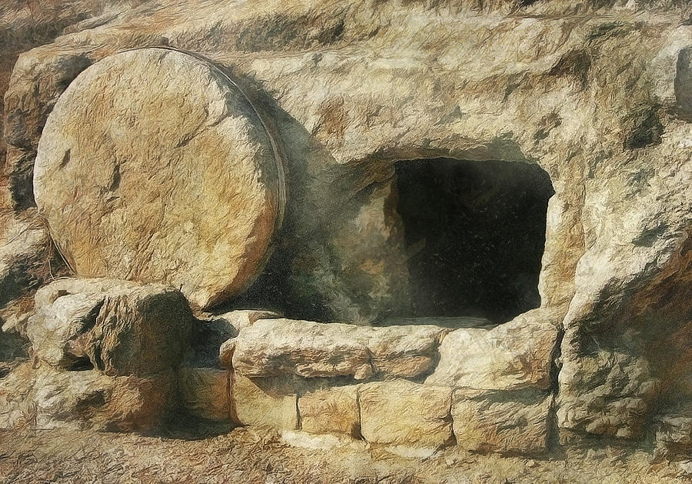
TIME OF JOY
Lent is a time of sacrifice and discipline, but it should not be a time of sadness. Instead, it should be a season of great joy. The first Preface for the Mass in Lent clearly reminds us of this:
For by your gracious gift each year your faithful
await the sacred paschal feasts with the joy of minds
made pure.
As Christians we are stirring up our faith and love for God and each other so that, on Easter, we are ready to meet the risen Lord refreshed and restored. (Taken from Our Sunday Visitor Pamphlet)
STEWARDSHIP – TIME/TALENT

March 23/24 5:00 PM 8:00 AM 10:30
Lectors: P. Snyder T. Vanderhoof R. Haggerty K. Fallon L. Espiritu L. Parker
--------------------------------------------
EME: M. Jones B. Quinzel E. Bauer
C. Jones T. Wilson Substitute
M. Foster T. VanHoudt D. Henley
P. Amos C. Buquor T. Hellebrandt
M. Baker T. Bernard B. Allaman
----------------------------------------------
Ushers: S. Mohnach J. Lee
C. Conway J. Canada E. Monfalcone
M. Fisher M. Renderle T. Dease

March 30/31 5:00 PM 8:00 AM 10:30
Lectors: C. Davis S. Raschke T. Sparicia B. Davis B. Bernard S. Sparicia
--------------------------------------------
EME: G. Carrington T. Wilson A. Vela P. Amos T. Bernard T. Hellebrandt
M. Foster G. Espiritu D. Henley
M. Carrington B. Quinzel E. Bauer Substitute J. Matthews B. Allaman
----------------------------------------------
Ushers: Schedule Not Available

April 6/7 5:00 PM 8:00 AM 10:30 AM
Lectors: M. Howell D. Guillory D. Rooks L. Gregory T. Rinderer R. Guest
--------------------------------------------
EME: P. Amos B. Quinzel E. Bauer M. Foster G. Espiritu D. Henley M. Jones S. McClellan Substitute C. Jones C. Buquor A. Vela M. Baker T. VanHoudt T. Hellebrandt
----------------------------------------------
Ushers: C. Conway E. Lechene D. Parker S. Sales A. Gerwitz G. Koos D. Gerwitz J. VanBuren
E. Anderson

April 13/14 5:00 PM 8:00 AM 10:30
Lectors: Schedule Not Available
--------------------------------------------
EME: M. Carrington T. Wilson Youth EME M. Baker J. Matthews Youth EME G. Carrington K. Gierlak Youth EME M. Foster Substitute Youth EME M. Jones B. Ittner Youth EME
----------------------------------------------
Ushers: C. Conway S. Mohnach J. Lee/Youth
S. Sales J. Canada E. Monfalcone
M. Renderle T. Dease

WHAT IS YOUR ORANGE JUICE?
When we squeeze an orange, we get orange juice. Why? Because that is what is inside the orange. The juice is the essence of the orange. Lent is a time to ask ourselves “What comes out of me when life puts the squeeze on me?” How we respond to life – our attitudes, values, and patterns of behavior – expresses who we are: it reveals our essence. Let us reflect on what ‘comes out of us’ when life squeezes us and pray that our way of proceeding will be recognized as worthy of the label ‘disciple of Jesus.’ Here are ten ways to revitalize the juice this Lenten season:
Slow Down – Set aside 10 minutes a day for silent prayer or meditation.
Read a good book – You could choose the life of a saint, a spiritual how-to, an inspirational book or one of the pope’s new books.
Be kind – Go out of your way to do something nice for someone else every day.
Get involved – Attend a Lenten lecture or spiritual program.
Volunteer at your parish – Whether it’s the parish fish fry, cleaning the church or helping with the food drive, it will give you a chance to help others.
Reach out – Invite an inactive Catholic to come with you to Mass, Bible Study or other Lenten program
Pray – Especially for people you don’t like and for people who don’t like you.
Tune out – Turn off the television and spend quality time talking with family members or friends.
Clean out closets – Donate gently used items to those less fortunate
Donate – Pick a Catholic mission and decide how you can help by sending money, clothing or supplies.

ST. THERESE STRIVES TO BE MORE WELCOMING:
You may have noticed the new-wheeled counter in the left corner of the gathering space of the church. This is where you will find the majority of materials for activities the parish offers. Please check the TV screen for information, and the countertop for sign-up sheets, flyers, etc. If your ministry/group wishes to promote an upcoming event, study, meal, etcetera, please contact Kerry Fallon or Ann Martin in the parish office to make sure we can accommodate your materials. This is the area for easels/posters, as well.
WE ARE IN NEED OF GREETERS/WELCOMERS for all the weekend Masses. If you are currently a greeter/welcomer, please encourage those you say hello to each weekend to consider offering their time to this very important ministry, too. Those interested in becoming a greeter/welcomer, please add your contact information to the sign up sheet on the Welcome counter, or contact Kerry Fallon in the parish office. K.fallon@stthersglo.org

FACILITIES UPDATE
Maintenance notes:
In February a roof consulting company was hire to perform an analysis of all parts of the Church roofs. The comprehensive report listed several deficiencies, the slate roof has some immediate concerns with some other minor faults on others style roofs. Corrective action will be taken soon.
Due to cost of repairing roof the painting of Sanctuary will be put on hold for now.
Lastly, the carpet in meeting room has been replaced.

YOUTH MINISTRY--THE ROSE TEAM
“Without love, deeds, even the most brilliant,
count as nothing.” ― Thérèse de Lisieux
The Rose team is Youth who are taking what St. Thérèse said and doing deeds for the parish community of St. Thérèse with love and joy. Whether you are elderly, a parent or business owner, if you have a deed that the youth can do please contact Brandon Allaman.
Deeds the Rose Team can do:
Yard Work Painting
Cleaning/Organize: Cars, houses, garages. Shoveling Snow
Small tedious tasks like changing a light bulb Change oil

BINGO UPDATE
On March 4, Bingo attendance included 23 players (5 parishioners) and 9 Bingo volunteers; our total deposit was $502. In 2019, $7,438.50 has been donated toward the new sound system for the sanctuary.
Plea to the Parish: The Charitable Gaming Board is seeking Board Members as well as volunteers on Monday nights, including Assistant Bingo/Game Managers, Admissions Cashiers, Callers, and Floor Sales personnel. To volunteer for Bingo, please call Terry 824-9028 or Carol 694-4915 or come in on Monday nights and check it out.

SOUP WITH LOVE
Soup with Love on Friday, March 8, served 82 people and received $310 in donations. Soup with Love will be held each Friday during Lent through April 12. If you would like to help arrive on Thursday to set-up at 9:00 AM and Friday at 10:30 AM. Thank you for your help. God Bless, Terry Sabourin and Linda Conway.

STEWARDSHIP AWARENESS CAMPAIGN
If you have not returned the pledge card that was mailed to all registered parishioners, please do so as soon as possible. The cards can be deposited in the collection basket at Mass or dropped by the office during regular office hours.
If you did not receive a pledge card in the mail, there are cards in the pews that can be filled out and placed in the collection basket.
Thank you to all who have already returned their card. The Parish Council will be tallying up the results of the campaign and reporting back to the parish shortly.

FUEL SECOND COLLECTION
This year the fuel oil prebuy cost the church $16,000. To date, we have received $1,100 in donations to help offset this expense. Thank you for your continued generosity!!

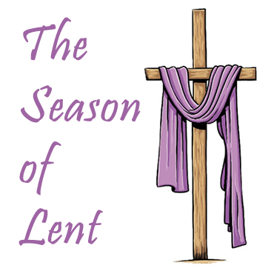
LENTEN SCHEDULE

March 19 Lenten Reconciliation
OLBS West Point 7:00 PM
March 22 Soup With Love 11:30 AM-1:00 PM
Lenten Fish Fry 5:00 PM – 7:00 PM
Stations of the Cross 7:00 PM
March 29 Soup With Love 11:30 AM-1:00 PM
Lenten Fish Fry 5:00 PM – 7:00 PM
Stations of the Cross 7:00 PM
April 5 Soup With Love 11:30 AM-1:00 PM
Stations of the Cross 7:00 PM
April 9 Lenten Reconciliation
Francis de Sales 7:00 PM
April 10 Lenten Reconciliation
St. Therese 7:00 PM
Lenten Reconciliation
St. Bede 7:00 PM
April 12 Soup With Love 11:30 AM-1:00 PM
Stations of the Cross 7:00 PM
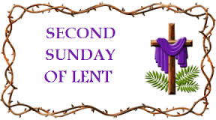

EASTER FLOWERS
We are accepting donations for Easter Lilies, which may be made in memory and/or honor of a loved in honor of a loved one. Easter Lily memorials will be collected from March 17 through April 14. Please put your intentions on the back of your envelope. A bulletin insert will be prepared for the Easter bulletin. We are blessed from your generosity!

CAREFREE SENIORS
If you and your friends are over 60, please plan to join our group “Carefree Seniors”. We meet the third Wednesday of every month at 1:00 PM in the church social hall. Our next gathering will be on Wednesday, March 20. Our goals are to have an outing, a fun and an educational session once a quarter. Everyone that is over 60 is invited (you don’t have to be a member of St. Therese Church). If you would like additional information, please contact Frank Rivera at cisci7@cox.net or Pat Snyder at pbspat@gmail.com

VIRGINIA BISHOPS’ STATEMENT ON
BORN ALIVE ACT VOTE
Virginia Bishops’ Statement on U.S. Senate’s Failure to Pass the Born-Alive Abortion Survivors Protection Act
February 25, 2019
We are deeply dismayed and astounded that the U.S. Senate has failed to pass the Born-Alive Abortion Survivors Protection Act (S. 311). It is a matter of common sense and basic human decency to require, as S. 311 would have, that any health care practitioner present when a child is born alive following an abortion give the same degree of care to preserve the life and health of the child as would be given to any other newborn. That this bill did not pass unanimously – let alone even pass at all – is appalling and beyond comprehension. We are dismayed and outraged that Virginia’s U.S. Senators Warner and Kaine voted against this critical lifesaving legislation.
We urge the Senate to reconsider its decision as soon as possible.
This joint statement has been issued by Most Reverend Michael F. Burbidge, Bishop of Arlington, and Most Reverend Barry C. Knestout, Bishop of Richmond.


The next Ultreya will be March 30, 2019
Christ The King Catholic Church
1803 Columbia Ave, Norfolk , VA 23509

All Cursillistas and Friends are Welcome!
Holy Mass begins at 5:30 PM
Potluck Dinner to Follow (Bring your favorite dish)
Questions? Contact Stephanie Brown: mstephaniebrown@icloud.com
EVERYONE IS INVITED SO BRING A FRIEND!
Make a Friend, Be a Friend, Bring a Friend to Christ.

