“You will be baptized with the Holy Spirit
and fire.”

Feast of the Baptism
of the Lord

January 13, 2019

MASSES AND INTENTIONS
THIS WEEKEND OF
JANUARY 12-13, 2019
Saturday 5:00 PM Mass
Intention: For all Ministry Volunteers
Sunday 8:00 AM Mass
Intention: Barry Stins
Requested By: Donna Hull
Sunday 10:30 AM Mass
Intention: St. Therese Parishioners

WEEK OF
JANUARY 14-18, 2019
Monday No Mass
Tuesday 11:00 AM Mass
Funeral--Lynne Casanave
Wednesday No Mass
Thursday No Mass
Friday 11:00 AM WRCC Mass
Intention: For all Homebound

WEEKEND OF
JANUARY 19-20, 2019
Saturday 5:00 PM Mass
Intention: St. Therese Parishioners
Sunday 8:00 AM Mass
Intention: Amelia Grace Byser (RIP)
Requested By: Tony Byser
Sunday 10:30AM Mass
Intention: William Thomas Leary (RIP)
Requested By: Angela Leary


DAILY SCRIPTURE READINGS
Daily Readings may be found at the
www.USCCB.org website.

If you wish to sign up for Altar Flowers, see the
Sign-up sheet on the bulletin board in the hallway
leading to the Social Hall. Thank you

BLESSED SACRAMENT CHAPEL
VASE FLOWERS
Perpetual living memorial for Anna Lupei

ST. THERESE’S TABERNACLE CANDLE
January 14-20, 2019
For Lee Blanding

GIFT GIVING UPDATE
Fiscal Year 7/1/18 through 6/30/2019
Annual operating expense budget: $604,400.00

Offertory Totals -- December 23, 24 & 25, 2018
Actual donations: $13,190.37
Catholic Charities totaled $2,010.01
E-giving support this week totaling $4,751.50
Weekend Mass Count total of 393
December 24 & 25 Christmas Mass Count 586

Offertory Totals--December 30, 2018 & January 1, 2019
Actual donations: $9,095.35
Other donations totaled $380.00
E-giving support this week totaling $3,576.50
Weekend Mass Count total of 356
January 1, 2019 Solemnity of Mary Mass Count 170

Offertory Totals--January 6, 2019
Actual donations 1/6/2019: $6,043.35
Gifts were in envelopes and in loose cash/checks
Other donations 1/6/2019 not used for
operations totaled $1,611.00

In addition, we received E-giving support this week totaling $3,795.50

With a Weekend Mass attendance total of 462

"For where your treasure is, there your heart will be also."
Matthew 6:21

ANNUAL PLEDGE MESSAGE
As St. Therese prepares for a new year, it is important to know that support we can depend on from our congregation members. By knowing what you are willing to commit financially, we are able to better plan for the future. Please consider setting up a recurring giving plan. Automating your financial commitments means your contributions will be received on a steady, uninterrupted basis.
To set-up a recurring giving schedule, visit us online at www.sttheresechurch.info, locate the Online Giving button and set-up your recurring giving schedule. The first time you give, you will select a password that will enable you to log in at any time and make changes to your giving or view your complete online giving history.
BINGO UPDATE
On December 17, Bingo attendance included 30 players (8 Parishioners) and 12 Bingo volunteers; our total deposit was $923. Calendar year 2018 donations: $12,571.97, including Parish Office printer supplies and computer support, a donation to SHINE for the Youth Ministry trip, ALC patio concrete, a vanity for the Rectory master bathroom and help with new kitchen floor.

Plea to the Parish: The Charitable Gaming Board is seeking Board Members as well as volunteers on Monday nights, including Assistant Bingo/Game Managers, Admissions Cashiers, Callers, and Floor Sales personnel. To volunteer for Bingo, please call Terry 824-9028 or Carol 694-4915 or come in on Monday nights and check it out.

RCIA, SATURDAY SCRIPTURE STUDY:
Please join us for Acts: the Spread of the Kingdom. This study takes us through the establishment and spread of the Early Church through the efforts of the Apostles, including St. Paul. How can their efforts, sanctified by the Holy Spirit, inspire us today to be better evangelizers? All are welcome. See the display in the Commons to fill out a registration. Please contact Kerry Fallon in the parish office for more details.


VOLUNTEER OPPORTUNITY
The Parish has just been made aware that as of December 19 per the Director of Waste Management, recycling materials will only be accepted at the County Convenience Centers, therefore no contract carriers will be picking up recycling products. Fr. Jim has asked that a group of volunteers be gathered to continue our mission of being good stewards of God’s earth by taking the church recycling to the convenience centers on perhaps a rotating schedule. Please reach out to Gary Dietz at 693-5939 if you are able to help and thank you!

THERESIANS MEETING
Ladies of the parish, please join us at our next Theresian meeting on Sunday, January 20, 2019. We will be meeting in the Social Hall beginning at 9:00 am.

VISITING PRIEST
Fr. Jim has invited Cross Catholic Outreach to our parish. Fr. Joseph Westfall will celebrate Mass with us the weekend of January 26-27. If you wish to volunteer to help with transportation or dinner that weekend, please contact Ann in the parish office at 804-693-5939. Thank you.

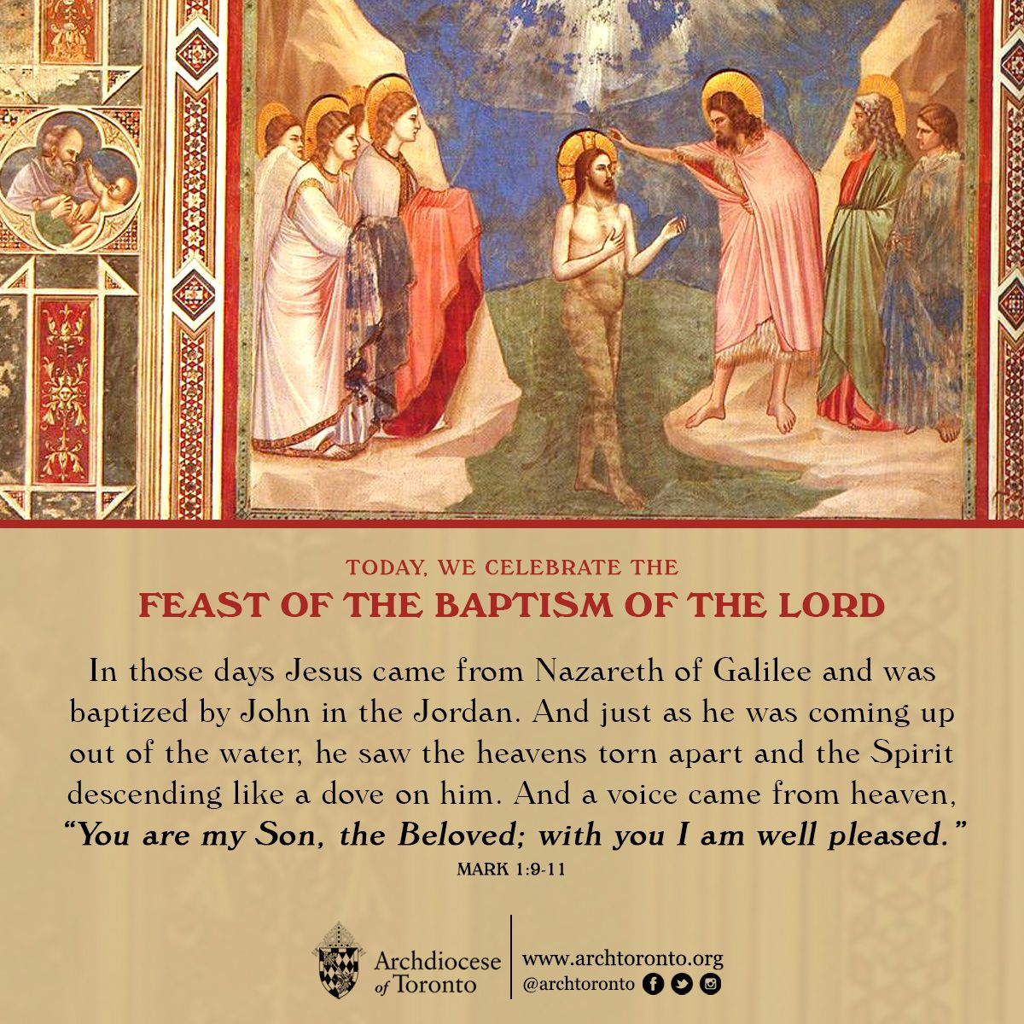
RACHEL’S VINEYARD RETREAT FOR
HEALING AFTER ABORTION
A Rachel’s Vineyard Weekend Retreat will be held January 25-27, at the Williamsburg Christian Retreat Center in Toano, VA sponsored by St. Joan of Arc Church. The weekend retreat includes, spiritual exercises, the Sacrament of Reconciliation, a Memorial Service and a Mass of Entrustment and is available to women, men and anyone adversely affected by an abortion. Participation is strictly confidential and offers a beautiful opportunity to experience God’s love, forgiveness and compassion. To register contact: Linda Riva at 757-997-3144; e-mail lindajr2@yahoo.com.

MINISTRY BUDGETS DUE February 1
As we prepare for another fiscal year, your ministry should have received its annual budget request by December 31 to return to the Parish Council by February 1. Our total parish budget is due to the Bishop by May 15th of every year. We have provided 6-month figures for your use in annualizing your expenses. Please be sure to return your budget request in order to be funded for the coming fiscal year. Of note: most g/l account numbers have been changed…I’m glad to help with questions…feel free to reach out to Deb at 693-5939. Thank you!

THE BAPTISM OF THE LORD—JANUARY 13, 2019
“I, the LORD, have called you for the victory of justice,” Do you feel the Lord calling your to consider becoming a priest? Call the Vocations Office, (804-359-5661, to speck with Fr. Michael Boehling or Fr. Brian Capuano: or write to vocations@richmonddiocese.org.

BRUNSWICK STEW FUNDRAISER SPONSORED
BY THE KNIGHTS OF COLUMBUS COUNCIL #9428
WHAT: Brunswick Stew Fundraiser
WHERE: Church of St. Therese
WHEN: Saturday, January 26, 2019 11:00 AM
(Take out only)
COST: $8:00 per quart
Come and take home a quart or two of delicious Brunswick Stew for a relaxing lunch or dinner. A portion of the proceeds to benefit Gloucester Volunteer Fire and Rescue.

JOB OPPORTUNITY
Catholic Charities is looking for a Part-Time Receptionist for its Norfolk office, 32 hours per week. The position will serve as Administrative Support for the Adoption Services department and will include front office management. The qualified candidate should be friendly and organized, have related office experience and must be proficient in Microsoft Outlook, Word and Excel and the ability to determine crisis situations and act appropriately. Please send resume and cover letter to: hr@cceva.org

LOST AND FOUND
If you have lost or left anything, please check the lost and found items by Friday, January 18. After that date, we will donate those articles in the lost and found if not claimed.

