“Prepare the way of the Lord.”

Second Sunday of Advent

December 9, 2018

MASSES AND INTENTIONS
THIS WEEKEND OF
DECEMBER 8-9, 2018
Saturday 5:00 PM Mass
Intention: St. Therese Parishioners
Sunday 8:00 AM Mass
Intention: Ramona Murawski (RIP)
Requested By: Theresians
Sunday 10:30 AM Mass
Intention: Christopher Jarrach (RIP)
Requested By: Parents

WEEK OF
DECEMBER 10-14, 2018
Monday No Mass
Tuesday 12:00 Noon Mass
Intention: For sleep and mercy
Requested By: Joel Rivera
Wednesday 12:00 Noon Mass
Intention: Ellen Groppe (RIP)
Thursday 9:00 AM Mass
Intention: For all those In need
Friday No Mass

WEEKEND OF
DECEMBER 15-16, 2018
Saturday 5:00 PM Mass
Intention: Alice Theresa McElhone (RIP)
Requested By: Bob & Cheryl Davis
Sunday 8:00 AM Mass
Intention: St. Therese Parishioners
Sunday 10:30 AM Mass
Intention: Mr. James Britt (RIP)
Requested By: Friends of James Britt


DAILY SCRIPTURE READINGS
Daily Readings may be found at the
www.USCCB.org website.

CHRISTMAS POINSETTIAS
For your convenience, there are donation envelopes in
your packets and on the bulletin board in the commons for Christmas poinsettias. Please clearly compose your intentions and we will prepare an insert for the Christmas bulletin with those intentions. Thank you so very much for your generosity!

BLESSED SACRAMENT CHAPEL
VASE FLOWERS
Perpetual living memorial for Anna Lupei

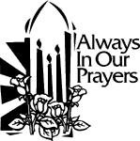 ST. THERESE’S TABERNACLE CANDLE
December 10-16, 2018
In Memory of Butch Adkins

GIFT GIVING UPDATE
Fiscal Year 7/1/18 through 6/30/2019
Annual operating expense budget: $604,400.00

Offertory Totals--November 25 Weekend
Actual donations 11/25/2018: $3,710.75
Gifts were in envelopes and in loose cash/checks

Other donations 11/25/2018 not used for
operations totaled $45.00

In addition we received E-giving support this week totaling $3,296.50

With a Weekend Mass attendance total of 363

Thanksgiving Mass Attendance 60
Total offertory $171.00
"No one shall appear before the LORD empty-handed, but each of you with as much as he can give, in proportion to the blessings which the LORD, your God, has bestowed on you."

CHRISTMAS GIFTS
In this season of gift giving to family, friends, and those less fortunate, we hope you will also consider your gifts to St. Therese. It is through the donations of every individual and family in the congregation that we are able to carry on your work. You can use electronic giving options for both regular offerings and one-time gifts. To help us achieve a more consistent level of funding, please visit www.sttheresechurch.info. Merry Christmas and God Bless!

We can accept Visa, MasterCard, Discover,
and American Express, debit cards and savings/checking drafts.

DECEMBER SECOND COLLECTION

December 24 & 25 Catholic Charities

BINGO UPDATE
No Bingo information. Plea to the Parish: The Charitable Gaming Board is seeking Board Members as well as volunteers on Monday nights, including Assistant Bingo/Game Managers, Admissions Cashiers, Callers, and Floor Sales personnel. To volunteer for Bingo, please call Terry 824-9028 or Carol 694-4915.

DONATIONS NEEDED FOR CHRISTMAS PAGENT
Looking for donations of gently used white First Communion dresses and robes (natural, brown or blue colors); please drop off in church office or give to Nadine McGrady or Ann Martin. If you would like the dress returned after use, please pin your name and contact information onto the clothing.

GIVE THE GIFT OF FAITH
Advent Candles are now available in the Religious Goods cabinet.
Other items, booklets, statues, rosaries and more are also available and make wonderful gifts not only for Christmas but birthdays and other gift-giving events. Contact Nadine McGrady 693-5939 or N.McGrady@StThersGlo.org for any questions or availability of items.
PRISON MINISTRY
If you have unwanted boxes or individual Christmas cards with envelopes, please place them in the box in the Commons Dec. 8 – Dec 16. These cards will be provided to inmates to write to their families and friends this Christmas season. Please do not place stamps on any of the envelopes. Contact Beverly Ittner, 941-266-4288, for questions.

IRA CHARITABLE CONTRIBUTIONS
You can make a charitable IRA gift this year! If you are 70 ½ or older and own an IRA, please consider making a charitable rollover gift before December 31. You can make a gift up to $100,000 directly from your IRA to our parish. Benefits of making a charitable contribution from your IRA:
- The charitable gift will not be included in your taxable income
- It can satisfy all or part of your required minimum distribution (RMD) for the year.
- The portion of the RMD donated will not be added to your total gross income, which could impact your Medicare premium.
- You will be able to reduce your taxable income, even if you do not itemize deductions and take the standard deduction
- Your gift will not be subject to the 50% limitation on charitable gifts…and, it will help the work of the Church
An IRA charitable rollover is a very simple gift to make. Please make your gift as soon as possible to avoid any processing delays at the end of the year. For more information about how you and the Church can benefit from an IRA charitable rollover, contact your IRA administrator, tax preparer, or the parish office for more information.

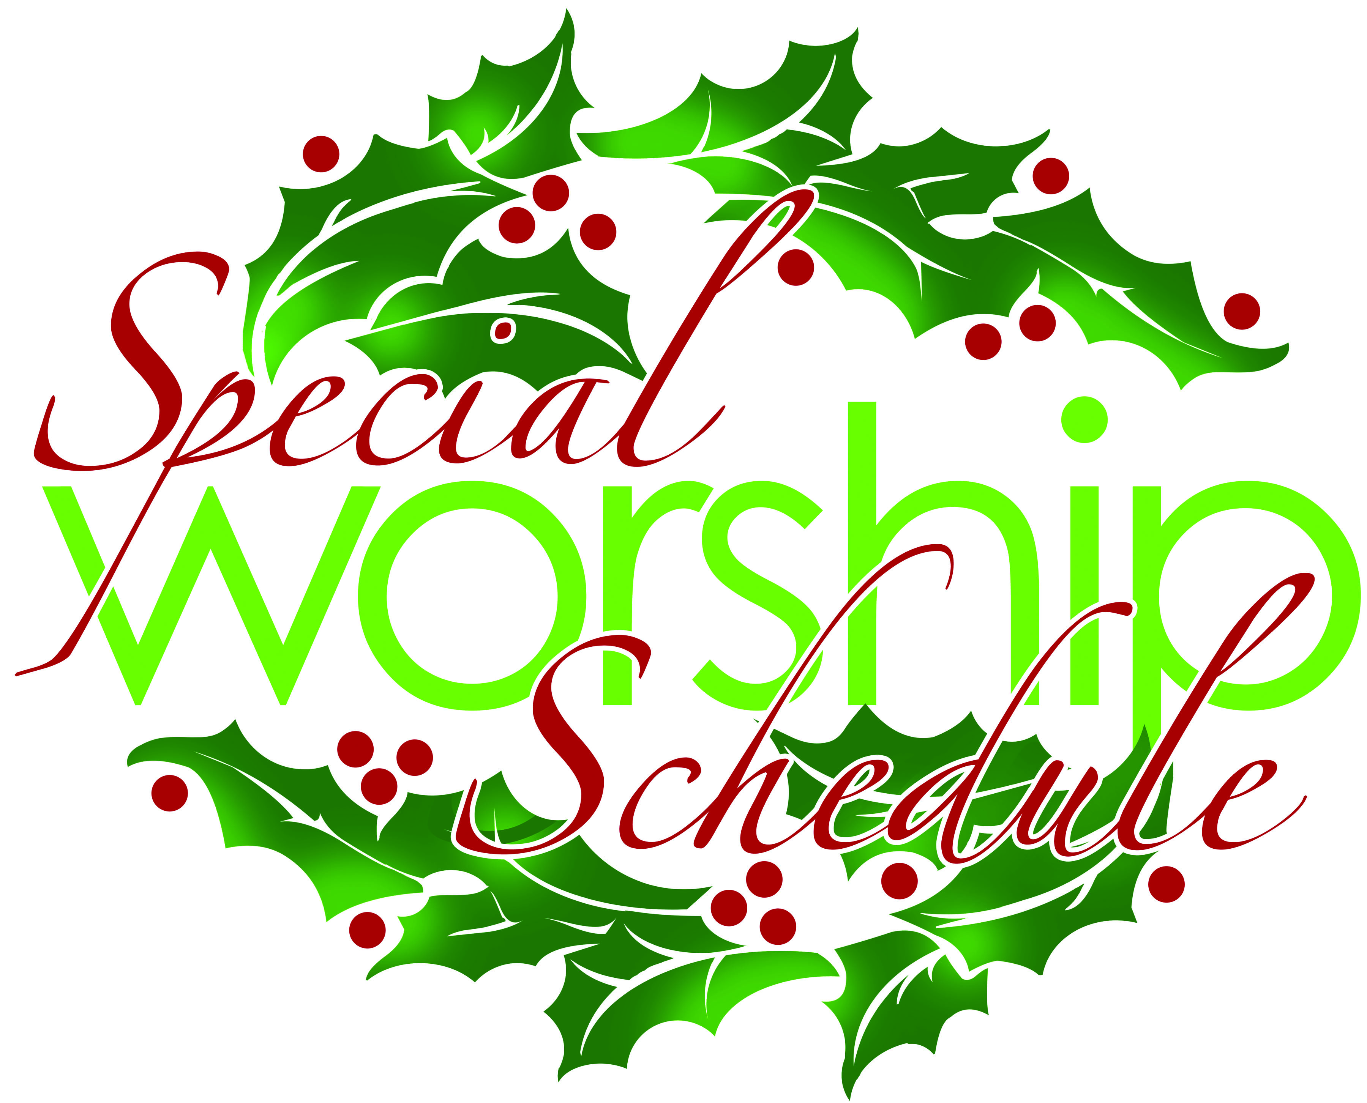
December 11 Advent Reconciliation
OLBS West Point 7:00 PM
December 24 Christmas Eve
Children’s Mass 5:00 PM
Christmas Eve Mass 9:00 PM
December 25 Christmas Day Mass 10:00 AM
January 1 Solemnity of Mary 10:00 AM

The Parish Office will be closed December 24, 25, 26, 27, 31 and January 1.

CHRISTMAS TREE HELP
Art and Environment is in the need of volunteers to help putting up the Christmas tree on the altar area. We think this is a 3-4 men job due the size of the tree. Please contact Ana Barranco, 757-508-6515 or ana.de.panama@gmail.com, if you are able to help on Dec. 22 in the morning.

TIME TO UPDATE THE PARISH DIRECTORY
We are getting ready to put the Parish Directory on the parish website. We would like to update information in the directory prior to putting it on the website so the directory is as accurate as possible. Please use the form provided on the table in the commons to update your information in the directory or if you are a new parishioner contact Ann in the parish office. To arrange to have your picture taken and information included in the online directory. Contact Cheryl Davis (cheryldavis50@gmail.com) for more information. Once the directory is on the website, parishioners will be notified as to how to set up their user name and password to view the directory. The directory will not be updated again for another year. The deadline for turning in your updated information is January 15, 2019.

THERESIANS CHRISTMAS BAKE SALE
The Theresian’s Christmas Bake Sale will be held before and after the Masses on December 15 and December 16. The bake sale will be held in the Social Hall. Assorted homemade cookies, candies and baked goods will be sold for $5 a pound. Raffle tickets will be sold during the bake sale, $1 each or six tickets for $5, for a variety of prizes.
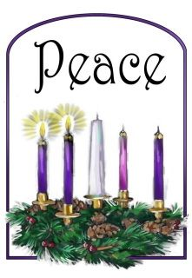
Second Sunday of Advent
Jesus, you are peace even when there is hatred.
Help us to forgive like you when we are hurt or wounded.
Bring peace into our hearts we pray.
Amen.
(childrens prayers for advent from www.lords-prayer.words.com)

