“Blessed are you among women.”

Fourth Sunday of Advent

December 23, 2018

MASSES AND INTENTIONS
THIS WEEKEND OF
DEMBER 22-23, 2018
Saturday 5:00 PM Mass
Intention: Helen Baum (RIP)
Requested By: Dru Adkins
Sunday 8:00 AM Mass
Intention: Gregory Espiritu (RIP)
Requested By: Larry & Glenda Espiritu
Sunday 10:30 AM Mass
Intention: St. Therese Parishioners

WEEK OF
DECEMBER 24-28, 2018
Christmas Eve Monday 5:00 PM Mass
Intention: For all children
Christmas Eve Monday 9:00 PM Mass
Intention: Fr. Jim and his family
Christmas Day Tuesday 10:00 AM Mass
Intention: St. Therese parishioners and their families
Wednesday No Mass
Thursday No Mass
Friday No Mass

WEEKEND OF
DECEMBER 29-30, 2018
Saturday 5:00 PM Mass
Intention: St. Therese Parishioners
Sunday 8:00 AM Mass
Intention: Delores Kane (RIP)
Requested By: Bob & Cheryl Davis
Sunday 10:30AM Mass
Intention: For all families


DAILY SCRIPTURE READINGS
Daily Readings may be found at the
www.USCCB.org website.

BLESSED SACRAMENT CHAPEL
VASE FLOWERS
Perpetual living memorial for Anna Lupei

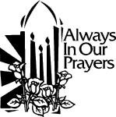 ST. THERESE’S TABERNACLE CANDLE
December 24-30, 2018
In Memory of the Fitzpatrick and Baker Family

GIFT GIVING UPDATE
Fiscal Year 7/1/18 through 6/30/2019
Annual operating expense budget: $604,400.00

Offertory Totals --December 9, 2018
Actual donations 12/9/2018: $6,519.70
Gifts were in envelopes and in loose cash/checks

Other donations 12/9/2018 not used for
operations totaled $195.00

In addition, we received E-giving support this week totaling $2,840.50

With a Weekend Mass attendance total of 388
"No one shall appear before the LORD empty-handed, but each of you with as much as he can give, in proportion to the blessings which the LORD, your God, has bestowed on you."

CHRISTMAS GIFTS
In this season of gift giving to family, friends, and those less fortunate, we hope you will also consider your gifts to St. Therese. It is through the donations of every individual and family in the congregation that we are able to carry on your work. You can use electronic giving options for both regular offerings and one-time gifts. To help us achieve a more consistent level of funding, please visit www.sttheresechurch.info. Merry Christmas and God Bless!

We can accept Visa, MasterCard, Discover,
and American Express, debit cards and savings/checking drafts.

DECEMBER SECOND COLLECTION
December 24 & 25 Catholic Charities

We can accept Visa, MasterCard, Discover,
and American Express, debit cards and savings/checking drafts.

BINGO UPDATE
No Bingo update due to early bulletin deadlines.

Plea to the Parish: The Charitable Gaming Board is seeking Board Members as well as volunteers on Monday nights, including Assistant Bingo/Game Managers, Admissions Cashiers, Callers, and Floor Sales personnel. To volunteer for Bingo, please call Terry 824-9028 or Carol 694-4915.

TIME TO UPDATE THE PARISH DIRECTORY
We are getting ready to put the Parish Directory on the parish website. We would like to update information in the directory prior to putting it on the website so the directory is as accurate as possible. Please use the form provided on the table in the commons to update your information in the directory or if you are a new parishioner contact Ann in the parish office. To arrange to have your picture taken and information included in the online directory. Contact Cheryl Davis (cheryldavis50@gmail.com) for more information. Once the directory is on the website, parishioners will be notified as to how to set up their user name and password to view the directory. The directory will not be updated again for another year. The deadline for turning in your updated information is January 15, 2019.

RCIA, SATURDAY SCRIPTURE STUDY:
Please join us for Acts: the Spread of the Kingdom. This study takes us through the establishment and spread of the Early Church through the efforts of the Apostles, including St. Paul. How can their efforts, sanctified by the Holy Spirit, inspire us today to be better evangelizers? All are welcome. See the display in the Commons to fill out a registration. Please contact Kerry Fallon in the parish office for more details.

NEW YEAR’S EVE CELEBRATION
Tickets will go on sale for the New Year’s Eve party after all Masses December 22, 23 and December 29, 30. Tickets will be $8.00 for a single ticket or $15.00 for couples.
The party will be held December 31, beginning at 8:00 pm in the church Social Hall and will end at 12:30 am.
Come and enjoy food, dancing and fellowship, as we welcome in 2019 with a champagne toast. This is an adults only, 21 and over, parish event

Volunteer Opportunity
The Parish has just been made aware that as of December 19 per the Director of Waste Management, recycling materials will only be accepted at the County Convenience Centers, therefore no contract carriers will be picking up recycling products. Fr. Jim has asked that a group of volunteers be gathered to continue our mission of being good stewards of God’s earth by taking the church recycling to the convenience centers on perhaps a rotating schedule. Please reach out to Gary Dietz at 693-5939 if you are able to help and thank you!

CATHOLIC CHARITIES SECOND COLLECTION
The second collection for Catholic Charities will be during the Holy Day Masses December 24 and 25. Catholic Charities of Eastern Virginia provides services for Adult & Senior Care, Community and Health Services, Financial and Housing Counseling, Mental Health Counseling and Youth and Family Services. Thank you for your continued support to Catholic Charities of Eastern Virginia.

IRA CHARITABLE CONTRIBUTIONS
You can make a charitable IRA gift this year! If you are 70 ½ or older and own an IRA, please consider making a charitable rollover gift before December 31. You can make a gift up to $100,000 directly from your IRA to our parish. Benefits of making a charitable contribution from your IRA:
- The charitable gift will not be included in your taxable income
- It can satisfy all or part of your required minimum distribution (RMD) for the year.
- The portion of the RMD donated will not be added to your total gross income, which could impact your Medicare premium.
- You will be able to reduce your taxable income, even if you do not itemize deductions and take the standard deduction
- Your gift will not be subject to the 50% limitation on charitable gifts…and, it will help the work of the Church
An IRA charitable rollover is a very simple gift to make. Please make your gift as soon as possible to avoid any processing delays at the end of the year. For more information about how you and the Church can benefit from an IRA charitable rollover, contact your IRA administrator, tax preparer, or the parish office for more information.

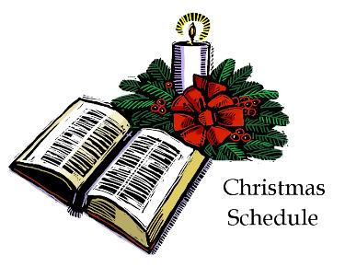
December 24 Christmas Eve
Children’s Mass 5:00 PM
Christmas Eve Mass 9:00 PM
December 25 Christmas Day Mass 10:00 AM
January 1 Solemnity of Mary 10:00 AM

The Parish Office will be closed December 24, 25, 26, 27, 31 and January 1.

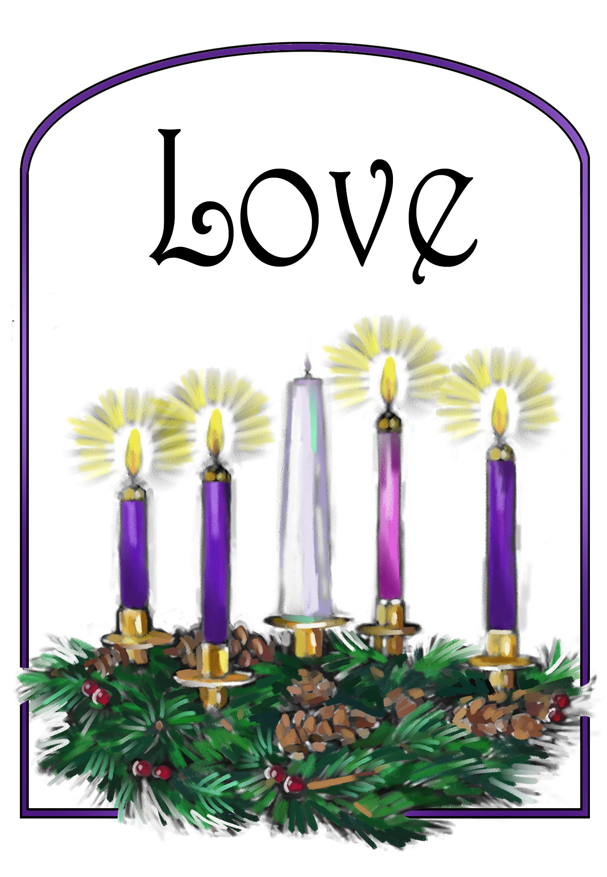
Forth Sunday of Advent
Jesus, you are love even if we are afraid.
Help us to pray to you when we are scared or fearful.
Bring love into our hearts we pray.
Amen.
(childrens prayers for advent from www.lords-prayer.words.com)

