“I will raise up for David a just shoot.”

First Sunday of Advent

December 2, 2018

MASSES AND INTENTIONS
THIS WEEKEND OF
DECEMBER 1-2, 2018
Saturday 5:00 PM Mass
Intention: Max Lupei (RIP)
Requested By: Linda Gregory
Sunday 8:00 AM Mass
Intention: St. Therese Parishioners
Sunday 10:30 AM Mass
Intention: Joan & Bernie Gillott (RIP)
Requested By: Debbie Kelly

WEEK OF
DECEMBER 3-7, 2018
Monday No Mass
Tuesday 12:00 Noon Mass
Intention: Susan Smith (RIP)
Requested By: Roger & June Young
Wednesday 12:00 Noon Mass
Intention: Jose Perez (RIP)
Requested By: William & Peggy Prucha
Thursday No Mass
Friday 9:00 AM Mass
Intention: Theresians

WEEKEND OF
DECEMBER 8-9, 2018
Saturday 5:00 PM Mass
Intention: St. Therese Parishioners
Sunday 8:00 AM Mass
Intention: Ramona Murawski (RIP)
Requested By: Theresians
Sunday 10:30 AM Mass
Intention: Christopher Jarrach (RIP)
Requested By: Parents


DAILY SCRIPTURE READINGS
Daily Readings may be found at the
www.USCCB.org website.

Christmas Poinsettia Memorials will be accepted
Now through December 16, 2018

BLESSED SACRAMENT CHAPEL
VASE FLOWERS
Perpetual living memorial for Anna Lupei

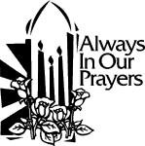 ST. THERESE’S TABERNACLE CANDLE
December 3-9, 2018
In Honor of Abuse Victims

GIFT GIVING UPDATE
Fiscal Year 7/1/18 through 6/30/2019
Annual operating expense budget: $604,400.00

Offertory Totals--November 18 Weekend
Actual donations 11/18/2018: 5,413.02
Gifts were in envelopes and in loose cash/checks

Other donations 11/18/2018 not used for
operations totaled $95.00

In addition we received E-giving support this week totaling $2,438.00

With a Weekend Mass attendance total of 371

"No one shall appear before the LORD empty-handed, but each of you with as much as he can give, in proportion to the blessings which the LORD, your God, has bestowed on you."

CHRISTMAS GIFTS
In this season of gift giving to family, friends, and those less fortunate, we hope you will also consider your gifts to St. Therese. It is through the donations of every individual and family in the congregation that we are able to carry on your work. You can use electronic giving options for both regular offerings and one-time gifts. To help us achieve a more consistent level of funding, please visit www.sttheresechurch.info. Merry Christmas and God Bless!

We can accept Visa, MasterCard, Discover,
and American Express, debit cards and savings/checking drafts.

DECEMBER SECOND COLLECTION

December 1 & 2 MM&R
December 24 & 25 Catholic Charities

BINGO UPDATE
On November 12, Bingo attendance included 18 players (6 parishioners) and 8 Bingo volunteers; our total deposit was $422. Calendar year 2018 donations: $11,421.97, including Parish Office printer supplies and computer support, a donation to SHINE for the Youth Ministry trip, ALC patio concrete, and a vanity for the Rectory master bathroom.

Plea to the Parish: The Charitable Gaming Board is seeking Board Members as well as volunteers on Monday nights, including Assistant Bingo/Game Managers, Admissions Cashiers, Callers, and Floor Sales personnel. To volunteer for Bingo, please call Terry 824-9028 or Carol 694-4915.

Catholic Charities Seeks Committed, Compassionate Individuals
Catholic Charities is hiring for two in-home care positions.
Companion Care Workers (contract - $10/hr)
CCEVA is hiring several Companion Care workers to provide companionship to clients enrolled in the Companion Care Pilot Program in order for them to stay socially engaged and to provide assistance with their daily activities in order to remain in their home comfortably and safely. The Companion Care Program provides non-medical, in-home support services such as: home management (light housekeeping, laundry, bed making, and trash removal), meal planning and preparation, grocery shopping and running errands for client, transporting clients in your car to run errands and shopping, and providing medication reminders. For more information, please call Vanessa Dunlap at (757) 875-0060.

In-Home Respite Care Workers (contract - $8/hr)
Applications are now being taken for In-Home Respite Care Workers ages 18 through retirement years. After completing a 25-hour free training program, the workers will be given assignments to work in 3- to 8-hour increments in various households in the Hampton Roads area. The position provides companionship for an elderly individual being cared for in the home, ensuring their safety. No transporting, cleaning or heavy lifting is required. This is considered a contracted position, part-time with flexible schedules. For more information, please call Rebecca Wirt at (757) 875-0060.

THERESIAN MASS/MEETING
Ladies of the parish please join the Theresians for our December meeting. It will be held on Friday the 7th of December. Mass is at 9:00 am and the meeting will be at 9:30 am. To be held in the social hall.

EARLY BULLETIN DEADLINE REMINDER
Just a reminder, over the next few weeks we have early bulletin deadlines with Dee Printing. Please have bulletin announcements to Ann in the Parish Office as soon as possible. Please note on the announcement the weekend you want it published. Thank you.

CAREFREE SENIORS DECEMBER
LUNCHEON
The December meeting to be held December 12th. This is opened to all members of the Parish, 60 or older. Christmas Covered dish luncheon and a generic wrapped gift between $5-$10 at 1:00....lot of fun!!


ST. THERESE PARISH APP INFORMATION
In order to receive notifications from the parish office, be sure to enable notifications. When you download the parish app to your smartphone or tablet, go to the main page, tap on “notifications setup”, the “general message” box should be checked, then tap on save. Once you have saved this, you will then receive any messages the parish office sends. Questions? Contact the Parish Office at 804-693-5939

GIVE THE GIFT OF FAITH
Advent Candles are now available in the Religious Goods cabinet.
Other items, booklets, statues, rosaries and more are also available and make wonderful gifts not only for Christmas but birthdays and other gift-giving events. Contact Nadine McGrady 693-5939 or N.McGrady@StThersGlo.org for any questions or availability of items.

ADVENT AND CHRISTMAS SCHEDULE

December 4 Advent Reconciliation
St. Therese 7:00 PM
December 7 Immaculate Conception
Vigil Mass 7:00 PM
December 11 Advent Reconciliation
OLBS West Point 7:00 PM
December 24 Christmas Eve
Children’s Mass 5:00 PM
Christmas Eve Mass 9:00 PM
December 25 Christmas Day Mass 10:00 AM
January 1 Solemnity of Mary 10:00 AM

The Parish Office will be closed December 24, 25, 26, 27, 31 and January 1.

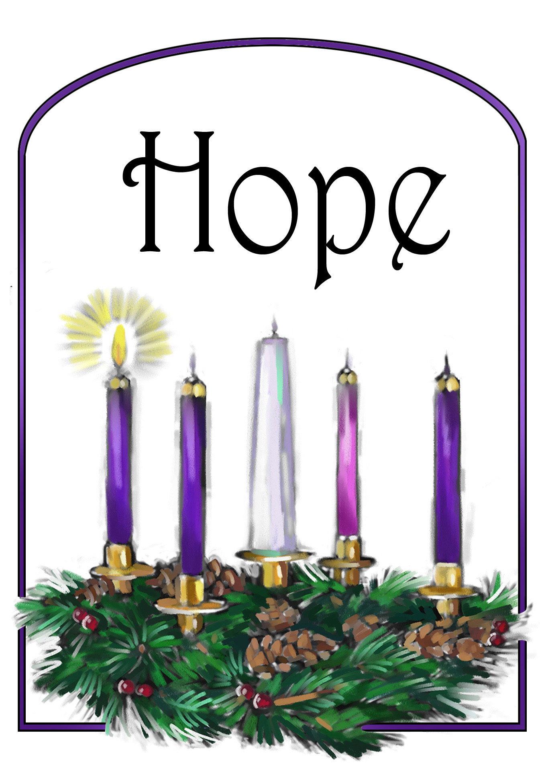
First Sunday of Advent
Jesus, you are light even in the darkest places.
Help us to trust in you when we are lost or lonely.
Shine hope into our hearts we pray.
Amen.
(childrens prayers for advent from www.lords-prayer.words.com)

