“The young man went away sad because he had many possessions.”

Twenty-eighth Sunday of Ordinary Time

October 14, 2018

MASSES AND INTENTIONS
THIS WEEKEND OF
OCTOBER 13-14, 2018
Saturday 5:00 PM Mass
Intention: Anthony Spinelli (RIP)
Requested By: Donna Hull
Sunday 8:00 AM Mass
Intention: St. Therese Parishioners
Sunday 10:30 AM Mass
Intention: Susan Smith (Health)
Requested By: Roger & June Young

WEEK OF
OCTOBER 15-19, 2018
Monday No Mass
Tuesday No Mass
Wednesday No Mass
Thursday No Mass
Friday 11:00 AM WRCC Mass
Intention: For all Healthcare Providers

WEEKEND OF
OCTOBER 20-21, 2018
Saturday 5:00 PM Mass
Intention: Richard Elmore (RIP)
Requested By: Linda Gregory
Sunday 8:00 AM Mass
Intention: St. Therese Parishioners
Sunday 10:30AM Mass
Intention: Nancy Collier (Health)
Requested By: Roger & June Young


DAILY SCRIPTURE READINGS
Daily Readings may be found at the
www.USCCB.org website.


Altar Flowers
Donated By: Ana Barranco
In Honor of: All Faith Formation Students

BLESSED SACRAMENT CHAPEL
VASE FLOWERS
Perpetual living memorial for Anna Lupei

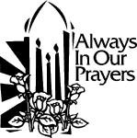 ST. THERESE’S TABERNACLE CANDLE
October 15-21, 2018
In Memory of Bill & Ann Skelley, Sr.

GIFT GIVING UPDATE
Fiscal Year 7/1/18 through 6/30/2019
Annual operating expense budget: $604,400.00

Offertory Totals
No offertory totals due to the
Columbus Day Holiday.

"To whom much is given, much is expected." Luke 12:48

CELEBRATE THE FEAST OF ST. THERESE!
On October 1^{st,} we honor our parish patron saint, Therese of Lisieux. We have a contribution line on our e-giving page if you wish to donate in honor of her. Thank you for your generosity and please visit www.sttheresechurch.info for more details.

Consider automating your offertory today!

We can accept Visa, MasterCard, Discover,
and American Express, debit cards and savings/checking drafts.

“There are laminated resuable egiving cards available in a bowl in the commons for you to drop into the offertory basket at Mass if you wish.” Thank you for egiving!

OCTOBER SECOND COLLECTIONS
October 20/21 World Mission
October 27/28 Catholic Virginian

BINGO UPDATE
On October 1, Bingo attendance included 28 players (8 parishioners) and 7 Bingo volunteers; our total deposit was $624. Calendar year 2018 donations: $11,421.97, including Parish Office printer supplies and computer support, a donation to SHINE for the Youth Ministry trip, ALC patio concrete, and a vanity for the Rectory master bathroom.

Plea to the Parish: The Charitable Gaming Board is seeking Board Members as well as volunteers on Monday nights, including Assistant Bingo/Game Managers, Admissions Cashiers, Callers, and Floor Sales personnel. To volunteer for Bingo, please call Terry 824-9028 or Carol 694-4915.

CAREFREE SENIORS
If you and your friends are over 60, please plan to join our group “Carefree Seniors”. We meet the third Wednesday of every month at 1:00 PM in the church social hall. Our next gathering will be on Wednesday, October 17. Our goals are to have an outing, a fun and an educational session once a quarter. Everyone that is over 60 is invited (you do not have to be a member of St. Therese Church). If you would like additional information, please contact Frank Rivera at cisci7@cox.net or Pat Snyder at pbspat@gmail.com

VOCATIONS INTO THE PRIESTHOOD
Good Teacher, what must I do to inherit eternal life?” No one wants to turn away from the Lord sad. Bring this question to Him in prayer, and He will give you the grace to respond with a joyful “yes” to what He asks. Consider following Christ more closely as a priest. Call Father Michael Boehling at (804) 359-5661, or write: mboehling@richmonddiocese.org.

THANK YOU!
The Parish Council would like to thank everyone that participated in the annual celebration of our patron saint, St. Therese. Thanks to all parishioners who donated food, everything was so delicious. A big thank you to Tom Trudeau and his crew who grilled all the hot dogs and hamburgers. Our DJ, Dan Wenner, kept the music playing and distributed all the beautiful door prizes that were donated. The music could not have happened without Rita Guest, Don Parker and George Rhodes at Office Supply. There were horses to ride and ponies to paint. Thanks to Karen Mohnach for them. Many people had butterflies and dragons painted on their faces by our Face Painter, Courtney. And finally, the Parish Council is so grateful to all the Theresians and Knights who helped set up and clean up for the picnic. If you missed the picnic this year, we hope you put it on your calendar for next year.

THERESIANS MEET AND GREET
The Theresians will hold a Meet and Greet on October 14 from 11:30 to 2:00 PM. All women of the parish are invited to come and get to know how this ministry helps our church and community. To be held in the social hall with light refreshments.


ALL SOUL’S DAY MASS AND LUNCHEON
Friday, November 2, is All Soul’s Day. This is the time for Catholics to remember loved ones who have died. We are called to Pray for the Dead in the Spiritual Works of Mercy. The Mass that day commemorates friends and family who have gone before us. After Mass, the Comfort Ministry is hosting their annual lunch. Please look for the signup sheet by the poster in the Commons and let us know if you will be attending.

THERESIANS MEETING
The Theresians meeting for November will be on Friday the 2nd at 9:30 AM. Mass will be after the meeting at 11:00 AM so those interested may join in the All Souls service.


CONGRATULATIONS!
Congratulations to Roger and June Young on their Wedding Anniversary! May God Bless you both on many more.

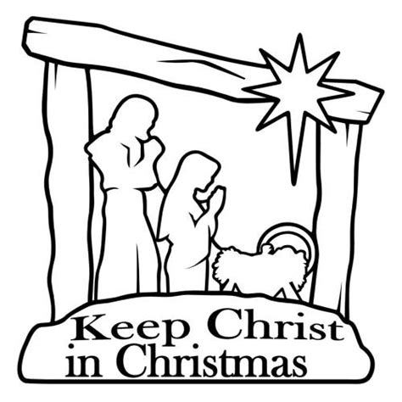
CHRISTMAS CARD SALES
Christmas will soon be upon us. This is evident in many of our retail stores. The Knights of Columbus will begin their annual Christmas card sales on the weekend of Oct 20th. They will be selling them before, after and in between Masses each weekend through Dec 2nd. Can you think of a more meaningful way to spread the word of Our Lord’s birth? When you purchase these Spiritual messages you not only help in keeping CHRIST in Christmas, but our proceeds go toward religious vocations.

PRAYER OF ATONEMENT
Our church, especially its bishops, must continually seek forgiveness for our failures from those who have suffered as a result of those failures. So let us pray for all victims of abuse, and express sorrow for the failure of Church leaders, let us seek forgiveness for our sins, and ask for the guidance of the Holy Spirit in the ongoing healing of the People of God. Amen
(excerpt from Bishop Barry C. Knestout’s invitation to Pray for Victims of Abuse issued August 15, 2018)


TOYS FOR TOTS
The annual US Marine Corp Reserves Toys for Tots Campaign has begun and will run through December. Purchase a new unwrapped toy for children and place in the box that is located in the commons. For more information, you may visit their website at www.toysfortots.org. Thank you.

