“Live by the Spirit and you will certainly not gratify the desires of the flesh.”

Pentecost Sunday

May 20, 2018

MASSES AND INTENTIONS
THIS WEEKEND OF
MAY 19-20, 2018
Saturday 5:00 PM Mass
Intention: James Fitzpatrick Sr & Jr (RIP)
Requested By: Fitzpatrick Family
Sunday 8:00 AM Mass
Intention: Patricia Villanell
Requested By: Donna Hull
Sunday 10:30 AM Mass
Intention: St. Therese Parishioners

WEEK OF
MAY 21-25, 2018
Monday No Mass
Tuesday 9:00 AM Mass
Intention: Welcome to Gary Dietz
Wednesday No Mass
Thursday No Mass
Friday 12:00 Noon Mass
Intention: For all who have been away from the Church

WEEKEND OF
MAY 26-27, 2018
Saturday 5:00 PM Mass
Intention: Victor Molnar (RIP)
Requested By: Zol & Pat Molnar
Sunday 8:00 AM Mass
Intention: John & Catherine Hall (RIP)
Requested By: Jim & Phyllis Hall
Sunday 10:30AM Mass
Intention: Matt Kolby (RIP)


DAILY SCRIPTURE READINGS
Daily Readings may be found at the
www.USCCB.org website.


Sign-up sheets for Altar flowers for 2018 is now posted
on the bulletin board leading to the social hall for anyone wishing to donate Altar flowers for weekend liturgies.

BLESSED SACRAMENT CHAPEL
VASE FLOWERS
Perpetual living memorial for Anna Lupei

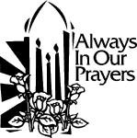 ST. THERESE’S TABERNACLE CANDLE
May 21-27, 2018
In Memory Paul Fitzpatrick

GIFT GIVING UPDATE
Fiscal Year 7/1/17 through 6/30/2018
Annual operating expense budget: $661,243

Offertory Totals
Actual donations 5/13/2018: $7,082.96
Gifts were in envelopes and in loose cash/checks
With a Weekend Mass attendance total of 406

Other donations 5/13/2018 not used for
operations totaled $320.00

In addition we received E-giving support this week totaling
$1,663.00

"No one shall appear before the LORD empty-handed, but each of you with as much as he can give, proportion to the blessings which the LORD, your God, has bestowed on you." Deuteronomy 16:17

EASTER OFFERINGS
The Easter Season presents a wonderful opportunity for St. Therese to thank those individuals and families that support the church throughout the year with their time, talent, and financial contributions. And, with services well attended during this season, it is also a good opportunity to extend a warm welcome to our new and returning congregation members. We hope that you also will be generous with your time and financial support. To assist everyone in making the consistent offerings that are so important to us, we are pleased to offer the option of giving electronically. Please visit www.sttheresechurch.info to help us continue to receive consistent donations. May Christ’s light shine upon you and your families!

We can accept Visa, MasterCard, Discover, American Express, debit cards and savings/checking drafts.
MAY SECOND COLLECTIONS

May 26 & 27 Home Missions


Two Sundays ago I had the privilege of participating in the Liturgy of Confirmation at St. Olaf Church in Norge Virginia. Our new Bishop, His Excellency Barry Knestout presided. In this Sacrament, we are sealed with the Holy Spirit as the Bishop anoints our head with the Sacred Chrism. Confirmation is intended to be a personal Pentecost for each Catholic. We, like the disciples in the upper room, are given the grace to witness to our faith through the gifts of the Holy Spirit.

Confirmation is such a wonderful Sacrament, but it is also one of the most underappreciated Sacraments. Few of us give much thought to our Confirmation. And even fewer; realize on a daily basis that we have been CHANGED by our Confirmation. We now have an indelible mark and a commission to spread the Gospel. Yet this was most likely the case with the 11 disciples as well. Jesus had told them multiple times after the Resurrection that He would send the “Advocate” the “Spirit of Truth” to be with them. They had to wait and pray for this Holy Spirit, but their prayer was not yet filled with confidence.

Through all their doubts, discouragements, and weaknesses the disciples can remind us of ourselves. We received the Holy Spirit at baptism. We are told that this Spirit is within us as we grow up. But, so many of us do not really appreciate this presence. We have an opportunity to grow in the Gifts of the Holy Spirit at Confirmation. However, for many, Confirmation has just become a “rite of passage” or even worse, for some, the last time they will attend religious education or even Mass! The disciples in the closed room may have had the same mixed feelings before their Pentecost.

Then, all of a sudden a “strong driving wind” and “Tongues of fire” come to rest on each of them. They are filled with the Holy Spirit to go forth proclaiming the Gospel in different languages and with great courage. For us too, God does desire Confirmation to be a personal Pentecost for each Catholic Christian. Let us pray today on the Solemnity of Pentecost that God would inspire us with the same fervor that led the 11 disciples to spread the saving message of Christ. May we be open to the ordinary and extraordinary ways the Holy Spirit wishes to work in our lives.

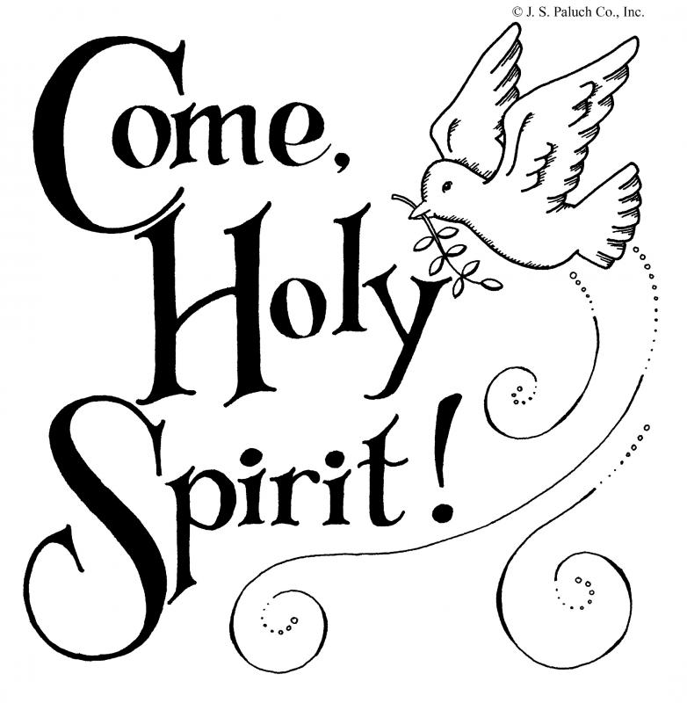
FROM THE DIOCESE
What is the Diocesan Work Camp? The Diocesan Work Camp is a weeklong camp experience for high school youth to serve our brothers and sisters in need by making their homes safer, warmer, drier, and greener while also having the opportunity to grow in our Catholic faith.
Work Camp is not just a youth event. It is an opportunity for parishes to make a difference in the lives of those in need right here in our diocese while encouraging youth to answer their baptismal call to serve others. If interested, visit the Diocesan website for more information and to register.

COME MAKE A JOYFUL NOISE!
You are invited to join the choir at 5:00 PM, 8:00 AM or 10:30 AM Mass. Singers and/or musicians are welcome. Please contact Kitty Witty at 642-6990.
FACILITIES
My sincerest thanks to all of you who have been such an inspiration to me during my time as Facilities Manager at St Therese. I have thoroughly enjoyed working with Fr Jim and the many loving and thoughtful members of the parish staff. Our parish is so blessed! We have a group of dedicated volunteers who tirelessly donate their precious time and talents to do so much in support of various church ministries and community service projects. Our Bread for Life Food Pantry provides over 7000 Lbs. of food to the needy of Gloucester County every week. Our parishioners provide soup and bread during Lent in support of our Soup with Love program, the proceeds of which goes to charities near and far. Since its inception, our BINGO team has donated over $130,000.00 to our church. The Theresians do so much in support of this church. I don’t what we would do without them. The Grounds Maintenance Crew works each week during the season to keep our church grounds looking great. Our Knights of Columbus council provides support to a number of church and community projects throughout the year. Our church Choir groups provide heart felt, uplifting music for us during Mass and all of our Liturgical celebrations. In short, we truly are a blessed family of Catholic Christians devoted to using our time, talents and treasure in support of our church, our community and our nation and I am so thankful to have been a small part of it all. Thank you all for supporting me in my ministry and may God continue to bless us to do His Work.

Mike

WELCOME TO OUR PARISH
We welcome the following new parishioners who recently have joined the St. Therese Family, Tom and Ann Davidson.

NEWS FROM THE PEWS
Congratulations to Deacon Sandy and Mary Jane Mattson on the birth of their new granddaughter, Elizabeth Ann Perez, daughter of Michelle and Benny Perez. May God bless Elizabeth Ann and her family.

CONGRATULATIONS!
Congratulations to Khatiana Perez and Alex Roberts and their families as they received the sacrament of Confirmation on Sunday, May 6, at St. Olaf.

WELCOME!
Welcome to our new facilities maintenance staff member, Gary Dietz! He will begin in this position on Monday, May 21!
STEWARDSHIP – TIME/TALENT
May 19 & 20 5:00 PM 8:00 AM 10:30
Lectors: K. Fallon S. Raschke E. Bauer M. Fisher A. Reynolds B. McGovern
--------------------------------------------
EME: M. Jones Substitute A. Vela
C. Jones J. Matthews M. Campo
M. Foster T. Wilson D. Henley
P. Amos C. Buquor E. Bauer
M. Baker B. Quinzel T. Hellebrandt
----------------------------------------------
Ushers: No Schedule No Schedule No Schedule

-----------------------------------------------
May 26 & 27 5:00 PM 8:00 AM 10:30
Lectors: L. Gregory T. Vanderhoof R. Guest P. Snyder G. Zahn J. Martin
--------------------------------------------
EME: G. Carrington Substitute A. Vela
M. Carrington K. Gierlak E. Bauer
M. Baker S. McClellan D. Henley
M Foster J. Matthews B. Allaman M. Jones Substitute M. Campo
----------------------------------------------
Ushers: No Schedule No Schedule No Schedule

-----------------------------------------------
June 2 & 3 5:00 PM 8:00 AM 10:30
Lectors: M. Fisher J. Gierlak D. Wenner
B. Sabourin-Moore T. Rinderer L. Parker
--------------------------------------------
EME: P. Amos K. Gierlak T. Hellebrandt
M. Baker B. Quinzel E. Bauer
M. Jones T. Wilson M. Campo
C. Jones C. Buquor B. Allaman
M. Carrington S. McClellan A. Vela
----------------------------------------------
Ushers: No Schedule No Schedule No Schedule

-----------------------------------------------
June 9 & 10 5:00 PM 8:00 AM 10:30
Lectors: P. Snyder A. Reynolds B. McGovern K. Fallon P. Casanave W. Priest
--------------------------------------------
EME: G. Carrington S. McClellan Youth EME M. Carrington B. Quinzel Youth EME M. Foster Substitute Youth EME
P. Amos J. Matthews Youth EME C. Jones T. Wilson Youth EME

----------------------------------------------
Ushers: No Schedule No Schedule No Schedule

June 16 & 17 5:00 PM 8:00 AM 10:30
Lectors: B. Sabourin-Moore G. Zahn J. Martin L. Gregory J. Cronin E. Bauer
--------------------------------------------
EME: C. Jones J. Matthews E. Bauer M. Jones T. Wilson A. Vela
M. Foster C. Buquor D. Henley
Substitue T. Bernard T. Hellebrandt P. Amos Substitute B. Allaman

----------------------------------------------
Ushers: No Schedule No Schedule No Schedule

CHRISTIAN FORMATION
Eucharist – Daily Bread or Cake for Special Occasion?
(excerpt from Bishop Robert Barron Reflection of the Second Week of Easter – John 6:1-15) Jesus instructs the crowd to recline on the grass. Taking the barley loaves and dried fish, Jesus makes a meal that satisfies the enormous crown. They are hungry, tired and worn out from their exertions, and Jesus gives them sustenance for the day.
For Thomas Aquinas, the great metaphor for the Eucharist is sustenance, food for the journey. Baptism defines us, making us sons and daughters of God; confirmation confirms and deepens this identity; marriage and holy orders seal us in our life’s vocation. These are sacraments offered once at key moments in our life.
Then there is the Eucharist, which is daily food, nourishment to get us through the day-to-day. How effective would we be if we never ate, or ate only on special occasions and in a festive environment? Not very. So, in the spiritual life, we must eat and drink or we will not have the strength.

RCIA AND ADULT FAITH FORMATION UPDATE:
By popular demand, we are going to offer another Ascension Press 24-week study: Matthew: The King and His Kingdom. This is a Bible study that brings the history of Christ to life through Matthew’s Gospel. You will see Jesus as the awaited Messiah who fulfills the promises and prophecies of the Old Testament, establishes the New Law, and inaugurates the Kingdom of Heaven.

Join us for Matthew: The King and His Kingdom at Church of St. Therese in the social hall beginning June 16th at 2:30pm and continuing most Saturdays until December 15th. This is a Catholic study, meaning we unpack the Scriptures according to Catholic teaching. BUT the study is open to all interested in learning more about the Christian faith; we are an ecumenical bunch of Scripture enthusiasts! Plus, the study will work very well for those who wish to discern more about the Catholic faith and perhaps come into full communion with the Church. For more information or to register for the study, call Kerry Fallon at 804-693-5939 or via email: k.fallon@stthersglo.org.

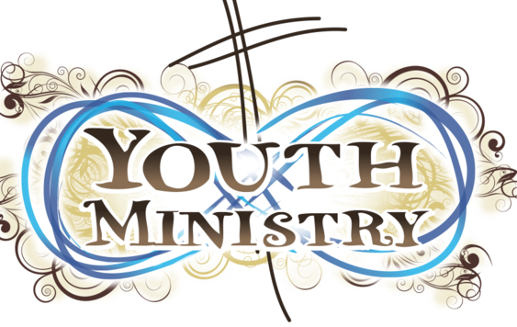
The Rose Team
“Without love, deeds, even the most brilliant, count as nothing.”
― Thérèse de Lisieux
The Rose team is Youth who are taking what St. Thérèse said and doing deeds for the parish community of St. Thérèse with love and joy. Whether you are elderly, a parent or business owner, if you have a deed that the youth can do please contact Brandon Allaman @ liviniamthird@gmail.com or the parish office at 804-693-5939.
Deeds the Rose Team can do:
Yard Work
Cleaning/Organize: Cars, houses, garages.
Change oil
Paint
Shoveling snow
Small tedious task like changing a light bulb
If you want to give a donation they will go towards the Youth Ministry.

BINGO UPDATE
On May 7, Bingo attendance included 29 players (6 parishioners) and 9 Bingo volunteers; our total deposit was $571.50. Calendar year 2018 donations: $5,573.01 ($4,073.01 for the kitchen/pantry floor and $1,500 catering for parish event). Join us and play the new Star Progressive; bingo on the star and win the jackpot!

Plea to the Parish: The Charitable Gaming Board is seeking Board Members as well as volunteers on Monday nights, including: Assistant Bingo/Game Managers, Admissions Cashiers, Callers, and Floor Sales personnel. To volunteer for Bingo, please call Terry 824-9028 or Carol 694-4915.

2018 ANNUAL DIOCESAN APPEAL:
BUILDING OUR FAMILY OF FAITH
Over the past month, many of our parishioners have contributed their support to the 2018 Annual Diocesan Appeal. To date, we have raised $8,505 on a target of $20,500 putting us at 47.06% of our collected target. If you have already made your 2018 Appeal gift, please accept our gratitude for your commitment.
If you are praying about your decision, we ask you to think about the ways the Appeal is making an impact right now in our Catholic Church. For instance, did you know –
- Nearly $11 million has been sent back to the parishes for their local priorities since 2010.
- The Fuel & Hunger Fund is 100% funded by the Appeal and over the past five years, $1,410,000 has been distributed to parishes and Catholic organizations.
- Our retired priests receive pension, health insurance and long-term care due in part to the generosity of those who support the Appeal.
If you have not had the opportunity to contribute, please pick up a pledge envelope from our parish office. You can also donate securely online, as well as learn more about the ministries the Appeal supports, by visiting richmondcatholicfoundation.org/giving/annual-appeal/.

THRESHOLD BIBLE STUDY
The Evening Bible Study group will soon begin a new book in the Threshold Bible Study series, “Church of the Holy Spirit: Acts of the Apostles.” The Threshold Bible Study gospel series is a dynamic, informative, and inspiring way for you to enter into a deeper relationship with God through Scripture. If you’re being called to have a more intimate relationship with Christ, please join our small group of fellow parishioners for a deep, insightful, and rewarding study of the Bible. We meet every other Friday at 6:00 PM. The next Friday we will meet is Friday, May 18. For more information, please contact Jim Lee at (804) 693-0826.


FOR YOUR INFORMATION
While construction is going on in the front of the Church Monday through Friday, please use the kitchen door to enter the Church. Thank you for your patience during the construction!

SUMMER WILL SOON BE HERE!
It is time to plan for this summer’s Vacation Bible School, scheduled for June 18-22 from 9:00 AM to 12:00 Noon. Volunteers are needed for Crafts, Music, Storytelling and more. For questions or to volunteer contact Nadine McGrady at N.McGrady@Stthersglo.org or 693-5935.
DATYTIME EUCHARISITIC ADORATION
A daytime Holy Hour of Eucharistic Adoration is being considered. Two persons must be present for the whole of the hour. If you are interested in participating contact Nadine McGrady at N.McGrady@stthersglo.or or 693-5939.

DO YOU REMEMBER YOUR “BLANKIE”?
The warmth, the comfort, the security? A Prayer Shawl is ‘Blankie’ all grown up. Each shawl is knitted or crocheted by volunteers here at St. Therese and is prayed over through its entire creation. Once finished the shawls are gifted to persons for multiple reasons, loss of a loved one, personal trials, heath issues, celebrations (Baptism, weddings, anniversaries, birthdays etc.). Volunteers are needed! If you knit or crochet (or would like to learn) contact Nadine McGrady at N.McGrady@sttheresglo.org or 693-5939. All materials are provided.
A MINUTE IN THE CHURCH BOOK SERIES
It is vitally important that we never stop learning about and growing in our faith. In an effort to help our parishioners better understand and defend the faith, the Parish Council will be distributing copies of the A Minute in the Church series of books, written by popular radio host and Catholic evangelist, Gus Lloyd. The books are broken into short segments, covering over 200 individual topics, each designed to be read in one minute, with references to the Bible and the Catechism for further reading if desired. The first book is entitled The Mass. As quantities are limited, please take only one per family. The other three books in the series will be distributed over the course of the year.

VOCATIONS FOR PRIESTHOOD
“When the Spirit of truth comes, He will guide you into all the truth” Will you let the Holy Spirit lead you to your true vocation in the Risen Lord…perhaps as a priest ? Call Father Michael Boehling at (804) 359-5661, or write: mboehling@richmonddiocese.org.

HIRING FOR THE HEART
Start your career by making a difference. Commonwealth Senior Living at Gloucester House is interested in caring individuals who want to make a difference in senior’s lives. Do you have a hospitality spirit? You bring the heart, we will bring the skills and training. You can earn a certificate to be a Direct Care Aide and we will pay for your class! Full and part time positions are currently available! Contact the Gloucester House for more information.

CATHOLIC HOME MISSIONS APPEAL
STRENTHENING THE CHURCH AT HOME
Next week, we will take up the Catholic Home Missions Appeal. Right now, over 40 percent of dioceses in the United States are considered home mission territory because they are unable to fund the essential pastoral work needed in their communities. Your support of this appeal helps ease the struggle of these dioceses. Please prayerfully consider how you can support this appeal. More information can be found at www.usccb.org/home-missions.

