“Why do you let us wander, O Lord, from your ways?”

First Sunday of Advent

December 3, 2017

MASSES AND INTENTIONS
THIS WEEKEND OF
DECEMBER 2-3, 2017
Saturday 5:00 PM Mass
Intention: Hector Roberts (RIP)
Requested By: Joe & Linda O'Connell
Sunday 8:00 AM Mass
Intention: In Thanksgiving for Health
Requested By: Nina
Sunday 10:30AM Mass
Intention: James Walker (RIP)
Requested By: John & Gloria Wynne

WEEK OF
DECEMBER 4-8, 2017
Monday No Mass
Tuesday 12:00 NOON Mass
Intention: Cathy Liggins (RIP)
Requested By: Cheryl Davis
Wednesday No Mass
Thursday 7:00 PM Mass
Intention: Bernie & Joan Gillott (RIP)
Requested By: Debbie Kelly
Friday 12:00 NOON Mass
Intention: In Grateful Thanksgiving to Benny & Janet Leigh

DECEMBER 9-10, 2017
Saturday 5:00 PM Mass
Intention: St. Therese Parishioners
Sunday 8:00 AM Mass
Intention: To give thanks to St. Jude for favor granted
Requested By: Nina
Sunday 10:30 AM Mass
Intention: James Turley (RIP)
Requested By: John & Gloria Wynne


DAILY SCRIPTURE READINGS
Daily Readings may be found at the
www.USCCB.org website.

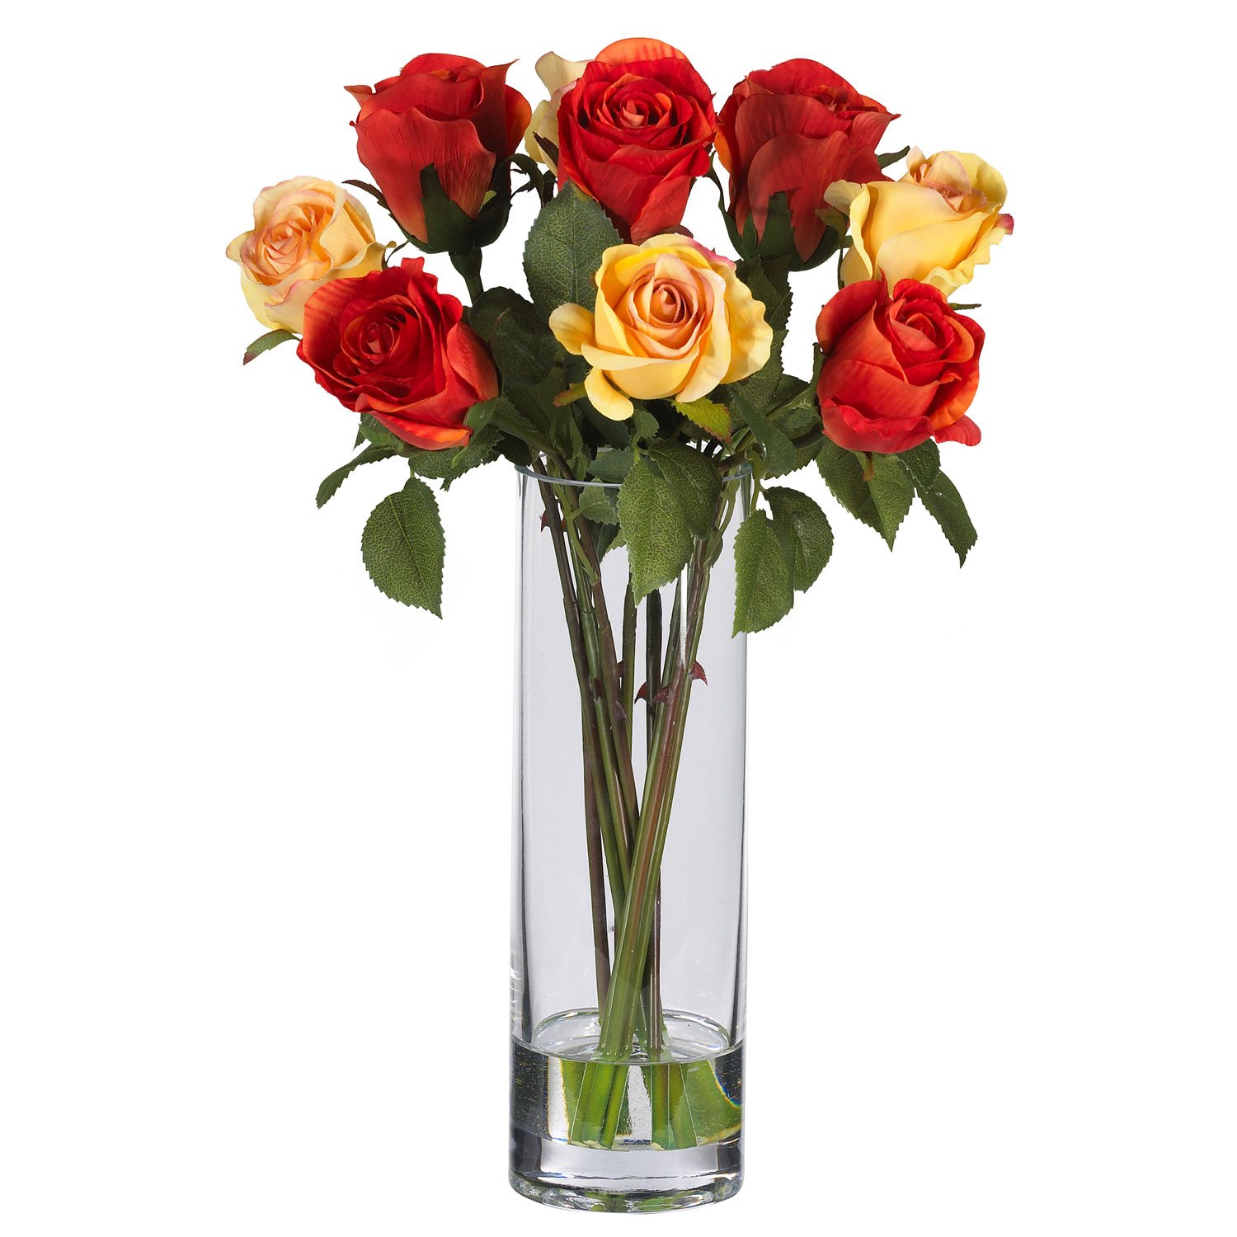
CHRISTMAS FLOWER/POINSETTIA MEMORIALS
Will be accepted November 26 through December 17

BLESSED SACRAMENT CHAPEL
VASE FLOWERS
Perpetual living memorial for Anna Lupei

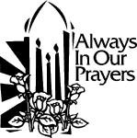 ST. THERESE’S TABERNACLE CANDLE
December 4-10, 2017
In Memory of Marianne Paterson

GIFT GIVING UPDATE
Fiscal Year 7/1/17 through 6/30/2018
Annual operating expense budget: $661,243

Offertory totals November 19
Actual donations 11/19/2017: $5,402.59
Gifts were in envelopes and in loose cash/checks
With a Weekend Mass attendance total of 386

Other donations 11/19/2017 not used for
operations totaled $100.00

In addition we received E-giving support this week totaling
$3,409.50

"Give, and gifts will be given to you; good measure, packed together, shaken down, and overflowing, will be poured into your lap. For the measure with which you measure will in return be measured out to you." Luke 6:38

CHRISTMAS GIFTS
In the season of gift giving to family, friends, and those less fortunate, we hope you will also consider your gifts to St. Therese. It is through the donations of every individual and family in the congregation that we are able to carry on our work. You can use electronic giving options for both regular offerings and one-time gifts. To help us achieve a more consistent level of funding, please visit www.sttheresechurch.info. Merry Christmas and God Bless!

We can accept Visa, MasterCard, Discover, American Express, debit cards and savings/checking drafts.

DECEMBER SECOND COLLECTIONS
Parish Growth December 2 and 3
Catholic Charities Christmas Holy Day Masses only
(December 24th 5 & 9 PM and December 25th 10 AM)

“There are laminated reusable e-giving cards available in a bowl in the commons for you to drop into the offertory at Mass if you wish.”

BINGO UPDATE
On November 20, Bingo attendance included 28 players (9 parishioners) and 11 Bingo volunteers; our total deposit was $847.50. Total donations to St. Therese for calendar year 2017 are $26,918.90.

2 FREE WAYS TO HELP YOUR CHURCH
Holiday shopping is easy with Amazon's Holiday Gift Guides. #StartWithaSmile at smile.amazon.com for your holiday gift purchases and choose our parish as your charity. Amazon donates directly to the Church of St. Therese every quarter, automatically and no cost to you!!

If you shop through igive on line, they will donate a % of purchases to the Church. Their list of hundreds of vendors and stores makes it easy to shop. Just choose to donate to St. Therese. It’s FREE and you can help with just a click! Please visit www.igive.com to participate.

EARLY BULLETIN DEADLINES
With the upcoming holidays, early bulletin deadlines have begun. Please have all bulletin announcements into the parish office for the Christmas and New Year’s bulletins in as soon as possible on December 12. Just be sure to highlight the date you would like the announcement to be in the bulletin. Thank you for your cooperation.

THE BIBLE TIMELINE STUDY AND RCIA
Come join the Bible Timeline and RCIA group as we continue to discuss the Conquest and Judges period of Salvation History. As we recall the scripture passages from the Book of Joshua, we come to know the Judges Gideon, Samson and Deborah and how they dealt with the growing pains the 12 Tribes of Israel endure as they settle into their territories. The Book of Ruth provides a great respite, a light in a dark time, as it chronicles the faithfulness of one gentile woman (great grandmother of King David) while so many Israelites struggle to remain true to their covenant with God.

THANK YOU!
Thank you to all those who donated their time or items to our packing for the adult migrant stockings! We collected well over 100 pounds of goods to donate to those in need. Thank you for your generosity!

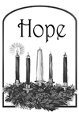
LOM AND ANNUAL APPEAL ADDRESS UPDATES
“Additional proceeds for the following should be mailed to:

For: LOM For: Annual Appeal
Catholic Diocese of Richmond Catholic Diocese of Richmond
Living Our Mission Annual Diocesan Appeal
PO Box 79160 PO Box 79212
Baltimore, MD 21279-0160 Baltimore, MD 21279-0212

The diocese local postal box in Richmond is closed. Please be sure to update bill pay at your bank as well. Thank you.”

NEW VOLUNTEERS TRAINING SESSION GUEST HOMELESS SHELTER
There will be a training session for new volunteers to the GUEST Homeless Shelter:
Sunday, December 3, 4:00 PM Grace Covenant
Presbyterian Church
Please come to a training session to learn more about this vital ministry!

WARE RIVER CIRCLE OF THE KINGS DAUGHTERS AND SONS CHRISTMAS OPEN HOUSE
On December 12 the Ware River Circle of the Kings Daughters and Sons Christmas Open House will be held at “Little England.” Nestled on a point of land between Sarah’s Creek and the York River. Donations are $25, make checks payable to WRCKD & S and are available at the Silver Box and Angelwing Stationers or by calling Sue Hewitt at 804-241-2757. Proceeds will be donated to the Children’s Hospital of the Kings Daughters, Ronald McDonald House and other Charities of WRCKD & S.

BINGO PLEA TO THE PARISH
The Charitable Gaming Board is seeking Board Members as well as volunteers on Monday nights, including Assistant Bingo/Game Managers, Admissions Cashiers, and Floor Sales personnel. To volunteer for Bingo, please contact Terry 824-9028 or Carol 694-4915; for Concessions please contact Milton 694-7500.

THE BIBLE AND THE VIRGIN MARY
This Advent, make time to grow in your faith—to ready your hearts for the arrival of our Lord and Savior. And who better to prepare with than Mary? Join host Matthew Leonard as he leads you through this beautiful study that examines the biblical basis for everything Catholics believe about Mary. The free online study begins on December 3, 2017 and will continue through the end of the year. Additional study materials may be purchased. Sign up at stpaulcenter.com.

ADVENT IN YOUR INBOX
A free program that will help you slow down and focus on what matters most during this busy season. You will experience Advent in a way you’ve never experienced it before—leading to the best Christmas of your life! Sign up for your Best Advent Ever at DynamicCatholic.com/SignUp.

