“What profit comes from toil and anxiety?”

18th Sunday in
Ordinary Time

July 31, 2016

MASSES AND INTENTIONS
THIS WEEKEND OF
JULY 30-31, 2016
Saturday 5:00 PM Mass
Intention: Helen Schmidt (RIP)
Requested By: Rosalie Helbig & Family
Sunday 8:00 AM Mass
Intention: Victor Molnar
Sunday 10:30 AM Mass
Intention: St. Therese Parishioners

WEEK OF
AUGUST 1-5, 2016
Monday NO Mass
Tuesday 12:00 NOON Mass
Intention: Matthew Barbour (RIP)
Requested By: Ray Daly & Shirley Seward
Wednesday 12:00 NOON Mass
Intention: Marie Kuska (RIP)
Thursday 9:00 AM Mass
Intention: For all volunteers
Friday NO Mass

THIS WEEKEND OF
AUGUST 6-7, 2016
Saturday 5:00 PM Mass
Intention: Alfredo & Maria Sanchez (RIP)
Requested By: Their Daughter
Sunday 8:00 AM Mass
Intention: Rose Mary May (Health)
Requested By: Monica May
Sunday 10:30 AM Mass
Intention: Patrick Mahon (RIP)
Requested By: Tom & Kitty Witty


DAILY SCRIPTURE READINGS
Daily Readings may be found at the
www.USCCB.org website.

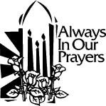 ST. THERESE’S TABERNACLE CANDLE
August 1-7, 2016
In Memory of: Family & Friends of the Carrington & Gunther Family


Altar Flowers
Donated By: Ana Raterman
In Memory Of: Ana Maria Acosta

BLESSED SACRAMENT CHAPEL
VASE FLOWERS
Perpetual living memorial for Anna Lupei

"Give, and gifts will be given to you; good measure, packed together, shaken down, and overflowing, will be poured into your lap. For the measure with which you measure will in return be measured out to you." Luke 6:38

OPERATING BUDGET
Fiscal Year 7/1/16 through 6/30/2017
Annual operating expense budget: $540,244

OFFERTORY
Actual 7/24/2016: $4,862.81
Gifts were in envelopes and in loose cash/checks with a total Weekend Mass attendance total of 362

Other contributions 7/24/2016 not used for operations totaled 40.00
In addition we received E-giving support this week totaling
$3,237.50


A SPECIAL MESSAGE FOR SUMMER TRAVELERS
Would you find it helpful to have your offerings debited directly from your bank account as you probably do with other obligations? St. Therese offers electronic giving for those of you who wish to have contributions transferred electronically to the church's accounts. If you have plans to travel this summer, electronic giving gives you a convenient way to keep up with your intended offerings. Simply visit www.sttheresechurch.Info to get started!

We can accept Visa, MasterCard, Discover, American Express,
Debit Cards, and savings/checking drafts.

AUGUST SECOND COLLECTION
August 6/7 Parish Growth


JULY 18, 2016 UPDATE
On July 18, 2016 attendance included 30 players (8 parishioners) and 13 volunteers. The night's deposit of $891.50 will be used for gaming expenses and donations to St. Therese. Donations for 2016 now total $15,600; these funds will be used for unbudgeted items and special projects. To volunteer, even one Monday night per month, please call Terry at 824-9028 or Carol at 694-4915. We will be closed September 5th and December 26th.

ARE YOU REGISTERED?
Often people attend Mass at this parish for several years, but never register. Registering in a parish is a declaration or your desire to be part of a Catholic community and to make a commitment to the life of St. Therese parish community. Being a registered parishioner makes the process much easier when it is time for infant baptism, religious education registration, weddings, when asked to be a baptismal or confirmation sponsor, and even funerals. A registered parishioner receives all parish mailings. Registration forms are in the magazine rack in the Commons or you may contact the parish office for more information.

RITE OF CHRISTIAN INITIATION OF ADULTS
Interested in coming into full communion in the Catholic Church? Or maybe just interested in learning more about the Catholic faith?
We welcome you to our parish and/or the RCIA program. Whether you are: baptized outside the Catholic Church; unbaptized; baptized in the Catholic Church, but never received the Sacrament of Confirmation….Whatever your state of faith, family history, etc. – there is a place for you at the Table of Plenty! We also seek volunteers as sponsors, presenters, hospitality coordinators, etc.
Formation begins Sunday, September 11th. Please contact Kerry Fallon in the parish office to sign up, ask questions, etcetera, or k.fallon@stthersglo.org

GET READY TO SAY CHEESE,
TO START OUR PARISH DIRECTORY
On August 13 and 14 after all the Masses we will have the opportunity to take pictures of all parishioners. This will not be the only weekend to take pictures we will have another weekend to follow. Information is still pending on the second weekend. Bring your smiles and families. We will also have raffle items to support the directory. Parish council looks forward to seeing you there.

SAINT LEO’S UNIVERSITY
The third largest Catholic University in the country has education centers in the local area for your convenience. Earn your Associates, Bachelors and/or Master’s Degree. For information please email: Newportnews@saintleo.edu. Regionally accredited and Certified by SCHEV
A FUN MINISTRY
Would you like to participate more fully and more joyfully as a community in the celebration of Mass? We would welcome you to become a more vital and important part of the liturgy by greeting visitors and fellow parishioners at the weekend liturgies. Please contact Scott Garrett at 695-0166 or Catherine Huckabee at 693-7745 or idac@cox.net for more information. God Bless!

BEREAVEMENT MINISTRY
Two of the Spiritual Works of Mercy are comfort the afflicted and pray for the living and the dead. If you would like to be a part of this new ministry, please plan on attending an organizational meeting on Sunday, August 14. We will meet in the small hall between the Masses. If you have lost a loved one, or know someone who has, join us to begin this new ministry at St. Therese.

COORDINATOR OF YOUTH MINISTRY
POSITION AVAILABLE
Our parish is seeking applicants who feel called to serve the mission of coordinating a strong faith-filled Middle and High School formation program. This position includes recruiting catechists as well as supervision and executions of parish programs to engage our youth and guide the Youth Council on fun and creative social activities. A commitment of about 15 hours per week including Sundays and some evenings is required. Hourly salary will be according to diocesan scale. Please contact the parish office at 693-5939 for application materials which are due by August 15, 2016 to Fr. Jim for review.

CATHOLIC MEN’S CONFERENCE
The Center for Marriage, Family, and Life is hosting the 5th Annual Catholic Men’s Conference in the Diocese of Richmond on Saturday, September 10 at the Double Tree Hotel in Williamsburg. The day will feature powerful and inspiring talks, an expo area, Adoration, the Sacrament of Reconciliation, and Mass. We are also pleased to welcome Catholic speaker and musician, Sean Forrest, and Father Damian Ference as our keynote speakers. All men 18 and older are invited to attend this one-day conference as an opportunity for learning, fraternity, and solidarity with other men of faith in the Diocese. Registration is $50 for general admission. Early-bird registrants who register before August 31 can attend at the discounted cost of $40. Permanent deacons registered by August 31 will receive an additional $10 discount and, as always, the conference is free for priests and religious brothers. Learn more and register at www.cdrcmfl.org or call 804-622-5109 for details.

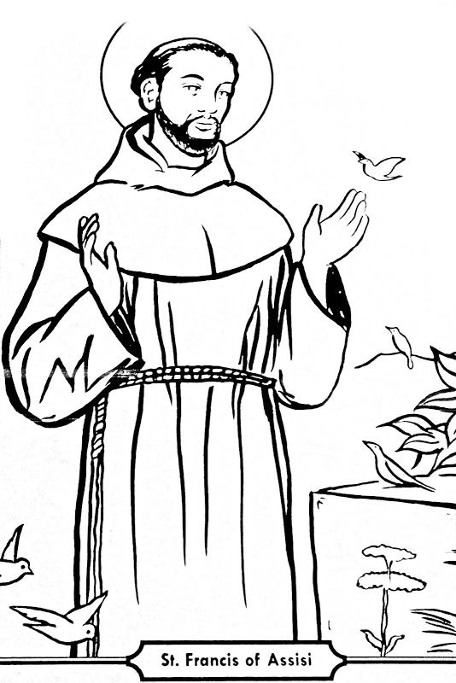
SAINT FRANCIS OF ASSISI
Lord, make me an instrument of your peace,
Where there is hatred, let me sow love;
where there is injury, pardon;
where there is doubt, faith;
where there is despair, hope;
where there is darkness, light;
where there is sadness, joy;
O Divine Master, grant that I may not so much seek to be consoled as to console;
to be understood as to understand;
to be loved as to love.
For it is in giving that we receive;
it is in pardoning that we are pardoned;
and it is in dying that we are born to eternal life.

