“There was a multitude standing before the Lamb with palm branches.”

Fourth Sunday of Easter

April 17, 2016

MASSES AND INTENTIONS
THIS WEEKEND OF
APRIL 16-17, 2016
Saturday 5:00 PM Mass
Intention: First Communion Students and their families
Sunday 8:00 AM Mass
Intention: St. Therese Parishioners
Sunday 10:30 AM Mass
Intention: Dennis Gregory (RIP)
Requested By: Bruce & Trudy Vanderhoof

WEEK OF
APRIL 18-22, 2016
Monday 12:00 Noon Mass
Intention: Keith Cornwell (RIP)
Requested By: Steve & Jan Daum
Tuesday No Mass
Wednesday 9:00 AM Mass
Intention: Marie Kuska (RIP)
Thursday No Mass
Friday No Mass

THIS WEEKEND OF
APRIL 23-24, 2016
Saturday 5:00 PM Mass
Intention: Timothy Roberts (RIP)
Requested By: Ollie Roberts
Sunday 8:00 AM Mass
Intention: Josephine (Josie) DeMay (RIP)
Requested By: Steve & Jan Daum
Sunday 10:30 AM Mass
Intention: St. Therese Parishioners


DAILY SCRIPTURE READINGS
Daily Readings may be found at the
www.USCCB.org website.

 ST. THERESE’S TABERNACLE CANDLE
April 18-24, 2016
In Memory of: Ray Binns


Altar Flowers
In Honor of: The First Communion Students

BLESSED SACRAMENT CHAPEL
VASE FLOWERS
Perpetual living memorial for Anna Lupei

"No one shall appear before the LORD empty-handed, but each of you with as much as he can give, in proportion to the blessings which the LORD, your God, has bestowed on you." Deuteronomy 16:17

Did you know….
It will likely cost us $8,500 for repairs and maintenance?

OPERATING BUDGET
Fiscal Year 7/1/15 through 6/30/2016
Annual operating expense budget: $488,906

OFFERTORY
Actual Contributions 4/10/2016: $7,089.07
Gifts were in envelopes and in loose cash/checks with a total Weekend Mass attendance total of 400

Other contributions 4/10/2016 not used for operations totaled $302.25
In addition we received E-giving support this week totaling
$2,258.50

EASTER OFFERINGS
The Easter season presents a wonderful opportunity for St. Therese to thank those individuals and families that support the church throughout the year with their time, talent and financial contributions. And, with services well attended during this season, it is also a good opportunity to extend a warm welcome to our new and returning congregation members. We hope that you also will be generous with your time and financial support. To assist everyone in making the consistent offerings that are so important to us, we are pleased to offer the option of giving electronically. Please visit www.sttheresechurch.info to help us continue to receive consistent donations. May Christ's light shine upon you and your families!

We can accept Visa, MasterCard, Discover, American Express,
Debit Cards, and savings/checking drafts.

APRIL 2ND COLLECTIONS

April 16/17 Catholic Virginian


WEEKLY BINGO RESULTS:
April 4, 2016
On April 4, 2016, attendance Included 42 players (9 parishioners) and 13 volunteers. The night's deposit of $1,550.00 will be used for gaming expenses and donations to St. Therese. Donations for 2016 total $5,500; these funds will be used for unbudgeted items and special projects. If you can volunteer at least one Monday a month, they would appreciate any help.

SCC BREAD FOR LIFE BBQ
The annual Small Christian Community BBQ fundraiser benefiting the Bread for Life Food Pantry will be held Thursday, April 28th, at the Ware River Yacht Club. Tickets are $25 each and will be on sale in the Church Commons before and after each Mass prior to the event. Please join us for food and fun in this worthwhile cause.

RELAY FOR LIFE
Everyone has a relative or knows a person with cancer. The Relay for Life and American Cancer Society fundraiser is May 14th at the Lighthouse Worship Center on Route 17. Personalized Luminaries, the lighted remembrances for those loved ones who have survived or died from cancer are being sold in the Commons before and after each Mass.


“BABY SHOWER” FOR CATHOLIC CHARITIES
The Justice and Peace committee will be collecting baby items for the Catholic Charities office in Newport News. They are in need of the following items to help families in our area. Please bring your donations to church April 30 through May 8. The Catholic Charities staff is very grateful for your support. Boys and girls summer clothing size 0 – 5T, Diapers size 1—6, baby wipes, baby lotion, baby wash, baby shampoo, wash cloths, bibs, burp cloths, pacifiers, and bottles are all needed.

PARISHIONER EMPLOYMENT
A parishioner is looking for an employment opportunity to provide personal care to include: dressing, feeding, bathing, activities of daily living and companionship. The parishioner is Hospice trained and has over 20 years of experience. Call the office for further information.

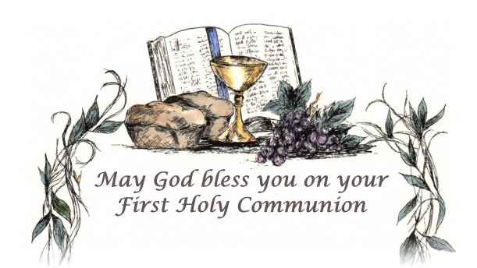
FIRST COMMUNION
Congratulations to the following students receiving their First Communion. Please take time to remember these children of God
in prayer.
Charlie Arnone Zach Roberts
Nicholas Bell Isaac Torres
Callie Laubacker Peyton Sutton
Marina Mayes Mia Van Buren

GET IN ON THE FUN!!
The Youth of St. Therese would like to have updated t-shirts to wear!! So we are asking everyone in the Parish that is interested—to enter a design in our ‘T-Shirt Design Contest’. We will be running the contest through the month of April and the Youth Council will be picking a winner at their May 1st meeting. The winning design will then be debuted on t-shirts we will be ordering to sell as a fundraiser! We are so excited to see the creativity of all!!


BIBLE STUDY
The Thursday Morning Bible Study Group is beginning a new eight-session book, “The Holy Year of Mercy” a Faith-Sharing Guide with reflections by Pope Francis. If this timely subject is of interest to you, please feel free to join the group. We meet on Thursday mornings from 10:15 to 11:45 AM. Please call Doris Melancon at 693-0311 or Sid Dugas at 642-5869 if interested or would like more information.

THE BISHOP KEANE INSTITUTE
PRESENTS JOHN L. ALLEN, JR.—FRIDAY, APRIL 22
The Bishop Keane Institute presents, “The New Christian Martyrs, “a lecture by John L. Allen, Jr. More Christians are being persecuted for their faith than any other religious community in our world today. Thousands are imprisoned, killed, or forced to flee each year. Allen will tell this important and largely unknown story, offering insights into its causes with ideas on how to work for change. Tickets are available on line beginning Monday, March 28 for $15 at keaneinstituet.org/tickets.

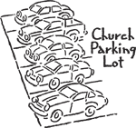
PARKING LOT SIGNS
Some have asked me the reason for the 10 new signs on the church side of the parking lot. At a Bread For Life Board meeting several months back I expressed my concern about the occasional HEAVY volume of parking due to clients of the pantry arriving to receive their food. As a result, there have been times when parishioners and even myself found we had no place to park when arriving at church. When there are multiple events occurring at the same time such as Soup with Love, Funerals, food pantry serving days, parking is extremely difficult. It was my suggestion to have the signs installed to ensure those coming to the church to conduct business and to pray would have a reserved spot. Thank you for your understanding on this matter. Fr. Jim

