“Blessed are you among women.”

4th Sunday of Advent

December 20, 2015

MASSES AND INTENTIONS
THIS WEEKEND OF
DECEMBER 19-20, 2015
Saturday 5:00 PM Mass
Intention: The Parents of KA
Requested By: KA
Sunday 8:00 AM Mass
Intention: St. Therese Parishioners
Sunday 10:30 AM Mass
Intention: Frankie & Sean Fostek (RIP)
Requested By: Philip & Anna Fostek

WEEK OF
DECEMBER 21-25, 2015
Monday No Mass
Tuesday No Mass
Wednesday No Mass

Thursday Christmas Eve 5:00 PM Mass
Intention: For All Children
Christmas Eve 9:00 PM Mass
Intention: St. Therese Parishioners

Friday Christmas Day 10:00 AM Mass
Intention: Elizabeth Cowles (RIP)
Requested By: Tom, Rowena, Amber & Kristen Fauber

THIS WEEKEND OF
DECEMBER 26-27, 2015
Saturday 5:00 PM Mass
Intention: Vernon Deihl (RIP)
Requested By: KA
Sunday 8:00 AM Mass
Intention: St. Therese Parishioners
Sunday 10:30 AM Mass
Intention: Dorothy Bachner (RIP)
Requested By: Bill & Debbie Kelly

DAILY SCRIPTURE READINGS
Daily Readings may be found at the
www.USCCB.org website.

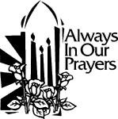 ST. THERESE’S TABERNACLE CANDLE
December 21-27, 2015
In Memory of: Vernon Deihl

If you wish to donate Altar Flowers
in memory or in honor of, sign up for a
weekend on the sheets on the bulletin
board leading to the Social Hall.

BLESSED SACRAMENT CHAPEL
VASE FLOWERS
Perpetual living memorial for Anna Lupei

"For where your treasure is, there your heart will be also." Matthew 6:21

OPERATING BUDGET
Fiscal Year 7/1/15 through 6/30/2016
Annual operating expense budget: $488,906

OFFERTORY
Actual Contributions 12/13/2015: $7,761.22
Gifts were in envelopes and in loose cash/checks with a total Weekend Mass attendance total of 350
December 8, Immaculate Conception Mass 186

Other contributions 12/13/2015 not used for operations totaled $242.00

In addition we received E-giving support this week totaling
$876.00

CHRISTMAS GIFTS
In this season of gift giving to family, friends, and those less fortunate, we hope you will also consider your gift to St. Therese. It is through the donations of every individual and family in the congregation that we are able to carry on our work. You can use electronic giving options for both regular offerings and one-time gifts. To help us achieve a more consistent level of funding, please visit www.sttheresechurch.info. Remember your year-end gifts will be posted as they are received per Diocesan policy. Merry Christmas and God Bless!

The Church of St. Therese is a STEWARDSHIP parish. Each week we depend upon and are grateful for your generous support of time, talents, and treasure to strengthen this, YOUR parish community.

We can accept Visa, MasterCard, Discover, American Express,
Debit Cards, and savings/checking drafts.

DECEMBER 2ND COLLECTIONS
December 24/25 Catholic Charities

*2016 Offertory Envelopes will be available starting
December 19th in the Social Hall.

WEEKLY BINGO RESULTS:
December 7, 2015
On December 7, attendance included 40 players (6 parishioners) and 11 volunteers. The night's deposit totaled $1,120.75 is used for gaming expenses and donations to St Therese. Donations for 2015
now total $27,810; these funds will be used for unbudgeted items and special projects.

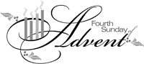

LIVING OUR MISSION
Once again I would like to express how tremendously grateful I am for all who participated in the Diocesan Campaign and helped make it such a huge success. Over the five year span of Living Our Mission our parish will receive quarterly distribution checks which will be based on the amount of actual pledges collected from donors either through written checks or automatic withdrawal from personal accounts or by credit card.
In the past several months several parishioners have either talked to me personally or inquired at the office with questions and some confusion on the proper procedure for making certain types of payments. Of course automatic withdrawals are just that and any record would be on your personal statements. Other questions, concerns or suggestions on how to make the payment option you chose more user friendly can be made directly to Amanda Glass at the Catholic Diocese at 1-804-622-5122. Fr. Jim

WORLDWIDE MARRIAGE ENCOUNTER
Jesus came into the world to testify to the truth. If we belong to the truth we will listen to His voice. Are you listening to His voice and letting Him lead and guide you in all areas of your life? The next Worldwide Marriage Encounter Weekends are on February 19-21 in Herndon or April 22-24 in Fredericksburg. For more information or to apply, visit our website at www.renewmarriage-vasouth.org or contact us at applications@renewmarriage-vasouth.org or
757-483-3209

YOUTH FAITH FORMATION NEWS
There will be NO Youth Faith Formation on Sunday, December 27th. The next Youth Faith Formation for grades K-5 will be held on Sunday, January 3, beginning at 12:00 noon. Have a Merry Christmas!


HAVE YOU NOTICED?
We have tried to keep the parish posted by means of the website and we hope you have found it useful. Please continue to enjoy our new features and let us know if you would like to see anything else updated. Merry Christmas and Peace to each of you!

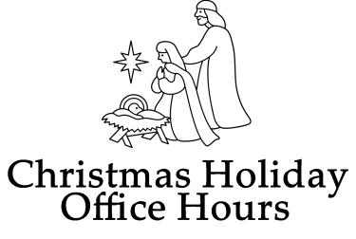
The following will be the office hours for the Christmas week:

December 21 through December 23 9:00 -- 12:00 Noon.

December 29 and 30 9:00 -- 12:00 Noon.

December 24 through December 28 Office will be closed December 31 and January 1 Office will be closed

We would like to wish everyone a Merry Christmas and a Happy and safe New Year.

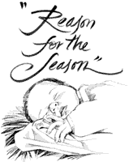
“SING THE REASON FOR THE SEASON”
As we celebrate Christ’s birth, join the choir prior to the 5:00 PM Christmas Eve Mass, for “Sing the Reason for the Season,” a collection of songs that tell of Christ’s coming. The program will start at 4:00 PM.

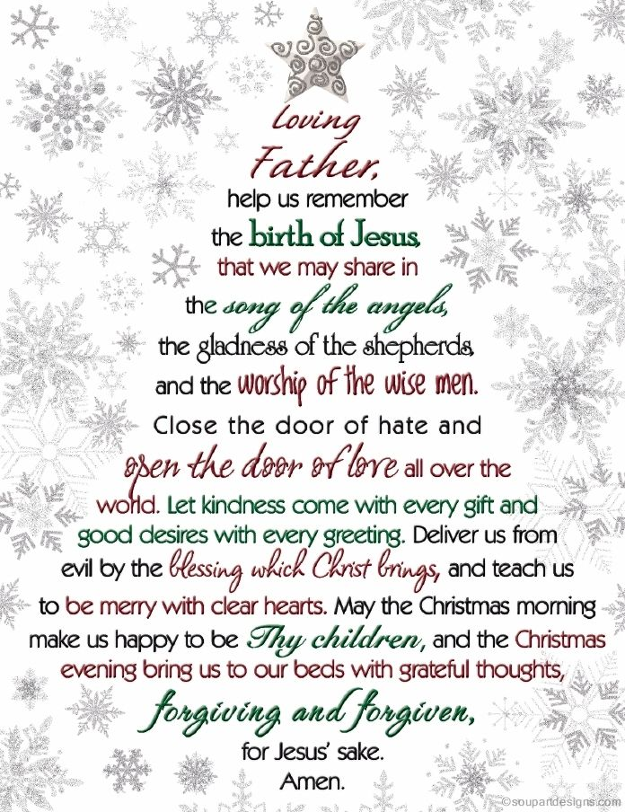

EARLY BULLETIN DEADLINE
Any bulletin announcements for the January 3rd bulletin must be into the office no later than Monday, December 21st. Thank you for your cooperation with the early bulletin deadlines.

