“Blessed are the meek, for they will inherit the land.”

All Saints

November 1, 2015

MASSES AND INTENTIONS
THIS WEEKEND OF
OCTOBER 31-NOVEMBER 1, 2015
Saturday 5:00 PM Mass
Intention: Vernon Deihl (RIP)
Requested By: KA
Sunday 8:00 AM Mass
Intention: St. Therese Parishioners
Sunday 10:30 AM Mass
Intention: Michael Tutaj
Requested By: Tom & Jeri Trudeau

WEEK OF
NOVEMBER 2-8, 2015
Monday 12:00 NOON Mass
Intention: All Soul's
Tuesday No Mass
Wednesday 9:00 AM Mass
Intention: Nicholas Carone (RIP)
Requested by: William Prucha
Thursday No Mass
Friday 9:00 AM Mass
Intention: The Theresians

THE WEEKEND OF
November 7-8, 2015
Saturday 5:00 PM Mass
Intention: Kathy Abers
Requested By: Ed Dreschl
Sunday 8:00 AM Mass
Intention: St. Therese Parishioners
Sunday 10:30 AM Mass
Intention: John Hoover (RIP)
Requested By: Mike & Ann Foster

DAILY SCRIPTURE READINGS
Daily Readings may be found at the
www.USCCB.org website.

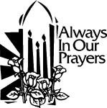
ST. THERESE’S TABERNACLE CANDLE
November 2-8, 2015
In Memory of: Petra Rascon


DONATED BY: The McCloskey Family
IN HONOR OF: John McCloskey

BLESSED SACRAMENT CHAPEL
VASE FLOWERS
Perpetual living memorial for Anna Lupei

"But when you give alms, do not let your left hand know what your right is doing." Matthew 6:3

OPERATING BUDGET
Fiscal Year 7/1/15 through 6/30/2016
Annual operating expense budget: $488,906

Did you know…
We will spend $8,500 for service contracts this year?

OFFERTORY
Actual Contributions 10/25/2015: $6,233.38
Gifts were in envelopes and in loose cash/checks with a total Weekend Mass attendance total of 346

Other contributions 10/25/2015 not used for operations totaled $125.00

In addition, we received E-giving support this week totaling
$1,954.50

THANKSGIVING MESSAGE
As the St. Therese parish family prepares for this holiday, it is Important to share our wishes for your family's blessings. We pray for your continued health and happiness as we enter this season of Advent. Please be reminded that you can set-up a recurring giving schedule. Visit us online at www.sttheresechurch.info. Locate the Online Giving button and set-up your recurring giving schedule. The first time you give, you will select a password that will enable you to log in at any time and make changes to your giving or view your complete online giving history

The Church of St. Therese is a
STEWARDSHIP parish.
Each week we depend upon and are
grateful for your generous support of
time, talents, and treasure to strengthen this,
YOUR parish community.

We can accept Visa, MasterCard, Discover, American Express,
Debit Cards, and savings/checking drafts.

NOVEMBER'S 2ND COLLECTIONS
November 21/22 Catholic Campaign for Human Development
November 28 Begin Poinsettia memorials

WEEKLY BINGO RESULTS:
October 19, 2015
On October 19, attendance included 34 players (7 parishioners) and 11 volunteers. The night's deposit totaled $871.30 is used for gaming expenses and donations to St Therese. Donations for 2015
now total $22,310; these funds will be used for unbudgeted items and special projects.

LIVING OUR MISSION
I would like to thank the 162 households for generously pledging a gift to the Living Our Mission Campaign. However, 162 households equals only thirty-five percent of our 485 registered families. A campaign of this scale comes along once in a lifetime and is a chance to do something really great for our parish. So, if you have not made your gift, please prayerfully consider doing so. For your convenience envelopes are available in the basket on the desk to mail your pledges to the Diocese. I thank you for your prayerful consideration of a pledge, and again to those of you who have already done so, God Bless you and thank you.

WE ARE HALFWAY THERE!!!
Justice & Peace wants to recycle your plastic bags! We have received nearly 300 pounds of plastic bags and our goal is 500 pounds by December 31st. Help St. Therese earn a free bench by turning in your plastic grocery bags to the recycling boxes in the social hall. Thank you for helping us!

ARE YOU INTERESTED IN BECOMING CATHOLIC?
RCIA (Rite of Christian Initiation of Adults) sessions meet each Thursday from 7:00—9:00 PM at the Adult Learning Center. These sessions are for anyone interested in learning more about the Catholic Church or is interested in becoming Catholic. Contact Nadine McGrady at 693-5939 or N.McGrady@StThersGlo.org for more information.

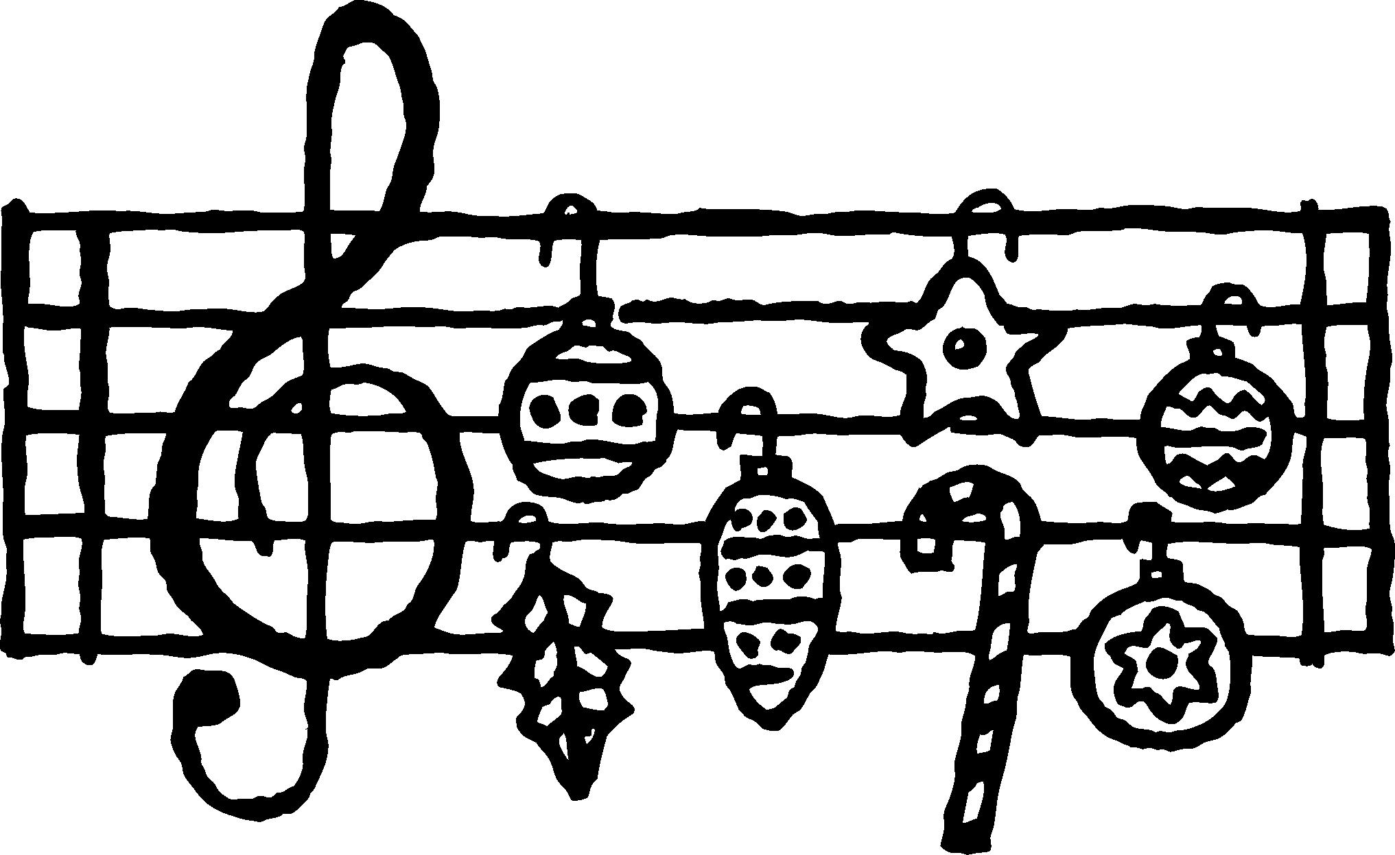
CHRISTMAS EVE MUSIC PROGRAM
Sing the Song of the Lamb; sing the praises of His birth. The 5 PM choir of St. Therese Music Ministry will soon be rehearsing for the Christmas Eve music program. Fifth grade children and up are invited to come to the rehearsals every Monday at 6:30 PM. Please consider joining us in lifting our voices to celebrate the miracle of Christmas.

RUN WITH THE SON FOR HAITI 5K
St. Kateri Tekakwitha, Tabb/Poquoson, is sponsoring a 5K Run/Walk on December 5, 2015 to raise funds to support the schools in their Haitian twin parish of St. Michel in Boucan-Carre. The run starts at 8:30 AM at the church, 3800 Big Bethel Road, Tabb. The cost is $25 for single runners/walkers; $20 for students and $20 family rate, per person. There will be awards to top finishers. Registration and additional information available at the race website: www.stkaterirun.com

RACHEL’S VINEYARD RETREAT
For healing after abortion, a Rachel’s Vineyard Retreat will be held December 11-13 at Shalom House Retreat Center, for women and men who have known regret, sorrow, guild or shame from abortion. The weekend combines living scripture meditations, spiritual exercises, and discussion in a guided process that leads to the heart of God’s love and compassion. If you would like to learn more about this retreat, contact Mary Montgomery-Jennings at 804-704-0429, or Maggai Carlson at 804-432-2589 or email: RV4hope@gmail.com. Their website is www.rachelsvineyard.org. Inquiries, registration and participation are strictly confidential.

2015 RED MASS
The Most Reverend Francis X. DiLorenzo, Bishop of Richmond, and The Saint Thomas More Society invite everyone in the Richmond Diocese to join in worship and fellowship at the 32nd Annual Red Mass and Dinner on Wednesday, November 4. Rev. Msgr. R. Francis Muench, J.C.L., Judicial Vicar for the Diocese of Richmond, will celebrate the Red Mass. Mass is at 5:30 p.m. at Saint Benedict Catholic Church, 300 North Sheppard Street, Richmond. The Dinner will follow in the Halsey Lecture Hall at the Virginia Historical Society, across the street from Saint Benedict Catholic Church. The keynote address will be given by Ryan T. Anderson, Ph.D., Senior Research Fellow in American Principles and Public Policy at The Heritage Foundation who researches and writes on marriage and religious liberty. Dinner tickets are $50 each. Further information can be obtained from Society President, James Schliessmann, jeschliessmann@hotmail.com or 804-873-1035.

ANNUAL VETERANS BRUNCH
The Knights of Columbus Council invites Veterans and their families to the Annual Veterans Brunch on Sunday, November 8th, at 11:45 AM in the Social Hall. A sign-up sheet is located in the Commons. Please submit a short-story (2 minutes) from your time in uniform that is humorous, thoughtful, emotional, or inspiring to Jim Gierlak at jegierlak@gmail.com or call (804) 832-8595. In keeping with military tradition, we encourage veterans to wear their medals or ribbons and veterans service organization hats on that solemn day.
OLD GLORY
The Knights of Columbus will be collecting worn and tattered US flags for proper disposal. A faded or torn flag should be retired properly and replaced with a vibrant new flag. Please bring in your old flags and place them in the old soldier’s footlocker which will be located in the Social Hall during November in honor of our Veterans. Thank you.

YOUR MINISTRY IS INVITED…
Please visit the updated parish website at sttherschurch.info! We are asking ministry chairs to submit any updates to the parish office that you would like to see posted. The parish staff will be trained to update the webpages within the next several weeks. Please submit your information by January 1 so we can begin incorporating your updates. Again, we are so grateful for your patience and hope you are delighted with the new site!

2014 ANNUAL APPEAL
We have received a check in the amount of $74.60 from the 2014 Annual Appeal Funds. Thank you for your support in the Diocesan Appeal.

